Unit 2 Lessons in life
Guided Teaching with Learning Plan
Period 2 Using language
(Grammar & Vocabulary & Listening)
导学案

1. To review and correctly use the passive voice in real situations.
2. To learn some proverbs about life and put them into use in communication.
3. To practice listening and get key information and understand the main idea of the listening material.
4. To learn how to share his or her life experiences and give others some advice or comments. .

1. Master the structures of the passive voice and correctly use them for expression.
2. Develop the listening ability and complete the tasks given in this lesson.
3. Lear some proverbs about life and use personal experiences of life to illustrate the understanding of the proverbs. .

New words and expressions for Period Two.
1 phrase | 7 come true
2 cooperate | 8 passive
3 fee | 9 fable
4 university fees | 10 omit
5 rather than | 11 lengthy
6 put...into... | 12 credit to

Step 1 Review the passive voice
Activity 1 Review the rules and the basic structures of the passive voice.
1. Active sentences are changed into passive sentences.
Active sentences are changed into passive sentences
The active voice in different tenses |  | The passive voice in different tenses
... do | →
...did | →
... be doing | →
... will do | →
... should do | →
... have done | →
... had done | →
... will have dome | →
2. Summarize the rules of using the passive voice.
① | A book of tissues will be needed to get through this book!
① | Rule :
② | Tuesday with Morrie is just made up of a collection of over- emotional thoughts.
② | Rule:
③ | On discovering that Morrie is being weakened by a severe illness,...
③ | Rule:

Step 2 Practice Activity 2 & Activity 3
Activity 2 Rewrite the paragraph about Aesop’s Fables by using the passive voice.
Since ancient times, storytelling has been a way to share and pass on wisdom①. One important early work that did so was Aesop’s Fables, a collection of stories that history credits to Aesop, a Greek storyteller. People believe that he lived in Ancient Greece between 620 BC and 564 BC②. Most of the characters in his stories are animals, the qualities of which Aesop used to reflect human traits and wisdom③. Each fable teachers a life lesson that Aesop summaries in a short phrase at the end of the story④, called a moral. Today, children and adults all around the world still enjoy Aesop’s Fables⑤.
①
②
③
④
⑤
Activity 3 Look at the four pictures on Page 17 and Write the story using the passive voice where appropriate and share it with the class.
Picture1 
Picture2 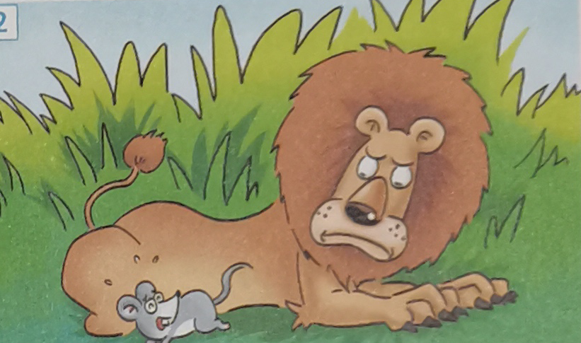
Picture 3 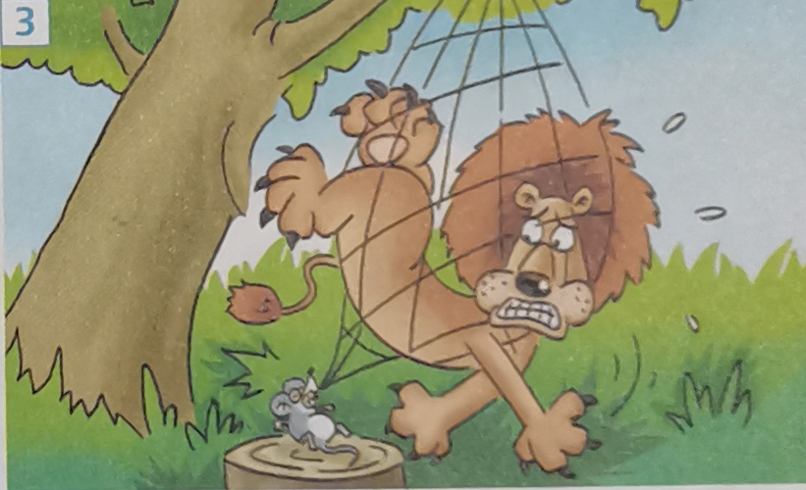
Picture 4 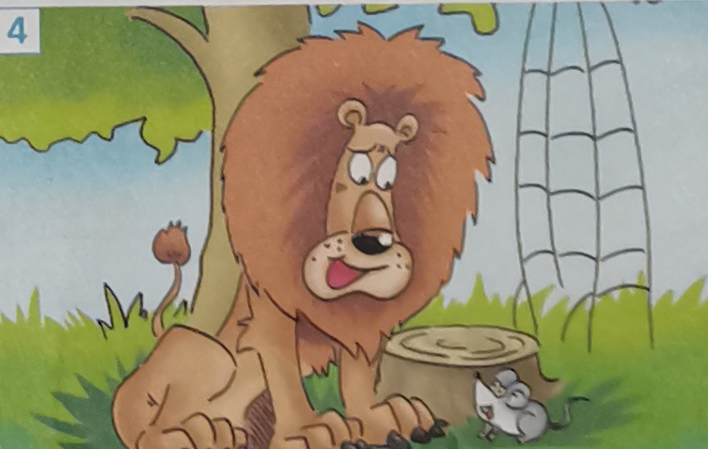
Step 3 Focus on vocabulary-- “proverbs about life”
Activity 5 Listen and write down the proverbs about life you hear.
①
②
③
④
⑤
⑥
Step 4 Listen and talk about proverbs about life
Activity 6 & Activity 7
1. Students listen for the first time and complete the conversations on Page 18.
a |  | You must face challenges in order to be successful
b |  | It’s easier to achieve something if you cooperate with someone else.
c |  | Doing something late is better than not doing it at all.
d |  | You should start things earlier rather than later.
e |  | Do not put all your efforts or resources into doing one thing.
f |  | Problems don’t matter if the final result is good.
2. Find some Chinese proverbs with similar meanings.
Step 5 Listen to the interview and finish the following task.
Activity 8
1. Have students choose the best headline after listening to the interview with Janet Rose.
A. University Fees are No Barrie to Grandma!
B. Dream Come True for Graduating Grandma
C. Jane Says: “Family first!” That’s what matters!”
D. How the Students Experience Has Changed with the Centuries
Activity 9
2. Listen again and complete the notes of the interview.
Interview with Janet Rose
1 | Age: ____________
2 | First attended university in: ______________
3 | Reason for leaving university: ________________
4 | Reason for going back to university: ______________________
5 | Initial feelings on returning to university: ____________________________
6 | University major: _____________________________
7 | Feeling on graduation:
8 | Advice to others:
9 | Future plans:
Activity 10 Complete the boxes with the expressions form the interview.
1. I start... back in.. 2. After that I ... 3. But then five years ago...
4. I felt... at first. 5. I suggest that... 6. Remember,...
Talking about experiences | Giving advice

Step 6: Language appreciation
1. Recently, there has been an increase in the number of mature students going to university after working for a few or many years.
[句式分析] 现在分词短语 “going to university” 充当名词students的后置定语，相当于定语从句 ________________________. 而现在分词短语 “after working for a few or many years” 在本语境中充当时间状语，相当于时间状语从句 _________________________________.
[尝试翻译] ___________________________________________________________.
2. In China, a man from Jiangsu Province graduated from university at the age of 88, making him the oldest university graduate in the country.
[句式分析] 现在分词短语 “making him the oldest university graduate in the country”, 在本语境中充当 _____________；而且采用“make + 宾语(him) + 宾语补足语(___________________)”复合结构。
[尝试翻译] _______________________________________________________________.
Step 7: Assignments
1. Review the new words and expressions learned in this period.
2. Review the usages of the passive voice in different tenses.
3. Write a short story about yourself to can be summarized by a proverb of life.

【参考答案】
Step 1 Review the passive voice
Activity 1 Review the rules and the basic structures of the passive voice.
1. Active sentences are changed into passive sentences.
Active sentences are changed into passive sentences
The active voice in different tenses |  | The passive voice in different tenses
... do | → | ... is/ am/ are done
...did | → | ...was/ were done
... be doing | → | ...be being done
... will do | → | ... will be done
... should do | → | ...should be done
... have/has done | → | ...have/ has been done
... had done | → | ...had been done
... will have dome | → | ...will have been done
2. Summarize the rules of using the passive voice.
① | A book of tissues will be needed to get through this book!
① | Rule: The subject, if not known or unimportant, can be omitted.
② | Tuesday with Morrie is just made up of a collection of over- emotional thoughts.
② | Rule: The subject goes with lengthy expressions that are better put at the end.
③ | On discovering that Morrie is being weakened by a severe illness,...
③ | Rule: The focus of the sentence is on the recipient of the action.
Step 2 Practice Activity 2 & Activity 3
Activity 2 Rewrite the paragraph about Aesop’s Fables by using the passive voice.
Since ancient times, storytelling has been a way to share and pass on wisdom①. One important early work that did so was Aesop’s Fables, a collection of stories that history credits to Aesop, a Greek storyteller. People believe that he lived in Ancient Greece between 620 BC and 564 BC②. Most of the characters in his stories are animals, the qualities of which Aesop used to reflect human traits and wisdom③. Each fable teachers a life lesson that Aesop summaries in a short phrase at the end of the story④, called a moral. Today, children and adults all around the world still enjoy Aesop’s Fables⑤.
① | Wisdom has been shared and passed on by storytelling.
② | It’s believed that that he lived in Ancient Greece between 620 BC and 564 BC.
③ | which were used by Aesop to reflect human traits and wisdom.
④ | that is summarized by Aesop in a short phrase at the end of the the story.
⑤ | Aesop’s Fables is still enjoyed by children and adults all around the world.
Activity 3 Look at the four pictures on Page 17 and Write the story using the passive voice where appropriate and share it with the class.
Picture1 | One day a little mouse was caught by a lion because the lion was weakened by the little mouse, which made him angry.
Picture2 | “Forgive me, please.” cried the little mouse. “I may be able to help you someday.” The lion was delighted by these words. He thought, “How could this mouse help me?” however, he lifted up his paws and the mouse was released.
Picture 3 | A few days later, the lion was caught in a trap. The hunters wanted to take him alive to the king, so he was tried to a tree, and the hunter went away to look for a carriage.
Picture 4 | Just then the little mouse passed by, and saw the sad lion. He went up to him, and soon the ropes were loosened. “Was I not right?”asked the little mouse.
Step 3 Focus on vocabulary-- “proverbs about life”
Activity 5 Listen and write down the proverbs about life you hear.
① | Better late than never.
② | No pains, no gains.
③ | Never put off until tomorrow what you can do today.
④ | All’s well that ends well.
⑤ | Two heads are better one.
⑥ | Don’t put all of your eggs in one basket.
Step 4 Listen and talk about proverbs about life
Activity 6 & Activity 7
1. Match the proverbs in Activity to their meanings.
a | No pains, no gains. | You must face challenges in order to be successful
b | Two heads are better one. | It’s easier to achieve something if you cooperate with someone else.
c | Better late than never. | Doing something late is better than not doing it at all.
d | Never put off until tomorrow what you can do today. | You should start things earlier rather than later.
e | Don’t put all of your eggs in one basket. | Do not put all your efforts or resources into doing one thing.
f | All’s well that ends well. | Problems don’t matter if the final result is good.
2. Find some Chinese proverbs with similar meanings.
【Suggested answer】
A. Roman was not built in a day. (罗马并非一日建成。)
B. A slow sparrow should make an early start. (笨鸟先飞。)
C. Practice makes perfect.(熟能生巧。)
Step 5 Listen to the interview and finish the following task.
Activity 8
1. Have students choose the best headline after listening to the interview with Janet Rose.
A. University Fees are No Barrie to Grandma!
B. Dream Come True for Graduating Grandma
C. Jane Says: “Family first!” That’s what matters!”
D. How the Students Experience Has Changed with the Centuries
【答案】 B .
Activity 9
2. Listen again and complete the notes of the interview.
Interview with Janet Rose
1 | Age: 81
2 | First attended university in: 1955
3 | Reason for leaving university: She took care of her ill mother and helped her father.
4 | Reason for going back to university: Her daughter suggested she go back to school five years ago and she jumped at the chance.
5 | Initial feelings on returning to university: She felt nervous at first and she felt so old.
6 | University major: American literature
7 | Feeling on graduation: She feels great.
8 | Advice to others: You are never too old to learn.
9 | Future plans: Starting a master’s degree.

Activity 10 Complete the boxes with the expressions form the interview.
1. I start... back in.. 2. After that I ... 3. But then five years ago...
4. I felt... at first. 5. I suggest that... 6. Remember,...
Talking about experiences | Giving advice
1/ 2/ 3/ 4 | 5/6
Step 6: Language appreciation
1. Recently, there has been an increase in the number of mature students going to university after working for a few or many years.
[句式分析] 现在分词短语 “going to university” 充当名词students的后置定语，相当于定语从句who are going to university. 而现在分词短语 “after working for a few or many years” 在本语境中充当时间状语，相当于时间状语从句after they worked for a few or many years.
[尝试翻译] 最近，有越来越多的成年学生在工作几年后去上大学。

2. In China, a man from Jiangsu Province graduated from university at the age of 88, making him the oldest university graduate in the country.
[句式分析] 现在分词短语 “making him the oldest university graduate in the country”, 在本语境中充当“伴随状语”；而且采用“make + 宾语(him) + 宾语补足语(the old ....the country)”复合结构。
[尝试翻译] 在中国，江苏一名男子以88岁的高龄大学毕业，成为中国年龄最大的大学毕业生。

