Unit 3 The world meets China
Guided Teaching with Learning Plan
Period 1 Starting out & understanding ideas
导学案

1. To enlarge your vocabulary and use new words and phrases to talk about the Silk Road and Dunhuang.
2. To improve reading ability and understand the theme and the type of the passage.
3. To think and share the opinion on how the Silk Road of Dunhuang is once again a meeting place for people from around the world.
4. To practise writing a summary of the passage.

1. To talk about the history and the development of Dunhuang on the old Silk Road as well as the role in cultural exchange.
2. To analyze Dunhuang’s historical significance and influence on intercultural communication.
3. To think and share the opinion on why Dunhuang has once again become a global crossroads.
/7Key words and expressions for Period One
1 gateway | 10 immortal
2 oasis | 11 heavenly
3 glorious | 12 peak
4 boast | 13 Taoist priest
5 grotto | 14 scroll
6 testimony | 15 ceramics
7 statue | 16 expo
8 mural | 17 strengthen
9 religious | 18 coverage

Step 1 Starting out
1. Watch the video and get the key information for the answers of the questions.
① | What is the video about?
② | How did the road get its name?
③ | What is remarkable about the road?
2. Look at the pictures on Page 25 and talk about intercultural communication.
① | What can you see in the pictures?
① | 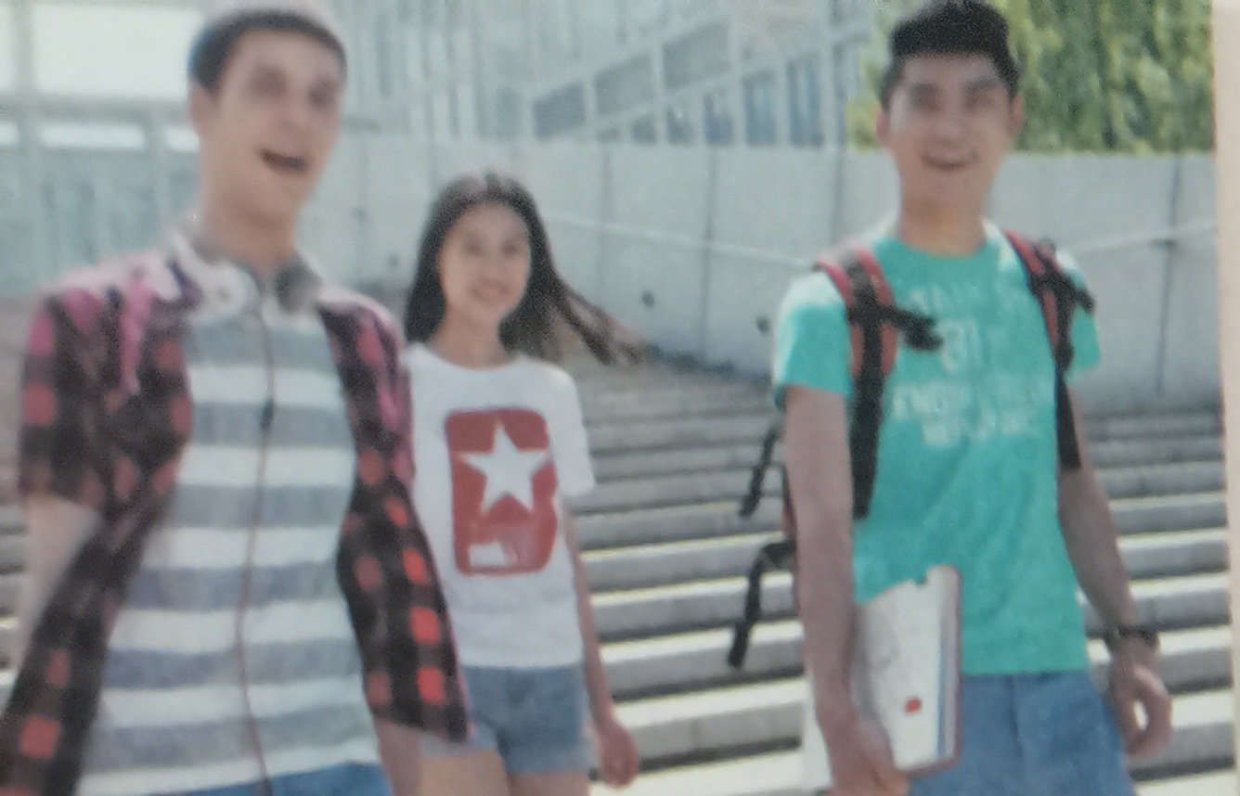
① | 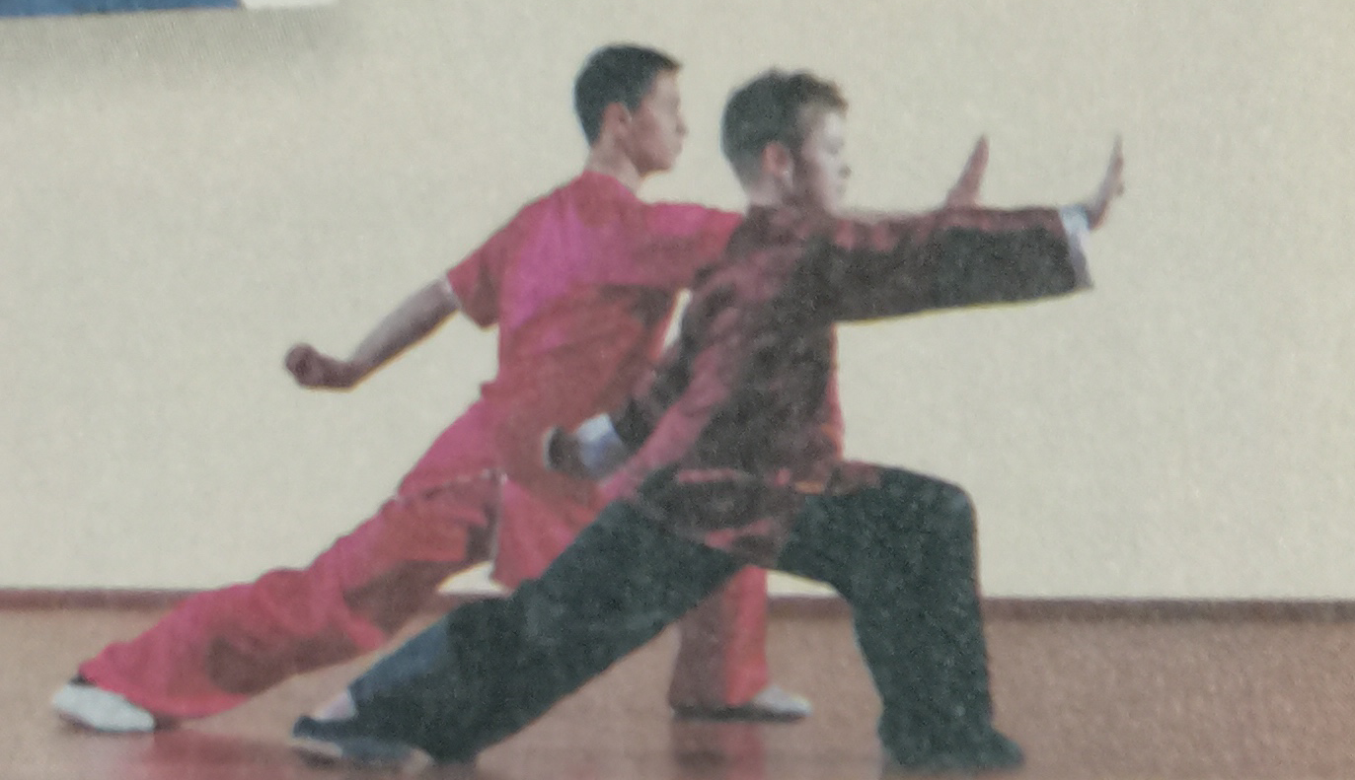
① | 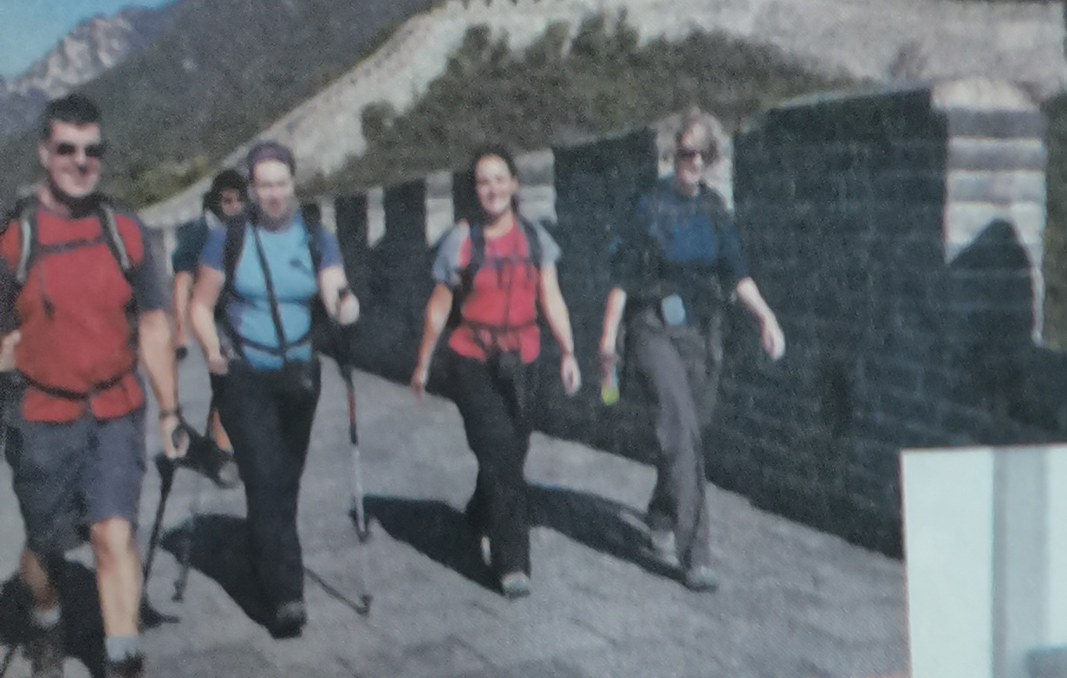
① | 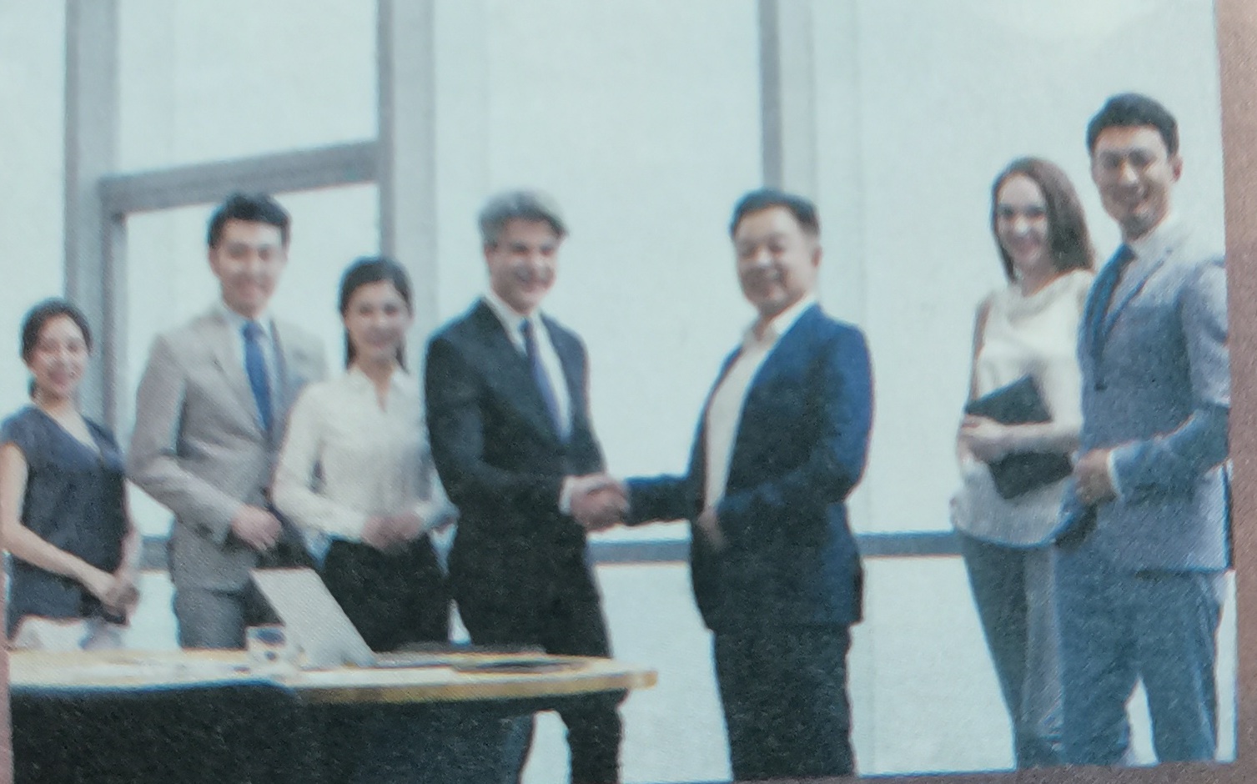
② | What messages do these picture convey?
③ | In what other areas is China attracting attention around the world?

Step 2 Before reading
Activity 1 Look at the pictures and answer the questions about Dunhuang characteristics.
1. What makes Dunhuang unique,Mogao Grottoes, murals or Mingsha Mountain? Why?
2. What else do you know about Dunhuang?
Step 3 First reading Activity 2 & Activity 3
Read the passage and answer the following question.
1. Which of the following is true about Library Cave?
A. It is the greatest finding of the 20th century. B. It was discovered by archaeologists.
C. It is far from other caves in good condition. D. Its treasures dates from 405AD to 1002AD.
2. Why is Dunhuan the ideal place for the 2017 Silk Road International Cultural Expo?
A. it meets the theme B. its location is important
C. it is prosperous as before D. it attracts visitor at home and abroad.
3. The best summary of the passage is __________________________.
A. The Silk Road was an ancient trade route between East and West, which passed through Dunhuang.
B. The Silk Road city of Dunhuang has a splendid history and is once again a meeting place for people from around the world.
C. In Dunhuang there are grottoes, murals and other sights that attract tourists from all over the world.
D. Dunhuang as a new place of interest is attracting visitors at home and abroad.
4. where is the passage most probably from?
A. A travel brochure B. A tour commentary C. A blog D. A lecture
Step 4: Second reading Activity 4
1. Analyze the structure of the passage and summarize the main idea of each paragraph.
Parts | Paragraph(s) | The main idea of each part
Part 1
Part 2
Part 3
2. Organize information from the passage and complete the travel web-page.
Dunhuang | Caves in Mogao Grottoes
Location: Gansu Province | The caves were carved out of the rock ³ ______________
Significance:  ▼UNESCO-protected heritage sites  ▼¹ ____________________________  ▼² ___________________________  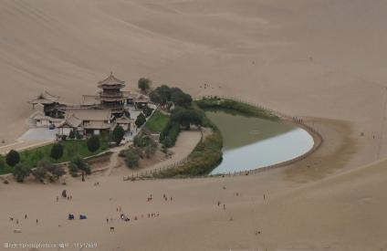 | Statues  The statues include elements from ⁴ ________________
Murals
▼Coverage: ⁵ _____________________________.
▼Topics: ⁶ ________________________________.
Apsaras
▼Also called ⁷ ________________________, they represent
⁸ ___________________________________.
▼Apsaras painted during the Tang Dynasty are a reflection of the ⁹ ________________________ during that time.
Dunhuang has once again become  ¹² ____________________________. | Library Cave  ▼Discovered inside were ¹⁰ _______________________  ▼These give us ¹¹ _______________________________

Step 5: Post- reading: Think & share
1. In what ways is present-day Dunhuang influenced by its past?
2. What would you most like to visit in Dunhuang? Why?
Step 6: Language appreciation
1. If you look up, you can see the paintings and other artworks that are testimony to how the Silk Road brought East and West together.
[句式分析] that are testimony to how the Silk Road brought East and West together 是that引导的________从句，修饰先行词the paintings and other artworks；其中how the Silk Road brought East and West together为how 引导的 __________ 从句并充当介词to________ (成分)。
[尝试翻译] ______________________________________________________________________.
2. In a sealed cave, now known as the famous Library Cave, were hidden thousands of manuscripts, paintings and scrolls as well as silk embroideries.
[句式分析] 本句采用一个完全倒装句，其结构为“___________________________”，正常句序是“hidden thousands of manuscripts, paintings and scrolls as well as silk embroideries were in a sealed cave..... ”；其中过去分词短语now known as the famous Library Cave 作__________ (成分)修饰说明名词短语a sealed cave;
[尝试翻译] _____________________________________________________________________.
3. Given that the theme of the Expo was to promote cultural exchange and strengthen mutual cooperation between the countries along the Silk Road, Dunhuang was the ideal place.
[句式分析] given that-从句，given 为介词, 意为“_______________”,常常用来引导__________从句。
[尝试翻译] ______________________________________________________________________.
Step 7: Assignments
1. Review the basic usage of the new words and expressions learned in this period.
2. Read and listen to the passage to get more information about Dunuang and the Silk Road.
3. Writing a 60-word summary of the passage.

【参考答案】
Step 1 Starting out
1. Watch the video and get the key information for the answers of the questions.
① | What is the video about?
② | How did the road get its name?
③ | What is remarkable about the road?
【答案】
① | The video is about the historical importance of the ancient Silk Road and its revival through the Belt and Road initiative.
② | It got its name because a lot of trade along the road was in Chinese silk.
③ | The road is remarkable firstly because it lasted around 1700 years from the Han Dynasty until the Ming Dynasty. Secondly, it’s a unique and important cultural crossroads between the East and West.

2. Look at the pictures on Page 25 and talk about intercultural communication.
① | What can you see in the pictures?
① | The picture shows Chinese and foreign students are walking through their school.
① | It shows Chinese and foreigners are doing body-building exercise eg. tai chi.
① | A group of foreign tourists are exploring the Great Wall of China.
① | The picture shows a foreign business man is shaking hands with a Chinese one.
② | What messages do these picture convey?  【答案】it is often common that overseas students come to China, studying, learning about traditional Chinese culture, exploring Chinese heritage sites or doing business.
③ | In what other areas is China attracting attention around the world?  【答案】To name but a few, high-speech rail, various delicious local food, mobile payment and online shopping,etc.
Step 2 Before reading
Activity 1 Look at the pictures and answer the questions about Dunhuang characteristics.
1. What makes Dunhuang unique,Mogao Grottoes, murals or Mingsha Mountain? Why?
2. What else do you know about Dunhuang?
【答案】
1 | Dunhuang is unique because of the Mogao Grottoes, its incredibly detailed, colourful murals and Mingsha Mountain, which is rarely seen in any other place.
2 | As far as I’m concerned, Dunhuang is a place where many cultures meet and collide, where Chinese, Indian, Greek and Islamic cultures meet. Dunhuang is a temple of art. The murals and sculptures from the 4th to the 11th centuries give people a very powerful artistic experience.

Step 3 First reading Activity 2 & Activity 3
Read the passage and answer the following question.
1. Which of the following is true about Library Cave?
A. It is the greatest finding of the 20th century. B. It was discovered by archaeologists.
C. It is far from other caves in good condition. D. Its treasures dates from 405AD to 1002AD.
2. Why is Dunhuan the ideal place for the 2017 Silk Road International Cultural Expo?
A. it meets the theme B. its location is important
C. it is prosperous as before D. it attracts visitor at home and abroad.
3. The best summary of the passage is __________________________.
A. The Silk Road was an ancient trade route between East and West, which passed through Dunhuang.
B. The Silk Road city of Dunhuang has a splendid history and is once again a meeting place for people from around the world.
C. In Dunhuang there are grottoes, murals and other sights that attract tourists from all over the world.
D. Dunhuang as a new place of interest is attracting visitors at home and abroad.
4. where is the passage most probably from?
A. A travel brochure B. A tour commentary C. A blog D. A lecture
【答案】1--4 DABB
Step 4: Second reading Activity 4
1. Analyze the structure of the passage and summarize the main idea of each paragraph.
【答案】
Parts | Paragraph(s) | The main idea of each part
Part 1 | Para 1, 2 | Dunhuang’s great history and its present-day status as a world-class tourist destination.
Part 2 | Para 3, 4,5 | Dunhuang’s tourist attractions with a long history and splendid culture such as murals and the Library Cave.
Part 3 | Para 6 | The Belt and Road Initiative is bringing Dunhuang to life once more.

2. Organize information from the passage and complete the travel web-page.
Dunhuang | Caves in Mogao Grottoes
Location: Gansu Province | The caves were carved out of the rock ³ ______________
Significance:  ▼UNESCO-protected heritage sites  ▼¹ ____________________________  ▼² ___________________________ | Statues  The statues include elements from ⁴ ________________
Murals
▼Coverage: ⁵ _____________________________.
▼Topics: ⁶ ________________________________.
Apsaras
▼Also called ⁷ ________________________, they represent
⁸ ___________________________________.
▼Apsaras painted during the Tang Dynasty are a reflection of the ⁹ ________________________ during that time.
Dunhuang has once again become  ¹² ____________________________. | Library Cave  ▼Discovered inside were ¹⁰ _______________________  ▼These give us ¹¹ _______________________________
【答案】
1. long and glorious history 2. a centre of cultural and commercial exchange
3. over a period of 1000 years 4. Ancient Greece,, India and Iran
5. 45000 square meters 6. from religious stories to scenes of everyday life
7. Flying Immortals 8. heavenly musicians, singers and dancers
9. confidence and optimism of people
10. thousands of manuscripts, paintings and scrolls as well as silk embroideries
11. a picture of Dunhuang when it was at the very centre of the Silk Road trade
12. a global crossroads
Step 5: Post- reading: Think & share
1. In what ways is present-day Dunhuang influenced by its past?
2. What would you most like to visit in Dunhuang? Why?
【答案】
1 | Its long and glorious history, its cultural and commercial value and a flourishing trade in goods.
2. | The famous Library Cave, where is hidden abundant cultural heritages.

Step 6: Language appreciation 【答案】
1. If you look up, you can see the paintings and other artworks that are testimony to how the Silk Road brought East and West together.
[句式分析] that are testimony to how the Silk Road brought East and West together 是关系代词that引导的定语 从句，修饰先行词the paintings and other artworks；其中how the Silk Road brought East and West together为how 引导的 宾语 从句并充当介词to 宾语 。
[尝试翻译] 如果你抬头看，你会看到绘画和其他艺术品，它们证明了丝绸之路是如何把东西方联系在一起的。

2. In a sealed cave, now known as the famous Library Cave, were hidden thousands of manuscripts, paintings and scrolls as well as silk embroideries.
[句式分析] 本句采用一个完全倒装句，其结构为 “介词短语+谓语+主语” ，正常句序是“hidden thousands of manuscripts, paintings and scrolls as well as silk embroideries were in a sealed cave..... ”；其中过去分词短语now known as the famous Library Cave 作后置 定语 修饰说明名词短语a sealed cave;
[尝试翻译] 在一个封闭的洞穴里，现在被称为著名的图书馆洞穴，隐藏着成千上万的手稿，绘画和卷轴以及丝绸刺绣。

3. Given that the theme of the Expo was to promote cultural exchange and strengthen mutual cooperation between the countries along the Silk Road, Dunhuang was the ideal place.
[句式分析] given that-从句，given 为介词, 意为 “考虑到...，鉴于...” ,常常用来引导原因状语 从句。
[尝试翻译] 鉴于本届世博会的主题是促进丝绸之路沿线国家之间的文化交流和加强相互合作，敦煌是一个理想的地方。

