Unit 4 Everyday economics
Guided Teaching with Learning Plan
Period 1 Starting out & understanding ideas
导学案

1. To get key information about the development of monetary by watching the video about monetary and everyday economics.
2. To describe daily economic activities and talk about the role of monetary in life and the trend of development of future monetary system.
3. To understand a feature story, including its structure, its writing purpose, key details, and effectively dealing with reading tasks.
4. To share what to learn from the heroine of a successful business, including her personal character, her positive attitude towards life and so on.

1. Lead the students to get key information and talk about pictures about everyday economic activities.
2. Develop students’ reading comprehension and better understand the characteristics of a feature story.
3. Guide the students to think about and share the reasons why the heroine achieved success in her business.
Key words and expressions for Period One
1 forehead | 10 phase
2 blank | 11 manufacturer
3. dizzy | 12 cosmetics
4 chairwoman | 13 purchase
5 potential | 14 distribute
6 bug | 15 bonus
7 enterprising | 16 consultant
8 input | 17 guidance
9 obstacle | 18 entrepreneurial

Step 1 Starting out
Activity 1 Watch the video and answer the questions.
① What is the video about?
② What stages are mentioned in the video? What are they like?
Activity 2 Look at the pictures on Page 37 and complete the following the forms.
Pictures | What activities? | what they have in common?




Step 2 Before reading
Activity 1 Look at the charts on Page 38and answer the questions.
Career development of Chinese college  students in 2017 (6 months after graduation) |  | Trend of Chinese college graduates starting a business  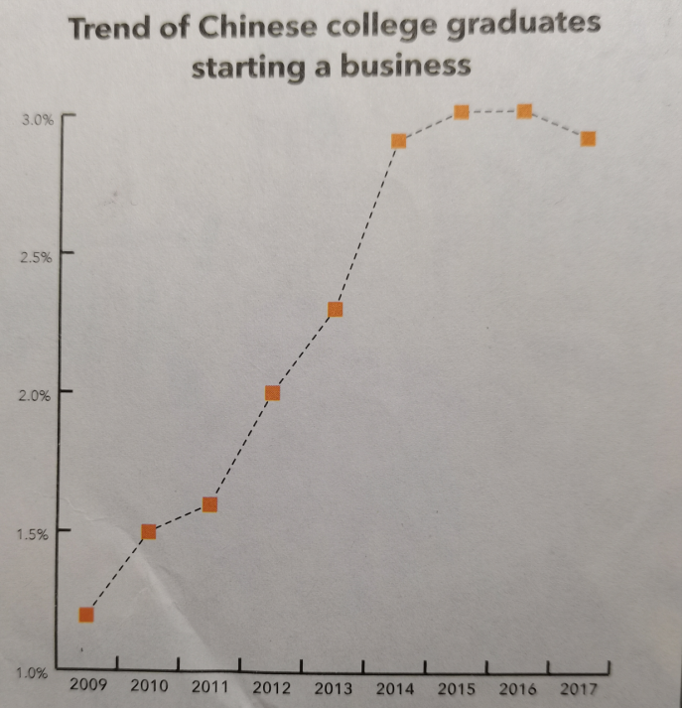
◎ in full-time employment | 78.9%
◎ starting a business | 2.9%
◎ attending graduate school | 10.8%
◎ Unemployed | 7.2%
◎ other | 0.4%
Question 1: What options do college students have after graduation?
Question 2: What does the chart tell you about the trend of college graduates starting their own business?
Step 3 Fast reading
Activity 2 Read the passage on Page 38 fast and answer the following questions.
1. What decision did Zhang Yue make to develop her career?
A. She decided to return her home town and start a business growing roses.
B. She decided to return her home and start a company selling cosmetics.
C. She decided to return her home town and run a training school.
2. Which words can best describe Zhang Yue?
A. Diligent and experienced
B. Passionate and devoted
C. Potential and doubtful
3. What was Zhang Yue biggest difficulty at the beginning?
A. Lacking much money
B. Being refused by others
D. Lacking labour force
Step 4 Further reading
Activity 3 Choose the main purpose of the text and give your reasons.
A. To introduce the main reasons why young people choose to start their own businesses.
B. To analyse the pros and cons of young people starting their own business.
C. To encourage all young people to start their own business after graduation.
D. To help young think more realistically before starting their own business.
E. To teach young people the correct procedures for starting their own businesses.
Activity 4 Organize information from the passage and complete the interview notes.
Interview notes |  | 
Programme | Young start-ups
Interviewee | Zhang Yue
Occupation | ¹________ of Rose Valley Co.Ltd
Date | 26th April
General situation of the company |  | Challenges
◎ One of the best rose products in Asia.  ◎ A major Asia manufacturer of cosmetics ²____ |  | ◎ Getting investment.  ◎ ⁶ ________________________________
Reasons for starting a business in her hometown |  | Advice for young entrepreneurs
◎ ³__________________ for growing roses  ◎ Experience the freedom of ⁴ __________  ◎ ⁵________________________________ |  | ◎ You need a good idea, hard work, ⁷ _________  ◎ ⁸ _______, access to capital, and ⁹ ________  ◎ ¹⁰ _____________________  ◎ Your limits and the people you work with.
Step 5: Post- reading
Think & share
Think back the content of the passage and answer the following the question.
1. What do you think has contribute to Zhang Yue’s success?
2. What other difficulties do you think young people encounter when starting their own business?
3. How well do you understand the characteristics of a feature story? How are these characteristics reflected in the reading passage?
Step 6: Language appreciation
1. It was only after graduating from university overseas and returning to visit her parents that Zhang realized the potential.
[句式分析] 本句采用了强调句结构，即“______________________________”。使用强调句时注意几点：形式主语it不能用其它词代替；被强调部分指人时，可以用who代替，其它情况一律用that；强调句型的判断方法：去掉it’s 和who/that，适当调整语序，若能还原成完整的句子，则为强调句型，否则就不是。
[尝试翻译] ________________________________________________________________。
2. They stared back, their blank faces giving no clue as to what they would say next.
[句式分析] 该句中“their blank faces giving no clue”为“名词+现在分词”构成 _______________ 结构，在句子中作伴随状语。该结构的特点为：该结构的逻辑主语与句子的主语不相同，而且没有使用连接词。独立结构的逻辑主语与其后的动词构成主动关系时，用________分词；构成被动关系时，用 ________ 分词；表示将来动作时，用 ____________ 形式。
[尝试翻译] _____________________________________________________________。
3. She is not the only young person to have been bitten by the start-up bug.
[句式分析] 不定式短语“to have been bitten by the start-up bug”作__________ (成分)，修饰“the only young person”。
[尝试翻译] ______________________________________________。
Step 7: Assignments
1. Review the basic usage of the new words and expressions learned in this period.
2. Read and listen again for a better understanding of the text .
3. Writing a 60-word summary of the passage.
【参考答案】
Step 1 Starting out
Activity 1 Watch the video and answer the questions.
① What is the video about?
② What stages are mentioned in the video? What are they like?
【答案】
① The video is about the development of currency.
② There are different stages in the development of currency. Long before money was invented, people used a barter system to buy and sell things. A batter system is a way to exchange goods and service for other goods and services. Later, some goods became more widely accepted than others. These could be used to calculate the value of other products and services. Around the 11th century BC, Chinese people started to use small pieces of bronze to trade things. In the early stages, coins of different shapes were used. The coins were standardized in the Qin Dynasty and started to take a circular shape with a square hole through the middle. Around the year 1000, the Chinese began to use paper money. The Song Dynasty saw the introduction of jiaozi, which is said to be not only the first example of paper currency used in China, but also in the world. Today, we have a modern system of coins and paper notes, but this is continuing to change and develop to other forms.
Activity 2 Look at the pictures on Page 37 and complete the following the forms.
Pictures | What activities? | what they have in common?
【答案】
Pictures | What activities? | what they have in common?
 | Paying coins for vegetables | The pictures show types of economic behaviors and they are related to currency of various forms.
 | Using an ATM card
 | Donating money to people in need
 | Paying through an app on a smartphone
Step 2 Before reading
Activity 1 Look at the charts on Page 38and answer the questions.
Career development of Chinese college  students in 2017 (6 months after graduation) |  | Trend of Chinese college graduates starting a business
◎ in full-time employment | 78.9%
◎ starting a business | 2.9%
◎ attending graduate school | 10.8%
◎ Unemployed | 7.2%
◎ other | 0.4%
Question 1: What options do college students have after graduation?
Question 2: What does the chart tell you about the trend of college graduates starting their own business?
【答案】
Question 1: They can get a full-time job, pursue further education, or start their own business. They may also choose not to have a job.
Question 2:
(1) From 2009 to 2015, the percentage of university graduates who started a business rose.
(2) Between 2015 and 2016, the percentage remained almost at the same level, about 3%, while in 2017, the percentage declined.
Step 3 Fast reading
Activity 2 Read the passage on Page 38 fast and answer the following questions.
1. What decision did Zhang Yue make to develop her career? (Answer : A)
A. She decided to return her home town and start a business growing roses.
B. She decided to return her home and start a company selling cosmetics.
C. She decided to return her home town and run a training school.
2. Which words can best describe Zhang Yue? (Answer : B)
A. Diligent and experienced
B. Passionate and devoted
C. Potential and doubtful
3. What was Zhang Yue biggest difficulty at the beginning? (Answer : A)
A. Lacking much money
B. Being refused by others
D. Lacking labour force
Step 4 Further reading
Activity 3 Choose the main purpose of the text and give your reasons.
A. To introduce the main reasons why young people choose to start their own businesses.
B. To analyse the pros and cons of young people starting their own business.
C. To encourage all young people to start their own business after graduation.
D. To help young think more realistically before starting their own business.
E. To teach young people the correct procedures for starting their own businesses.
(Answer : D)
Activity 4 Organize information from the passage and complete the interview notes.
Interview notes
Programme | Young start-ups
Interviewee | Zhang Yue
Occupation | ¹________ of Rose Valley Co.Ltd
Date | 26th April
General situation of the company |  | Challenges
◎ One of the best rose products in Asia.  ◎ A major Asia manufacturer of cosmetics ²____ |  | ◎ Getting investment.  ◎ ⁶ ________________________________
Reasons for starting a business in her hometown |  | Advice for young entrepreneurs
◎ ³__________________ for growing roses  ◎ Experience the freedom of ⁴ __________  ◎ ⁵________________________________ |  | ◎ You need a good idea, hard work, ⁷ _________  ◎ ⁸ _______, access to capital, and ⁹ ________  ◎ ¹⁰ _____________________  ◎ Your limits and the people you work with.
【答案】
1 chairwoman | 6 Persuading people to work for her
2 was willing to purchase the product and help with it distribution | 7 determination
3. An ideal place | 8 a sound business plan
4. being her own boss | 9 good management and negotiating skills
5. Giving something back to her home town | 10 Don’t be too ambitious.

Step 5: Post- reading
Think & share
Think back the content of the passage and answer the following the question.
1. What do you think has contribute to Zhang Yue’s success?
2. What other difficulties do you think young people encounter when starting their own business?
3. How well do you understand the characteristics of a feature story? How are these characteristics reflected in the reading passage?
【答案】
1. In my point of view, she is passionate and devoted, which contributes to her success. Besides, she has a good idea and works so hard with a strong determination.
2. Except lacking enough money, they should take many things into consideration, including support from skilled working force, professional staff, good management and so on.
3. A feature story mainly describing the scene of an important event or some important and wonderful scenes, or an important character, vividly presenting the reported facts to the readers. The story focuses on key factors of the subject, which is real and thought-provoking in a humorous tone.
Step 6: Language appreciation
1. It was only after graduating from university overseas and returning to visit her parents that Zhang realized the potential.
[句式分析] 本句采用了强调句结构，即“It’s +被强调部分+that+其它部分”。使用强调句时注意几点：形式主语it不能用其它词代替；被强调部分指人时，可以用who代替，其它情况一律用that；强调句型的判断方法：去掉it’s 和who/that，适当调整语序，若能还原成完整的句子，则为强调句型，否则就不是。
[尝试翻译] 直到她从海外大学毕业回家看望父母后，张悦才意识到自己的潜力。
2. They stared back, their blank faces giving no clue as to what they would say next.
[句式分析] 该句中“their blank faces giving no clue”为“名词+现在分词”构成 独立主格 结构，在句子中作伴随状语。该结构的特点为：该结构的逻辑主语与句子的主语不相同，而且没有使用连接词。独立结构的逻辑主语与其后的动词构成主动关系时，用 现在 分词；构成被动关系时，用 过去 分词；表示将来动作时，用不定式形式。
[尝试翻译] 他们也盯着对方，脸上毫无表情，不知道接下来要说什么。
3. She is not the only young person to have been bitten by the start-up bug.
[句式分析] 不定式短语“to have been bitten by the start-up bug”作 后置定语 (成分)，修饰“the only young person”。
[尝试翻译] 她不是唯一一个对创业感兴趣的年轻人。

