Unit 6 Space and beyond
Guided Teaching with Learning Plan
Period 3 Developing ideas & Presenting ideas
导学案

1. To learn new words and expressions for reading and writing in this period .
2. To develop the reading ability by analyzing the passage themed “Eyes upon the night”.
3. To compare and explain the features of the two passages in this unit reflecting the spirit of exploration.
4. To develop the writing ability by writing a journey entry about living in space.

1. To have a better understanding the theme of this unit and develop their the spirit of space exploration.
2. To learn how to write a journey entry about living in space with the writing help.
3. To prepare and share a short presentation of an next imagined Voyager mission.
Key words and expressions for Period One
1 telescope | 10 straightforward
2 the naked eye | 11 self-discipline
3 angle | 12 fetch
4 galaxy | 13 muscle
5 cosmic | 14 pepper
6 conceivably | 15 sneeze
7 subatomic | 16 disc
8 particle | 17 interior
9 invisible | 18 earth-based

Step 1 Before reading
Activity 1 & Activity 2
1. Look at the images taken by the Hubble Space Telescope and match them to their nicknames.
A. 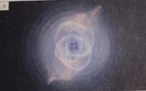 | 1. The Pillars of Creation
B. 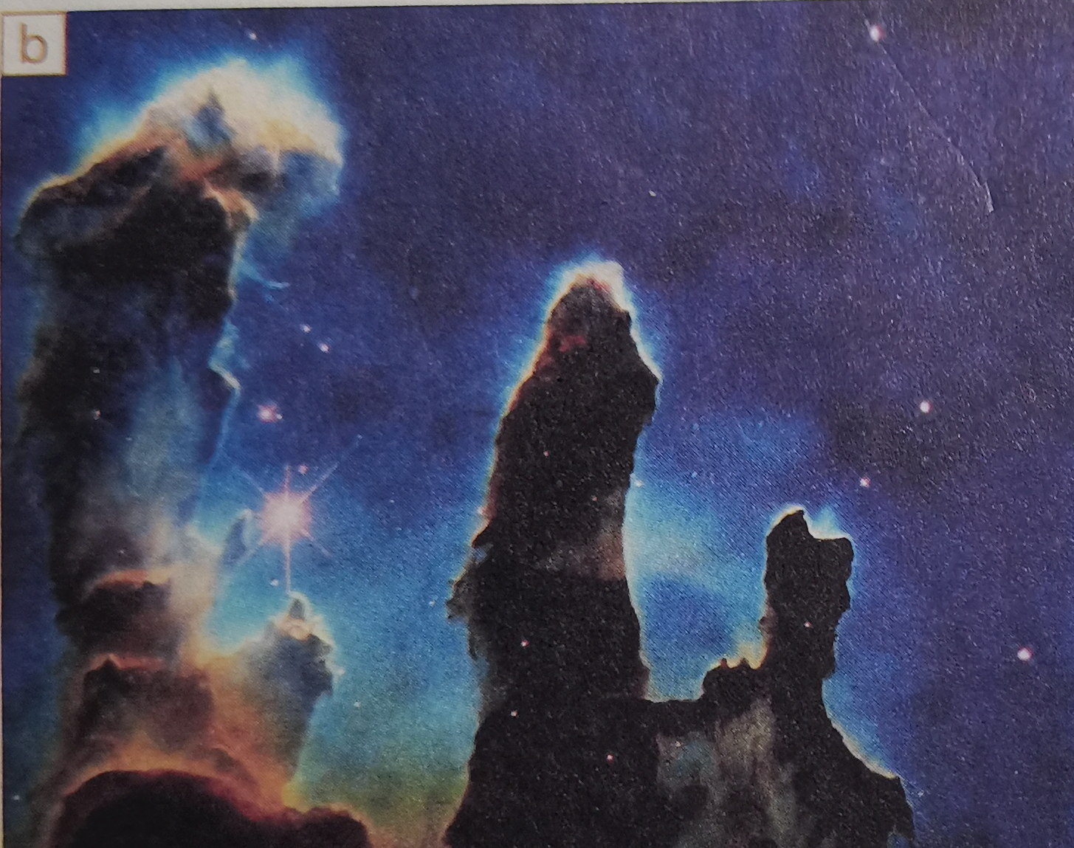 | 2. The Horse-head
C. 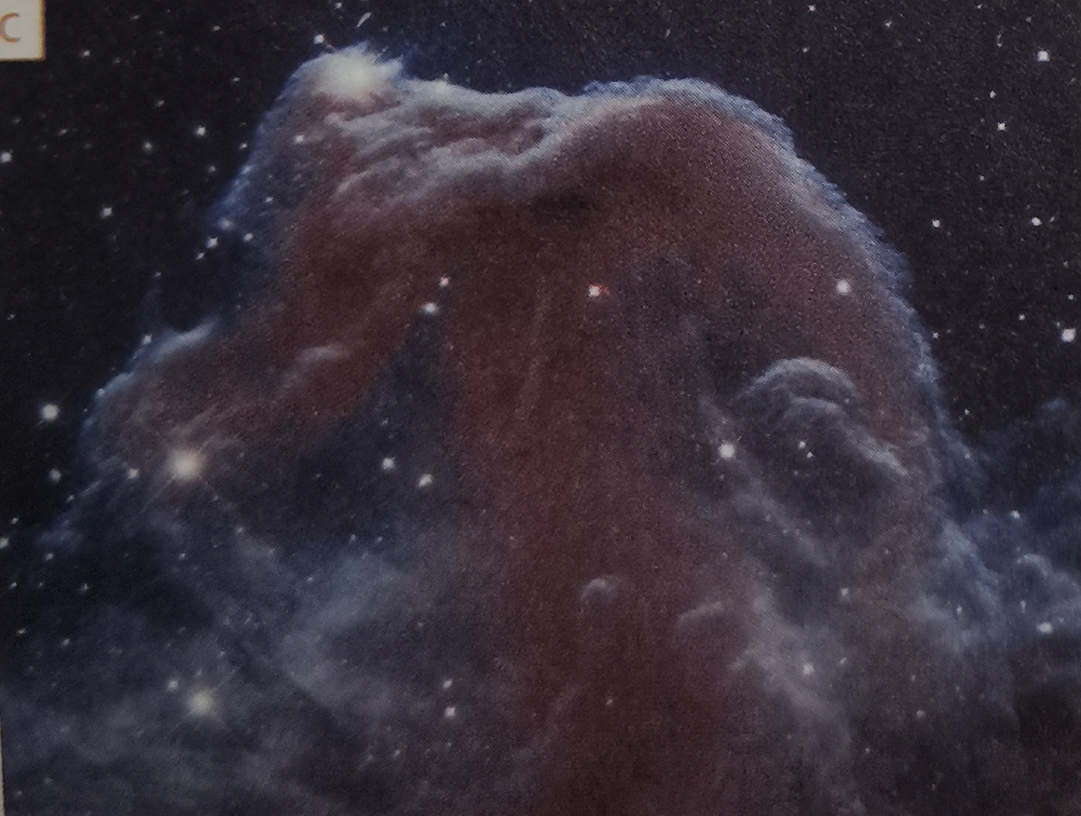 | 3. The Cat’s Eye
2. Look at the title of the passage and predict what “eyes” refers to.
Step 2 Fast reading
Skim the text and answer the following questions.
1. In ancient China, how did people understand the night sky?
2. When did human’s power to see the sky start changing dramatically?
3. What did the Hubble Space Telescope help people do when it was launched in 1990?
Step 3 Further reading Activity 3
1. The structure of the text and the theme
Parts | Paragraphs | The main idea
Part 1
Part 1
Part 1
2. Complete the timeline
Thousands of years ago, people already regarded the night sky as an ¹ __________. It was believed that the huge eyes of the large-eyed bronze statues from the Chinese archaeological site at Sanxindui were able to ² ______________.
Our power to see the sky changed dramatically when ³ _________. It extended ⁴ __________ and caused us to realize that the universe is a far larger place than we ever imagined.
In 1900, the Hubble Space Telescope was launched into orbit. For the first time, people could ⁵ ___. These ranged from ⁶ ________ and even to new planets.
In 2016, ⁷ __________ was built in China. It is used in the search for dark matter, which cannot be observed by ordinary telescopes. It ⁸ _________ has the ability to make discoveries beyond our imaginations.
Step 4 Post reading:
Think & Share
1. Why do you think people have always been interested in the stars?
2. Which development in astronomy mentioned in the passage has made the greatest impression on you?
3. In what different ways do the two reading passage in this unit reflect the spirit of exploration?
Activity 4
Give a talk about the quote:
The more we know, the more we feel our ignorance; the more we feel how much remains unknown. (Humphry Davy)
Point of view
Argument
Supporting examples:
Step 5 Before writing
Activity 5
1. Read the passage on Page 71 and answer the questions.
① What is the main reason why everyday tasks are less simple in space?
② Why is it important for astronauts to exercise regularly?
③ What else do you know about life on a spacecraft?
2. Help the students know more about the writing content and master useful expressions about the topic.
Step 6 Writing
Activity 6 & Activity 7
1. Write a passage about life that you imagine being on board a spacecraft.
2. Work in pairs. Polish each other’s journal entries and share them with the class.
Step 7 Presenting ideas
Activity 1
1. Read the news report and find out what the Voyager 1 spacecraft took into space.
Activity 2, Activity 3 & Activity 4
2. Ask students to decide which three things would be put on a disc to be set up on the next flight mission.
3. Discuss and prepare a short presentation about what will be on a final list.
Step 8 Language appreciation
1. ... increasing as it did the power of the human eye and enabling us to understand that the universe is far larger than was previously imaginable.
[句式分析] as it did the power of the human eye是由as引导的状语从句，其中助动词did代替实意动词________________; 比较连词than连接的状语从句省略了主语the universe,其完全形式为 “_________________________________________. ”
[尝试翻译] ____________________________________________________________________。
2. The 500-meter dish of the “Eye of Heaven”, as it is known, is being used in the search for dark matter, thought to be composed of subatomic particles invisible to ordinary telescopes.
[句式分析] “as it is known” 为as引导的状语从句，意为“_____________________”；“thought to be composed of subatomic particles invisible to ordinary telescopes.”为过去分词短语着后置定语，其完整形式为 “________________________________________________________________________”为形容词短语作定语修饰名词 subatomic particles.
[尝试翻译] _____________________________________________________________________。
Step 9 Assignments
1. Review new words , phrases and useful expressions learned in this period.
2. Think back about how to write a journal entry about living in space.
3. Polish your writing- an article about an unexplained phenomenon.
【参考答案】
Step 1 Before reading
Activity 1 & Activity 2
1. Look at the images taken by the Hubble Space Telescope and match them to their nicknames. 【答案】
A-3; B-1; C-2
2. Look at the title of the passage and predict what “eyes” refers to. 【答案】
“Eyes” in the passage refer to not only the mysterious large-eyed bronze statue of the ancient Shu Kingdom in China, the Hubble Space Telescope and the 500-metre dish of the “Eye of Heaven” built in Guizhou of China, but also stand for the spirit of space exploration.
Step 2 Fast reading
Skim the text and answer the following questions.
1. In ancient China, how did people understand the night sky?
2. When did human’s power to see the sky start change dramatically?
3. What did the Hubble Space Telescope help people do when it was launched in 1990?
【答案】
1. In fact, the people in ancient times were unable to understand what they could see. Not knowing what stars were, people used their imaginations to create a world in the night sky.
2. When the first telescope was angled at the night sky, it changed dramatically.
3. It allowed people to see much far from the earth and helped work out the age and nature of the universe as well as discover the incredible fact.
Step 3 Further reading Activity 3
1. The structure of the text and the theme 【答案】
Parts | Paragraphs | The main idea
Part 1 | Paragraph 1 | The way of understanding the night sky in ancient times
Part 1 | Paragraphs 2/3/4 | The development of the telescope and the development of the telescope
Part 1 | Paragraph 5 | There will be a long and incredible journey of space exploration.
2. Complete the timeline with information from the passage.
【答案】
1 endless source of fascination | 5 see breathtakingly beautiful images of our universe taken from beyond Earth
2 look across great distances into the stars | 6 enormous clouds of gas to huge block holes
3 the first telescope was angled at the night sky | 7 the FAST telescope
4 the power of the human eye | 8 vast dish
Step 4 Post reading:
Think & Share
1. Why do you think people have always been interested in the stars?
2. Which development in astronomy mentioned in the passage has made the greatest impression on you?
3. In what different ways do the two reading passage in this unit reflect the spirit of exploration?
【答案】
1. The reasons vary from person to person. As for me, I wonder whether other life exists there.
2. The FAST telescope called “Eye of Heaven” leaves me the greatest impression.
3. Suggested answer:
The first passage is mainly about the Challenger disaster. Although it was a tragedy, people did not stop exploring space. This shows that people will always seek to explore space, even if some lose their life in ding so. The second passage is about the development of the telescope, and how it reflects the desire to explore the unknown. Unlike the exploration conducted by astronauts of the Challenger such as those in the Challenger, the exploration in the second passage was conducted by people located on Earth, at no personal risk. Nevertheless, the knowledge gained from telescope is immense. The two passages show that there are different ways of exploring universe and of gaining knowledge.
Activity 4
Give a talk about the quote:【答案】
The more we know, the more we feel our ignorance; the more we feel how much remains unknown. (Humphry Davy)
Point of view | I can not agree with the saying more.
Argument | Take reading for example. The more you read good books, the more shallow you will feel, and the less when you realize that you know too little, you will actively do more reading. On the contrary, those who have read fewer books often think that they know a lot, but they do not realize that the ocean of knowledge is endless. As the saying goes, “My life is limited while knowledge is infinite.”
Supporting examples:
Step 5 Before writing
Activity 5
1. Read the passage on Page 71 and answer the questions.
① What is the main reason why everyday tasks are less simple in space?
② Why is it important for astronauts to exercise regularly?
③ What else do you know about life on a spacecraft?
【答案】
① Everyday tasks are less simple mainly because of the zero gravity in space.
② It’s important for astronauts to exercise regularly because with no gravity to push against, astronauts’ bones and muscles can become weak in space. Exercising regularly can help them stay fit.
③ For example, eating in the spacecraft needs special skills and eating tools.
2. Help the students know more about the writing content and master useful expressions about the topic.
Step 6 Writing
Activity 6 & Activity 7
1. Write a passage about life that you imagine being on board a spacecraft.
2. Work in pairs. Polish each other’s journal entries and share them with the class.
【答案】
Sunday 12 April
I was lucky enough to be chosen as a visitor to the space station! After an exciting blast into orbit, I couldn’t wait to look through the space station windows into deep space! You can imagine my disappointment when I didn’t see many stars. The astronauts laughed and explained to me that we were still in the sunlight, so of course we couldn’t see much, because the light was too bright.
Shortly after, we passed into Earth’s window, and I looked out of the window to see the most amazing number of stars! I felt very excited! This is the most unforgettable experience on the station. Soon after that, it was time for dinner. The thing I noticed most was not the zero gravity measures for eating, but the fact that the food didn’t have much taste. And my nose felt blocked. It turns out these things are related, because in zero gravity, your face swells up more. After that, it was time to get strapped into bed. It was a bit hard to sleep in zero gravity--my arms kept floating away, and I woke up to see them right in front of my face, instead of lying on the bed like they would on Earth.
Despite even simple things being harder to do, I really enjoyed being in zero gravity, and I loved being able to float around instead of having to walk. It’s a pity my stay on the station was so short. It would have been great to stay longer and learn more about life in space!
Step 7 Presenting ideas
Activity 1
1. Read the news report and find out what the Voyager 1 spacecraft took into space.
【答案】 Voyager 1 spacecraft took a record called Sounds of Earth, which has recordings of greetings, music and sounds from Earth, as well as many photographs of our world.
Activity 2, Activity 3 & Activity 4
2. Ask students to decide which three things would be put on a disc to be set up on the next flight mission.
3. Discuss and prepare a short presentation about what will be on a final list.
【答案】Maybe a video which shows the civilization from Earth, some information about how to reduce the pollution of Earth and so on.
Step 8 Language appreciation
1. ... increasing as it did the power of the human eye and enabling us to understand that the universe is far larger than was previously imaginable.
[句式分析] as it did the power of the human eye是由as引导的状语从句，其中助动词did代替实意动词 “increased” ; 比较连词than连接的状语从句省略了主语the universe,其完全形式为 “the universe was previously imaginable” .
[尝试翻译] 它增加了人类眼睛的力量，并且使我们能够理解宇宙比以前想象的要大得多。
2. The 500-meter dish of the “Eye of Heaven”, as it is known, is being used in the search for dark matter, thought to be composed of subatomic particles invisible to ordinary telescopes.
[句式分析] “as it is known” 为as引导的状语从句，意为“随着它被人们了解”；“thought to be composed of subatomic particles invisible to ordinary telescopes.”为过去分词短语着后置定语，其完整形式为 “which is thought to be composed of subatomic particles invisible to ordinary telescopes. “invisible to ordinary telescope” 为形容词短语作定语修饰名词 subatomic particles.
[尝试翻译] 人们逐渐了解，直径天500米的圆盘望远镜被用于寻找暗物质，人们认为暗物质是由普通望远镜无法观测到的亚原子粒子组成。
