学案设计
学习目标
1.Know the differences between -ing and to- infinitive as object,and use them flexibly in the real context;
2.Learn and use English idioms to express positive or negative attitudes,find more similar idioms,and understand the meanings of these English idioms;
3.Learn to express concern and comfort for others,and apply the relevant expressions learned in real life.
课堂探究
Step Ⅰ Lead-in
Look at the sentences and answer the questions.
a J.D.Salinger started writing short stories in high school,...
b J.D.Salinger started to write short stories in high school,...
c Nevertheless,the sisters didn’t stop trying.
d Nevertheless,the sisters didn’t stop to try.
e These are the words that every writer dreads receiving,...
1.Do sentences (a) and (b) have the same meaning?
2.Do sentences (c) and (d) have the same meaning?
3.Can “receiving” in sentence (e) be changed into “to receive”?
Step Ⅱ Analysis and identification
Activity 1 Look for more sentences with -ing and to do infinitive in the reading passage,and summarise their uses in your own words (Group work)

Activity 2 Complete the passage with the correct form of the verbs in brackets
At the age of ten,Liu Wei lost both his arms in an accident.Despite this,he wanted 1. (live) life to the full.He learnt 2. (use) his feet for everyday activities,such as eating and brushing his teeth.He also started 3. (swim) and won two gold medals at the National Games for People with Disabilities.When he had to stop 4. (swim) due to health problems,he decided 5. (learn) how to play the piano with his toes.It was difficult,but he kept 6.(practise) until he had achieved his goal.In 2010,he won in China’s Got Talent and became famous nationwide.Today,Liu Wei still enjoys 7. (play) music,and his positive attitude is an inspiration to us all.
Activity 3 Write a report based on the interview with the words in the box
admit decide enjoy fail regret want
Many students choose to take a camping programme during the summer holiday,aiming at building character and developing physical fitness.Today,we’re with camper Jamie Wells.Hi,Jamie.Could you share your experience with us?
Sure.I joined the sports camp because I like to challenge myself.I also like to meet new friends.The camp was fun,but not without its challenges! Each day began with a 5-kilometer cross-country run at 6 am! At first I couldn’t finish the whole route.On the fourth day,I was so tired that I even didn’t want to get out of bed.I felt homesick and almost phoned my dad to take me home.But I didn’t give up.Things soon got better.I felt I had become stronger and more confident and had made new friends.Even though being a camper has its challenges,I feel it is worthwhile.
Step Ⅲ Listening (Looking on the bright side)
Task 1 Listen to the first text
Activity 1 Listen to the conversations and match the expressions to their meanings
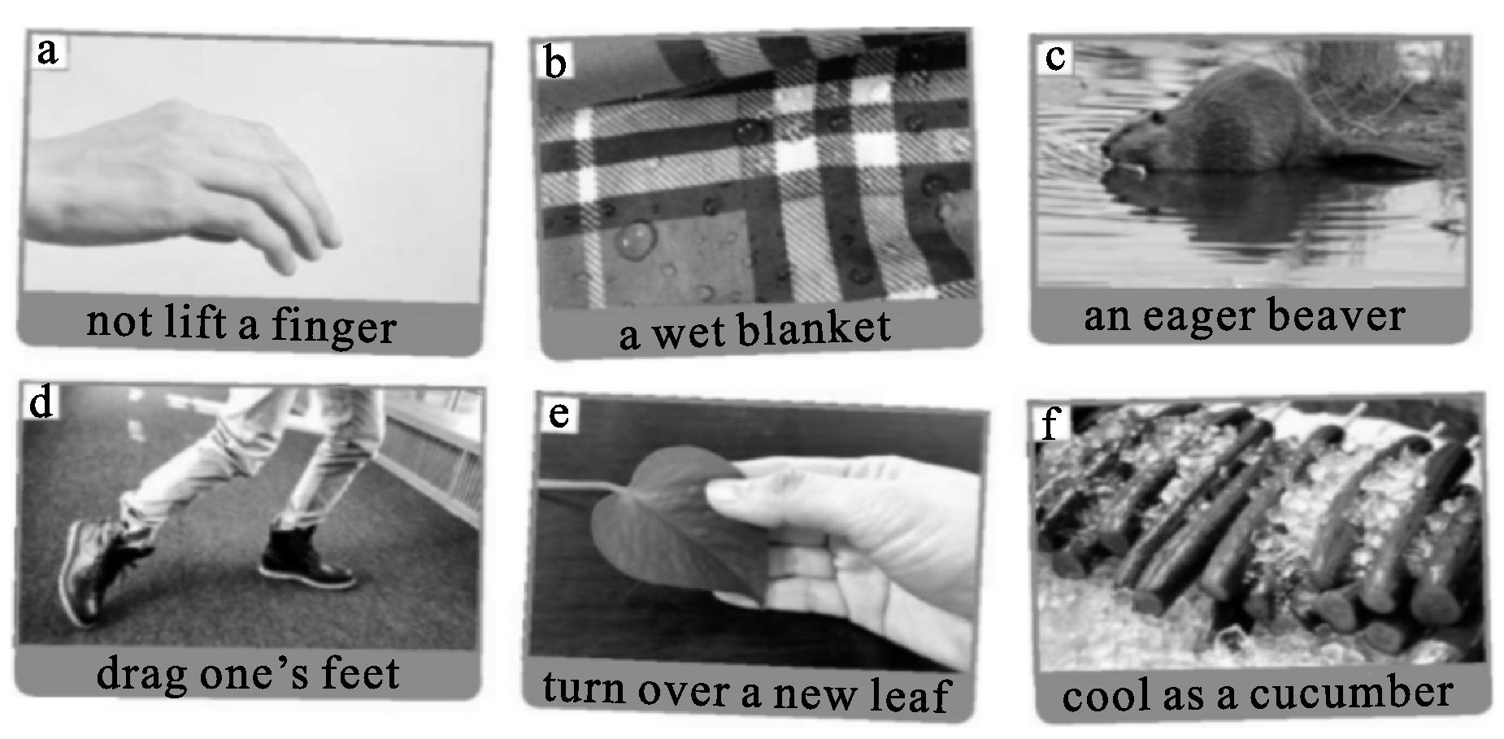
1. to change your life by starting to be a better person or stopping a bad habit
2. someone who is extremely enthusiastic and enjoys working extremely hard
3. to not make any effort
4. very calm and relaxed,especially in a difficult situation
5. to do something very slowly because you do not really want to do it
6. someone who refuses to join in,or wants to stop other people having fun
Activity 2 Put the expressions in Activity 1 into the boxes
Add any more you can think of.
Positive | Negative

Task 2 Listen to the second text
Activity 1 Read the passage and answer the questions
With life being made up of ups and downs,it is not always easy to maintain a good and enthusiastic attitude.Nevertheless,looking on the bright side is the best thing that we can do for ourselves as well as for others.A good attitude can have a positive effect on other people.So if someone you know is feeling low,lend them an ear and try to cheer them up.Remember,your attitude is contagious,so make sure you pass on a good one!
1.Why is it important to “look on the bright side”?
2.How can our attitude affect others?
Activity 2 Listen to the conversation and number the pictures according to the sequence of events
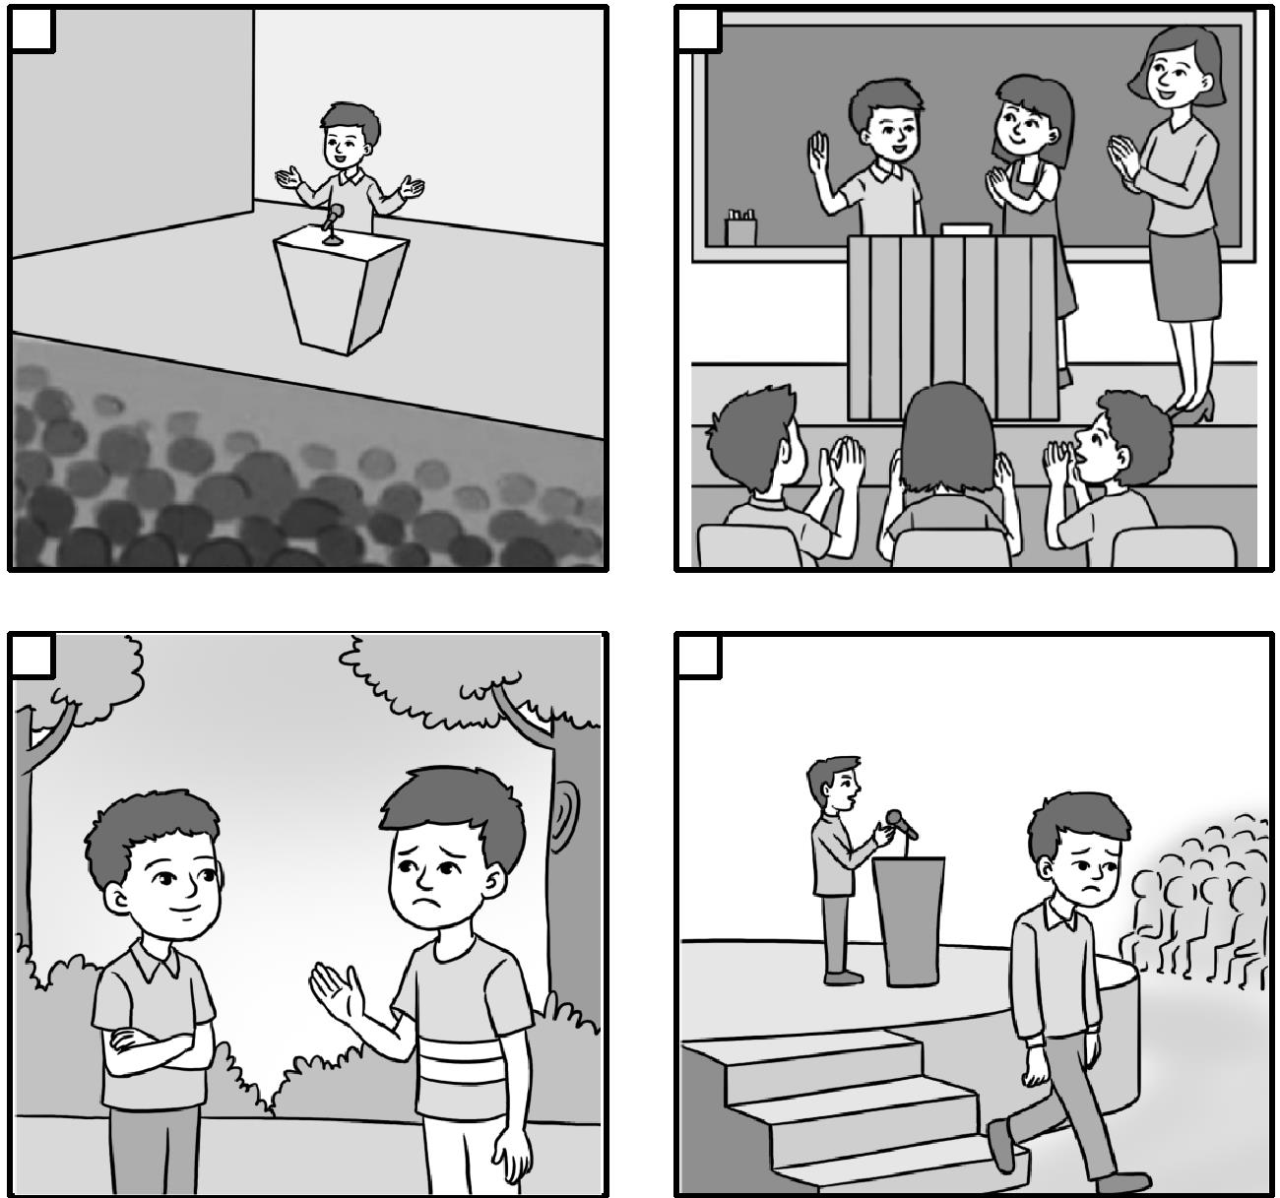
Activity 3 Listen again and complete the journal entry
Friday 10 May
Today I came across my friend Dawei.He looked sad,so I asked him what was wrong.He said that he failed in a 1. contest.Before the contest,he competed against a girl at school.He won,but he said it was because 2. .He thought the girl should have gone to 3. instead.If she had,the school would have been 4. .I tried to make him look on the bright side,and he admitted that he had a good time at the national contest.He met some 5. and he liked the city.He also said his parents felt 6. .I think I made him feel better.
Now act out a conversation between Dawei and Jack,and think about how you would comfort Dawei if you were Jack.
Activity 4 Complete the boxes with the expressions from the conversation
·Are you OK?
·I don’t mean to be nosy,but are you sure?
·Why don’t you tell me what’s up?
·I’m sure you did your best.
·You should be proud of yourself.
·Why are you so upset?
·I know this is hard for you,but you should cheer up.
Showing concern | Comforting people

Step Ⅳ Discussion
Choose one situation and act out a conversation to show concern for people and comfort them.Use the expressions in this section.
1.You ran for Head of the Student Committee but weren’t elected.
2.You feel annoyed because a group member doesn’t want to contribute to your group’s work.
Step Ⅴ 核心素养专练
Fill in the blanks.
1.(2023浙江卷)I removed the sticky spider-webs that covered her head and wings.Still,she made no attempt (fly).
2.(2022新高考全国Ⅰ卷)The GPNP is intended (provide) stronger protection for all the species that live within the Giant Panda Range and significantly improve the health of the ecosystem in the area.
3.(2021新高考全国Ⅰ卷)Why is Ms Raspopova’s husband “the worse page turner”?
Because he forgets (do) his job.
4.(2020新高考全国Ⅰ卷)As well as looking at exhibits,visitors can play with computer simulations (模拟) and imagine themselves living at a different time in history or (walk) through a rainforest.
5.(2020新高考全国Ⅱ卷)Readers are encouraged (continue) exploring the digital world with the guidance of our Further Resources section featured in each volume.
6.I quickly lower myself,ducking my head to avoid (look) directly into his eyes so he doesn’t feel challenged.
7.Once his message was delivered,he allowed me (stay) and watch.
8.I still remember (visit) a friend who’d lived here for five years and I was shocked when I learnt she hadn’t cooked once in all that time.
9.Fat and salt are very important parts of a diet.They are required (process) the food that we eat,to recover from injury and for several other bodily functions.
10.But Sarah,who has taken part in shows along with top models,wants (prove) that she has brains as well as beauty.
11.If you find something you love doing outside of the office,you’ll be less likely (bring) your work home.
评价量规
评价项目 | 自我评价 | 教师评价
能够正确运用非谓语动词作宾语 | □Excellent  □Good  □In need of  improvement | □Excellent  □Good  □In need of  improvement
能够掌握课本中对应图片的习语意思 | □Excellent  □Good  □In need of  improvement | □Excellent  □Good  □In need of  improvement

续 表
评价项目 | 自我评价 | 教师评价
能够运用新学语言知识进行对话交流,联系自身实际,谈论与人生态度有关的话题 | □Excellent  □Good  □In need of  improvement | □Excellent  □Good  □In need of  improvement
能够通过听力活动,正确获取主旨大意和详细信息 | □Excellent  □Good  □In need of  improvement | □Excellent  □Good  □In need of  improvement

续 表
评价项目 | 自我评价 | 教师评价
能够通过听力学习活动,学会如何“表达关心和安慰” | □Excellent  □Good  □In need of  improvement | □Excellent  □Good  □In need of  improvement
能够理解同伴的观点并给予恰当的评论 | □Excellent  □Good  □In need of  improvement | □Excellent  □Good  □In need of  improvement

参考答案
Step Ⅰ Lead-in
1.Yes,they do. 2.No,they don’t. 3.No,it can’t.
Step Ⅱ Analysis and identification
Activity 1
Students’ own answers.
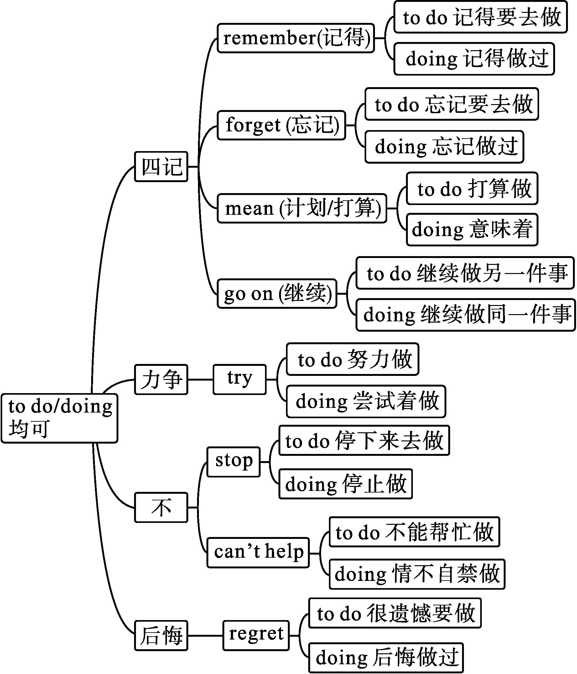
Activity 2
1.to live 2.to use 3.swimming/ to swim 4.swimming
5.to learn 6.practising 7.playing
Activity 3
Jamie Wells decided to join the sports camp because he enjoyed challenging himself as well as meeting new friends.He thought the camp was fun,but not without its challenges!Each day began with a 5-kilometer cross-country run at 6 am!At first he failed to finish the whole route.On the fourth day,he was so tired that he even didn’t want to get out of bed.Feeling homesick,he regretted attending the camp and wanted to phone his dad to take him home.But he didn’t give up.He became stronger and more confident and made new friends.He admitted being a camper had its challenges,but it was worthwhile.
Step Ⅲ Listening (Looking on the bright side)
Task 1
Activity 1
1.e 2.c 3.a 4.f 5.d 6.b
Activity 2
Positive | Negative
an eager beaver  turn over a new leaf  cool as a cucumber  like a duck to water | not lift a finger  a wet blanket  drag one’s feet  a fish out of water

Task 2
Activity 1
1.Because looking on the bright side is a type of good attitude,which can have a positive effect on other people.In this way,looking on the bright side is the best thing that we can do for ourselves as well as for others.
2.Our attitude is likely to spread to and affect others.If we have a good attitude,others will also feel it and be cheered up by it.
Activity 2
2,1,4,3
Activity 3
1.national English speaking 2.he was lucky 3.the national competition 4.well-known 5.fantastic people 6.proud of him
Activity 4
Showing concern | Comforting people
Are you OK?  I don’t mean to be nosy,but are you sure?  Why don’t you tell me what’s up?  Why are you so upset? | I’m sure you did your best.  You should be proud of yourself.  I know this is hard for you,but you should cheer up.

Step Ⅳ Discussion
Students’ own answers.
Step Ⅴ 核心素养专练
1.to fly 2.to provide 3.to do 4.walking 5.to continue 6.looking 7.to stay 8.visiting 9.to process
10.to prove 11.to bring

