学案设计
学习目标
1.Understand the main idea and structure of the text and clearly describe the wishes of Helen Keller for three days;
2.Use the subjunctive mood,inversion,parallelism and other rhetorical devices;
3.Have sympathy for people in trouble and form a positive life attitude in the face of adversity and failure.
课堂探究
Step Ⅰ Lead-in
Activity 1 Look at the charts and answer the questions
Percentage of adults with a disability in the US
People with a disability
People without a disability
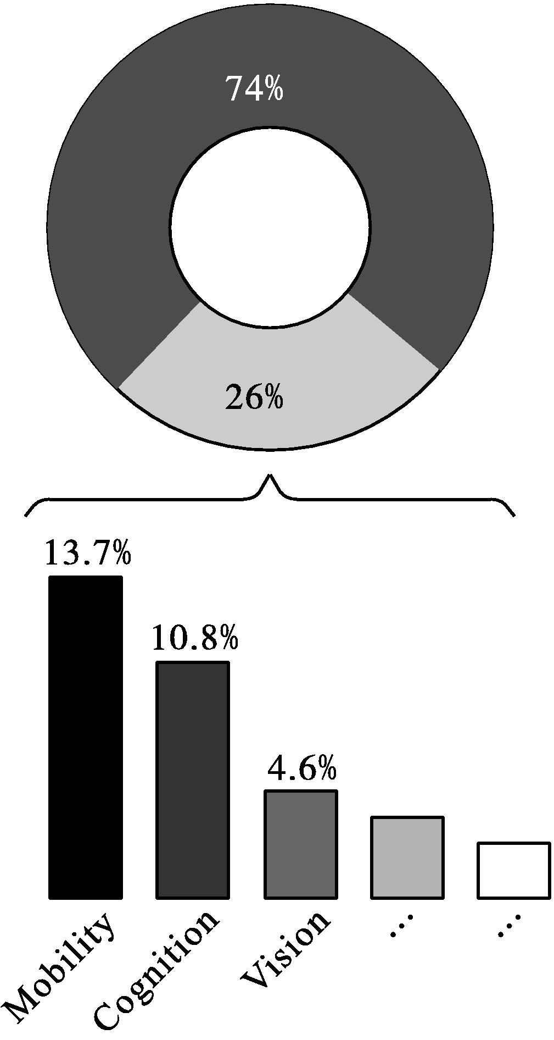
Percentage of adults with common
functional disability
1.Are the numbers different from what you expected?In what way?
2.What special assistance can people with disabilities make use of in their daily lives?
Activity 2 Look at the picture and answer the questions
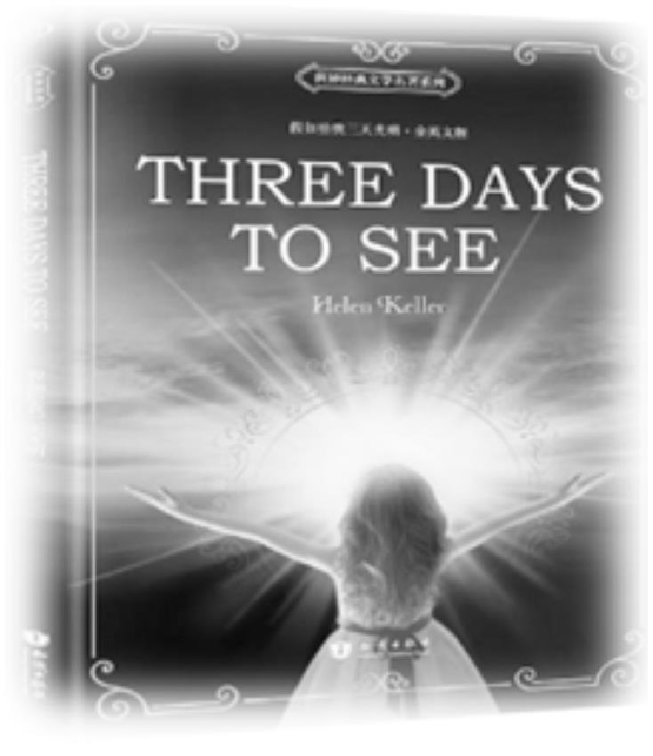
1.Have you ever read this book?Who is the writer of this book?
2.What do you know about the author?
Step Ⅱ While-reading
Task 1 Read for the main idea and structure
Go through the passage quickly to figure out the structure of it.
Part 1 Paras.( - )

Part 2 Paras.( - )

Part 3 Para.( )

Task 2 Read for details
Activity 1 Read part 1 and answer the question
What motivated Helen Keller to have such wishes?

Activity 2 Read part 2 and finish the tasks
1.Fill in the blanks about Helen Keller’s wishes for three days to see.(write down key words)
On the first day,she would .
On the second day,she would .
On the third day,she would .
Retell Hellen Keller’s wishes according to the key words.
2.How did Helen Keller feel at the end of the three days?

Activity 3 Read part 3 and finish the tasks
1.Finish Helen’s suggestion to those who can see.
(1) your eyes tomorrow you would be stricken blind.
(2) the music of voices,the song of a bird,the mighty strains of an orchestra, you would be stricken deaf tomorrow.
(3) each object you want to touch tomorrow your tactile sense would fail.
(4) the perfume of flowers,taste with relish each morsel, tomorrow you could never smell and taste again.
2.What figure of speech is used in this part?How does this technique help to express the author’s emotions?

Activity 4 Choose the author’s purpose in writing the passage
A.To help readers understand what it is like to be blind.
B.To make readers without disabilities appreciate what they have.
C.To persuade readers to care about the blind.
Step Ⅲ Post-reading
Think and share
Read and discuss the meaning of the sentence with your partners and decide whether you agree or disagree with it.
...it would be a blessing if each human being were stricken blind and deaf for a few days at some time during his early adult life.
Point of view 
Arguments
Supporting examples 
Step Ⅳ 核心素养专练
一、课文语法填空,在空白处填入1个适当的单词或括号内单词的正确形式。
Helen has often thought it would be a 1. (bless) if each human being 2. (be) stricken blind and deaf for a few days 3. some time during his early adult life.4. (dark) would make him more 5. (appreciate) of sight;silence would teach him the joys of sound.Recently she asked a friend 6. had just returned from a long walk in the woods what she had observed.“ Nothing in particular,” her friend replied.A little disappointed,she asked herself,“ How was 7. possible to walk for an hour through the woods and see nothing 8.(worth) of note?I who cannot see find hundreds of things to interest me through mere touch.How much more beauty must 9. (reveal) by sight?”She is sure that sight must be the most 10.(delight).
二、短语翻译。
1.be stricken blind and deaf
2.appreciative of
3.now and then
4.in particular
5.be worthy of note
6.probe into
7.go about
8.close in on
9.descend upon/on
10.give one hint to
11.as if
12.apply...to
评价量规
学习目标 | 目标达成评价等级
学习目标 | A | B | C | D
Understand the main idea and structure of the text and clearly describe the wishes of Helen Keller for three days.
Use the subjunctive mood,inversion,parallelism and other rhetorical devices.
Have sympathy for people in trouble and form a positive life attitude in the face of adversity and failure.

参考答案
Step Ⅰ Lead-in
Activity 1
1.Students’ own answers.
2.People with limited mobility problems could use wheelchairs,walking sticks,handrails...
People who have reduced vision could use special pavements for the blind,Braille signs...
Activity 2
1.Helen Keller. 2.Students’ own answers.
Step Ⅱ While-reading
Task 1
Part 1 Paras.(1-3) The reason for Helen Keller’s wishes.
Part 2 Paras.(4-7) Helen Keller’s wishes for three days to see.
Part 3 Para.(8) Helen’s hint for people who can see.
Task 2
Activity 1
People without disabilities are not appreciative of their sight and hearing.
Activity 2
1.First day:the people;books;nature (Helen’s love of her loved ones)
Second day:pageant of man’s progress;museums;theater or movies (Helen’s love of science)
Third day:dawn;new delights;revelations of beauty;workaday world (Helen’s love of life)
2.Helen must feel upset/sad/disappointed,thinking it was a pity not to be able to see any more.
Activity 3
1.(1)Use;as if (2)Hear;as if (3)Touch;as if
(4)Smell;as if
2.Parallelism.By using parallelism,Helen expressed her strong desire for light,the love of life and positive attitude towards life.It may make a person more appreciative.
Activity 4
B
Step Ⅲ Post-reading
Students’ own answers.
Step Ⅳ 核心素养专练
一、1.blessing 2.were 3.at 4.Darkness
5.appreciative 6.who/that 7.it 8.worthy
9.be revealed 10.delightful
二、1.突然失明失聪 2.感谢…… = appreciate v. 3.偶尔,有时,不时 4.尤其,特别 5.值得注意 6.探究,探索 7.从事;着手做……;闲逛 8.包围;逼近 9.逐渐接近;突然降临;突然袭击 10.给某人一个提示 11.好像;仿佛=as though 12.适用于;应用于;涂抹

