学案设计
学习目标
1.Look at the problem dialectically,find a new way to think about the solution to the problem;
2.Get familiar with the debate process and use the expressions learned in this unit to express ideas properly;
3.Understand the importance of perseverance and unyielding spirit to success;
4.Cultivate the sense of team cooperation and be able to work with group members to complete tasks.
课堂探究
Step Ⅰ Lead-in
Activity 1 Answer the question
As a high school student,we have gone through a lot of failure and success.What do you often do when you fail,lose heart and give up or just adjust yourself and go on fighting?

.
Activity 2 Read the two points of view and explain their meanings in your own words

Step Ⅱ Think and exploration
Activity 1 Work in groups and decide which opinion you agree with more
Think of arguments to support your point of view and make notes.

Point of view:
Arguments:
Supporting examples:
Activity 2 Prepare for a debate
Consider the following:
1.the roles and responsibilities for each member of your group
2.your arguments,opening and summary

3.the opposing arguments you might face and how you can respond to them
4.useful words,expressions and structures
Step Ⅲ Presentation
Team up with a group with the opposite point of view and hold the debate.
Step Ⅳ Reflection
Write a reflection after completing this unit.Consider the following:

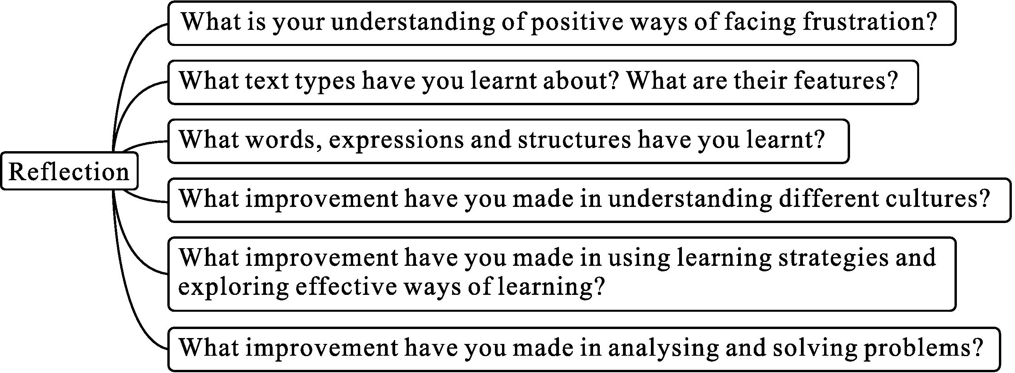
评价量规
Degree | Evidence (sufficient) | Logical thinking | Presentation skills | Team cooperation | Total score
A
B
C

参考答案
Step Ⅰ Lead-in
Students’ own answers.
Step Ⅱ Think and exploration
Activity 1
