Unit 4 Period 5 Writing & Presenting ideas
【学习目标】
Learning Objectives | 1 To get the main idea and specific information,find out the structure, style and features of an invitation, then write an invitation  2 To talk about different forms of art and give a presentation

【学习过程】
Learning activities
目标一: To get the main idea and specific information,find out the structure, style and features of an invitation, then write an invitation
Activity 1: Look at the invitation card, and find out what information is included.
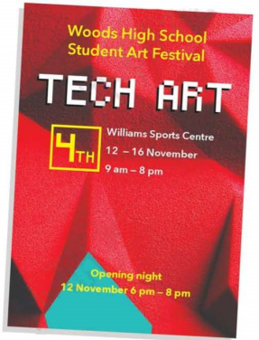
Answers: Organizer and type of activity, theme, location and time

Activity 2: Read the invitation to an art festival and answer the questions.
5 November 2019

Mr. John Smith
14 New Road
Surrey
TW14 2EH

Dear Mr. Smith,
Woods High School requests the honour of your presence at the opening of Tech Art Festival on the twelfth of November. The event will begin at Williams Sports Center at 6 pm with a welcome address followed by awards ceremony, with the evening closing at 8 pm.

Tech Art will run from the twelfth to the sixteenth of November and will feature the works of over one hundred of our students. Visitors will be able to see and experience a wide variety of artworks from 3D sculptures to artworks made out of phone and computer parts.

We do hope you are able to join us at this event. Please reply to confirm your attendance.

Yours sincerely,

Jane Brown
Woods High School

1 What is the topic of each paragraph?
2 Is the invitation written in formal or informal style?
Give three examples.
Answers:
1 Paragraph one: time, place of the event
Paragraph two: content of the event
Paragraph three: ending of the invitation
2 The invitation is written in formal style. First, it has an invitation card; second, the language is formal, like “... requests the honour of your presence at...”; third, it contains a specific date and address.

Activity 3: Read the invitation again and summarise the structure of it.
Learning to learn
An invitation should give clear details about the name, place and time of the event, and details about how to reply. A formal invitation letter may use either the third person or first person "we" with the place and date often spelt out. The wording and tone should be formal rather than conversational.

opening | date, recipient’s address
introduction | intention
body | detailed information (Who, What, Where, When, Why)
ending | expectation and gratitude

Activity 4: Imagine you are helping to prepare an art festival in your school. Answer the questions to help you write the invitation.
1 What is the topic of the art festival?
2 When and where will it be held?
3 What artworks will be included?
4 What style will you use for the invitation?
Now write your invitation.

Activity 5: Work in pairs. Make improvements to each other’s invitations and share them with the class.
Sample:
10 October 2020
Mr David Smith
18 Riverside Drive Road
Fushan 100567

Dear Mr Smith,
Redrose High School requests the honour of your presence at the Arts Centre opening ceremony on the 10th of November. The event will be held in the Great Hall at 10:00 a.m. with a welcome speech followed by the Book Donation, with the midday closing at 11:45 a.m. We have free lunch for guests.
The opening ceremony will feature an exhibition of the works of over 200 artists graduating from this school. Visitors will enjoy a variety of artworks made out of technological tools.

We do hope you are able to join us at this event.
Please reply to confirm your attendance.

Yours sincerely,
Li Hong
Redrose High School

目标二: To talk about different forms of art and give a presentation
Activity 1: Work in groups. Look at the pictures and answer the questions.
1 What form of art does each picture show?
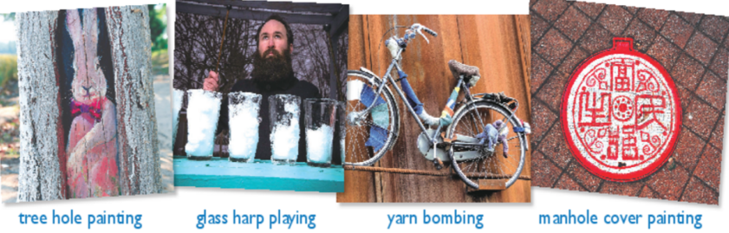
2 Have you ever come across them?
Answers:
1 树洞画；玻璃竖琴演奏；纤维编制艺术；井盖涂鸦
2 Your own answers

Activity 2: Think of other forms of art in daily life and make notes.
Examples of artworks:
_____________________________________________________________________
_____________________________________________________________________
_____________________________________________________________________
Detailed description:
_____________________________________________________________________
_____________________________________________________________________
_____________________________________________________________________

Activity 3: Talk about these artworks and complete the table. Do further research if necessary.
Inspiration for these artworks
Innovation behind these artworks
Importance of art in our life

Activity 3: Prepare a short presentation. Consider the following:
1 the structure of your presentation
2 useful words, expressions and structures
Give your presentation to the class
Summary:
1 What is the structure of an invitation?
2 Can you share any art form in your hometown?

