Teaching & Study plan-----Book1 Unit5 Revealing nature Period 3
Class |  |  | Name |  | Group |  | Evaluation
Three-dimensional  objectives | Knowledge and abilities：To grasp words and phrases  Process and methods：By taking notes and practising  Attitude and values： To develop the sense of responsibility
Important points | Memorizing the key points
Difficult points | Application
Learning methods | Student-centred (self –study,cooperation and exploration)
Teaching Contents
Step 1 Lead in  - survive v. _________→n. ______________  - adapt v.___________ → n. ________→ adj. ______________  - characteristic adj/n_________________ →adv_________  - compete v____________adj________→n____________  Step 2 Study (Thinking ; Presentation and Discussion)  1. blame v．责怪，指责；把……归咎于  (教材P₅₃) The extinction of the Pinta Island tortoise is blamed on humans.  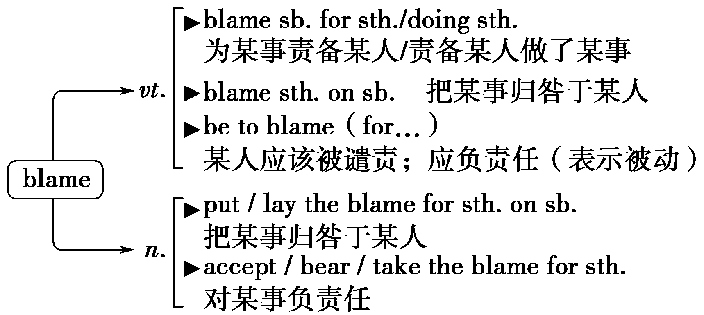  ①While we can't change the body type we are born with，we can't blame our genes _________ making us fat.  ②The police blamed the traffic accident ______ Jack's careless driving.  ③The driver was not_____________e(blame) for the traffic accident.  ④You must bear the blame _________ the accident.  2. decline vi.下降；减少；衰退；拒绝；谢绝  n．下降；衰退；衰退期  (教材P₅₃) After goats in particular had been brought to the island，the Pinta Island tortoise population declined.  [例] The number of staff has declined from 217,000 to 114,000.  员工人数已从217 000人减少到114 000人。  [知识拓展]  (1)decline(from...)to... (从……)下降/减少到……  decline by 下降/减少了……  decline doing/to do sth. 婉言拒绝做某事  (2)fall into (a) decline 开始衰落，衰弱下去；走下坡路  a decline in ……的下降  in decline 在下降，在衰退  ①Since the beginning of 2019，the price of worldwide milk products has declined ______ 3.8%.  ②Industry in Britain has been ______ decline since the 1970s.  ③He declined _____________ (go) to the party with her.  3. detect v．发现，察觉(尤指不易察觉到的事物)  (教材P₅₆) When another bean plant detects the chemicals from its injured neighbour，it starts to release its own，different chemicals.  [例] The dentist could detect no decay in her teeth.  (1)detect sb.in doing sth. 发现某人正在做某事(坏事)  (2)detective n. 侦探  detection n. 侦查，发现，发觉  ①He was detected in ____________(cheat) in the exam.  ②The _________(detect) was trying to winkle information out of her.  ③Last year the _____________(detect) rate for car theft was just 13%.  Sentence Patterns:  1. be said to据说……  (教材P₅₆) Alexander the Great and Marco Polo were said to have visited such a tree in India.  [例] He was said to have lost his will to live.  (1)本句型中的不定式可用一般时、进行时或完成时，分别表示与谓语动词动作同时发生或在其后发生的动作或状态、与谓语动词动作同时发生的进行动作或在谓语动词动作之前发生的完成动作。  (2)类似句型：  sb./sth.is believed/reported to do sth.  ＝It is believed/thought/hoped/reported that...  人们相信/认为/希望/据报道……  ①He is said to ________(write) another novel about the same theme.  ②She is said to ______________(go) abroad.  ③America is _____________(report) to declare war on Iran likely.  2. way后面跟定语从句  (教材P₅₇) Scientists are learning more every day about the secret ways in which plants talk to each other.  ①I'm disgusted with the way ______________ he was treated.  ②I couldn't understand the way _____________ he introduced to me.  Step 3 Summarize  Step 4 Practice  Sadiman，a 67-year-old man，single-handedly restored an entire forest to save his village from hunger. He is a（n）___1____ in Dali village，Indonesia. The Gendol hill was seriously deforested because of widespread logging（伐木）activities and a series of forest fires that took place in the 1960s. The extreme deforestation made the Gendol River ____2___，leading to serious water crisis.  He came up with a(n) ___3____ to restore the hill when he was working there to make ends meet. Sadiman started to ___4____ banyan（榕树）trees on about 500 hectares of the forest. He has been doing this for the last 21 years all by himself and his sacrifice is ___5___ surprising. His poor living conditions didn't stop him spending his hard-earned money ___6____ the seedlings for plantation to restore the forest. A banyan tree seedling cost about $5. 00，which was much money for him. To meet this _____7_____，Sadiman began to plant clove（丁香）tree seedling in his yards. Ten clove tree seedlings were worth a banyan tree seedling. Sadiman's devotion was beyond _____8_____，yet he was called a "crazy person" and some of his seedlings were _____9_____ pulled out of the ground by irresponsible people. However，this didn't stop him from planting the seedlings.  Non-stop since the early 1990s，Sadiman has _____10_____ on planting trees and taking care of them to ensure they grow strong and healthy. ______11____ his continuous hard work，the forest has started to recover. More and more springs and streams have been _____12_____ to provide a reliable water supply for the area. People are becoming _____13_____of the importance of the forest in the bigger _____34_____. The Gendol Hill，once wild，now returns to its former glory by one man and his action to save the whole region from drought and _____35_____. He truly is a one man army！  - A．salesman B．farmer C．reporter D．official  - A．polluted B．dirty C．dry D．wide  - A．project B．suggestion C．opinion D．idea  - A．cut B．protect C．plant D．inspect  - A．exactly B．gradually C．likely D．simply  - A．gathering B．growing C．buying D．raising  - A．challenge B．standard C．activity D．request  - A．reality B．question C．fact D．hope  - A．even B．thus C．just D．still  - A．lived B．relied C．moved D．kept  - A．Instead of B．As for C．Thanks to D．Apart from  - A．recovered B．cleaned C．applied D．expected  - A．sure B．proud C．fond D．aware  - A．forest B．picture C．task D．business  15. A. floods B．disease C．Storms D．Starvation  Step 5 Homework |  |  |  |  |  |  |  | What is  unique  to you?
Learning and Teaching  summary |  | Gains ：
 |  | Losses：

