Unit 6 Period 2 Grammar
【学习目标】
Learning Objectives | 1 To know the usage of present perfect continuous tense  2 To use present perfect continuous tense correctly

【学习过程】
Learning activities
目标一: To know the usage of present perfect continuous tense
Activity 1: Look at the sentences from the reading passage and answer the questions.
a Wild animals such as these Tibetan antelopes have now been using these passages for years.
b ...before I know it, we have reached Tanggula Station.
1 Which of these statements are true about sentence (a)?
(1) Wild animals started using these passages in the past.
(2) Wild animals used these passages only once.
(3) Wild animals still use these passages now.
2 What is the difference between the expressions in bold in sentences (a) and (b)?
Answers:
_______________________________________________________________________
_______________________________________________________________________

Now look for more sentences with the present perfect continuous tense in the reading passage, and summarise its uses in your own words.
_______________________________________________________________________
_______________________________________________________________________

Activity 2: Read the sentences below. Find out the common thing below and summarise the structure.
1. I have been reading the book.
2. I have been living here since 1988.
3. I have been waiting for two hours.
4. She is very tired. She has been working all morning.
Summary:
_______________________________________________________________________
_______________________________________________________________________
_______________________________________________________________________
_______________________________________________________________________

目标二: To use present perfect continuous tense correctly
Activity 1: Complete the passage with the correct form of the verb in brackets.
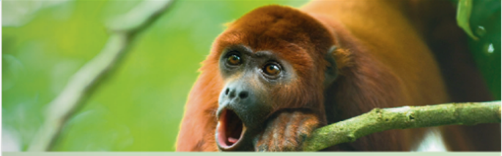

I ¹ ________ (hear) a strange sound for a while. It’s a deep, loud roar, like a lion’s. But there aren’t any lions here... Or are there? Soon I see what ² ________ (make) the noise: a howler monkey. Now I feel less worried. Realising that something ³________ (move) on my shoulder, I turn my head to look at it. Oh no! It’s a giant spider! I brush it off and it runs under some leaves. I try to bat away the huge insects, which ⁴ ________ (fly) around my head in a black cloud for quite a while.
I pull off the headset and I’m back in my living room. Thank goodness! I ⁵ ________ (give) the latest virtual reality headset and, for the last twenty minutes, I ⁶ ________ (use) it to explore the Amazon. This is an amazing experience and a reminder of how many species there are in the rain forest. We must do all we can to protect it.

Activity 2: Look at the charts and make sentences using the present perfect continuous tense.
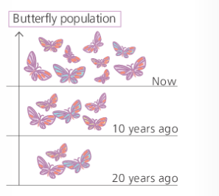
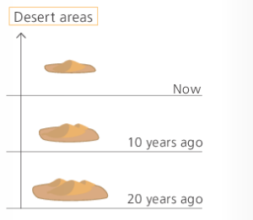
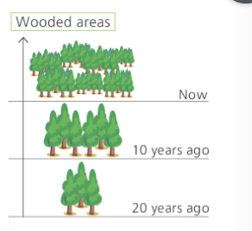
Answers:
_______________________________________________________________________
_______________________________________________________________________
_______________________________________________________________________
_______________________________________________________________________

Activity 3: Work in pairs. Talk about how the environment where you live has changed. Use the present perfect continuous tense where appropriate.
_______________________________________________________________________
_______________________________________________________________________
_______________________________________________________________________
_______________________________________________________________________

Summary:
1 Can you retell the usage of present perfect continuous tense?
2 Can you make some sentences with present perfect continuous tense?


