Unit 6 Period 1 Starting out
【学习目标】
Learning Objectives | 1 To know some World Heritage Sites by watching the pictures and video  2 To get the key information about the “Sky Railway” and get the challenges encountered during the construction of the railway and the solutions, then introduce the “Sky Railway”

【学习过程】
Learning activities
目标一: To know some World Heritage Sites by watching the pictures and video
Activity 1: Look at the pictures and answer the questions.
1 What do you know about these places?
2 What do these places have in common?
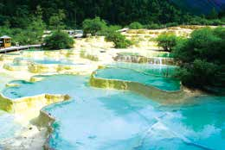Huanglong, China
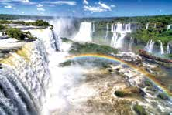Iguazú Falls, Argentina and Brazil
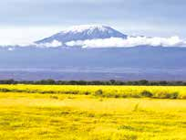Mount Kilimanjaro, Tanzania

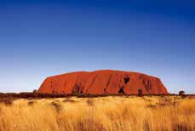Uluru, Australia
____________________________________________________________________
____________________________________________________________________

Activity 2: Watch the video and answer the questions.
1 What are the three types of World Heritage Sites?
2 What other natural heritage sites in China do you know of?
Answers:
____________________________________________________________________
____________________________________________________________________
____________________________________________________________________
____________________________________________________________________

目标二: To get the key information about the “Sky Railway” and get the challenges encountered during the construction of the railway and the solutions, then introduce the “Sky Railway”
Activity 1: Work in pairs and complete the quiz. Try to guess if you are not sure of the answers.
1 Which is the highest railway in the world?
a The Trans-Siberian Railway.
b The Qinghai-Tibet Railway.
c The Chengdu-Kunming Railway.
2 In which year was the completed Qinghai-Tibet Railway put into operation?
a 1984. b 2001. c 2006.
3 Which of these stations is not on the Qinghai-Tibet Railway?
a Lhasa. b Golmud. c Lanzhou.
4 Which of these natural World Heritage Sites does the Qinghai-Tibet Railway pass by?
a Xinjiang Tianshan.
b Qinghai Hoh Xil.
c South China Karst.

Activity 2: Please look at the title of the passage and the picture to predict
What is the text about?
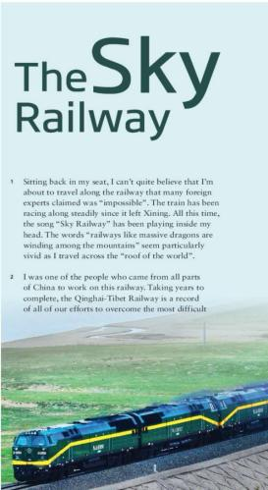
____________________________________________________________________
____________________________________________________________________

Activity 3: Read for main idea.
Task one: Please read the passage quickly and get the main idea of the passage.
____________________________________________________________________
____________________________________________________________________
Task two: Read and find out.
Why is the railway particularly special to the author?
____________________________________________________________________
____________________________________________________________________

Activity 4: Read for information
Task 1: Organise information from the passage and complete the table.
Challenges | Solutions
To protect wild animals. | •¹ __________________ have been built under the railway to allow the animals to ² ___________________
To ³ ______________________ | •675 bridges with ⁴___________ were built between Golmud and Lhasa.  •140,000 square metres of wetland were ⁵_____________ in order to protect its distinct ecosystem.
To make sure the workers stayed healthy. | • ⁶ ___________________ were constructed.  • The workers also enjoyed ⁷ ________________ in lower areas.
To ⁸ ______________________ | • Thousands and thousands of sandbags were used to 9 ___________ along the lake to 10 _____________________.
The above table explains how “impossible” railway was built. Now do some online research to find out what other challenges were wet and overcome by the railway workers.

Task 2: Please draw the Qinghai-Tibet Railway and mark the locations mentioned in the text.

Xi Ning Golmud Qingshuihe Tanggula Cuona Lake Lhasa
Bridge

Activity 5: Choose the author’s purpose in writing the passage and give your reasons.
1. To prove that humans can conquer nature.
2. To highlight the amount of work required to build the Qinghai-Tibet Railway.
3. To praise the workers’ efforts in building the Qinghai-Tibet Railway.

Activity 6: Think & Share
1 Which of the solutions are you most impressed by? Why?
2 Which words in the passage are used to describe the Qinghai-Tibet Railway? What other words could you think of to describe it?
3 What changes do you think the Qinghai-Tibet Railway has brought to the people living along the railway?
4 What method did you use to collect information? How did the information help you to better understand the passage?
Answers:
______________________________________________________________________________________________________________________________________________________________

Activity 7: Find the important words, phrases, and language points you want to share with your partner. Then discuss in groups and share their usage with the class.
_______________________________________________________________________________
_______________________________________________________________________________
_______________________________________________________________________________
_______________________________________________________________________________

Activity 8: Complete the summary with the correct words or the correct forms of the words in the bracket according to the passage.
With the song “Sky Railway” 1.__________ (play) in my head, I am travelling along the “impossible” railway across the “roof of the world”. As a worker who worked on the railway myself, I know clearly that we have overcome lots of 2.__________ (difficulty) because we had to protect the delicate ecosystem all along the way.
3 __________ (protect) the wild animals, we built the splendid Qingshuihe Bridge to allow the animals to move under the bridge 4.__________ (free) and safely in their natural habitat. To prevent damage to wetlands and grasslands , we built 675 bridges between Golmud and Lhasa, 5.__________ measure about 160 kilometres in total. What’s more, to make sure that the workers on the railway stay 6.__________ (health), several oxygen-making stations 7.__________ (build). In order to protect Cuona Lake 8.__________ construction waste, we used thousands and thousands of sandbags to build a wall along the lake.
Thanks to our efforts, all the wild animals and the whole natural ecosystem are well protected along the “Sky Railway”. I am filled with 9.__________ sense of pride and achievement. We 10.__________ (construct) our “Sky Railway”, which was considered to be “impossible” by foreign experts.
Summary:
1 Can you introduce the Qinghai-Tibet Railway?
2 What are the challenges in building the railway?


