Unit 6 Period 3 Listening and Speaking
【学习目标】
Learning Objectives | 1 To listen for the information of the listening material and learn how to persuade other and make a compromise  2 To talk about how to make a balance between economic development and tourism

【学习过程】
Learning activities
目标一: To listen for the information of the listening material and learn how to persuade other and make a compromise
Activity 1: Listen to the conversation and choose the places mentioned.
a
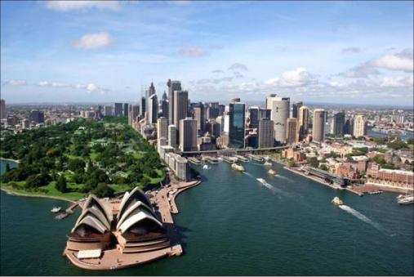
Australia
b
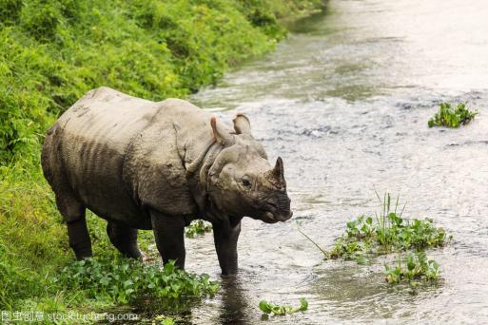
Nepal
c
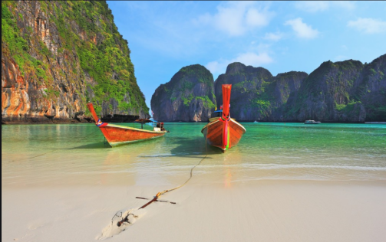
Thailand
d
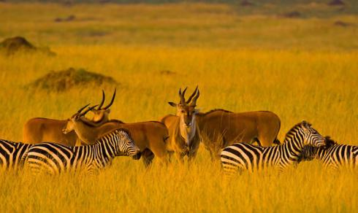
South Africa
Answers:
_____________________________________________________________________
_____________________________________________________________________

Activity 2: Listen again and complete the notes.
The first option
Rachel wants to
• 1 ______________________ and plant trees.
• also 2 __________________ rhinos, which will help protect them.
• eat local food.
Rachel’s dad thinks
• he can eat that kind of food at home.
• the activities sound like 3 _________________________.

The second option
Rachel wants to
• look after 4 ______________________________.
• sleep in a treehouse.
Rachel’s dad wants to
• 5 _______________________ and read a book.

Compromise
They will stay in 6 _______________________.
Rachel can do ecotourism activities while her dad does what he likes.
They will go on 7 _______________________________ of the jungle.
Now work in pairs. Discuss what type of travel you prefer.

Activity 3: Complete the boxes with the expressions from the conversation.
• The fact is that...
• Wouldn’t you agree that...?
• Let’s find a compromise.
• Let’s meet in the middle.
• As a compromise,...
• I agree, but...

Persuading others
Compromise

目标二: To talk about how to make a balance between economic development and tourism
Activity 1: Complete the passage with the expressions in the box.
not eco-friendly
create opportunities for new businesses
disturb the wildlife help the local economy
higher carbon emissions provide more jobs
use up natural resources

As tourism develops, people are becoming increasingly concerned about the environment. Here in our city, there is a heated discussion about whether a hotel should be built at White Beach. The owner of the company thinks the hotel would attract more tourists, which will ¹ ____________________ and ² ____________________. However, the local people worry that building the hotel is ³ __________________ and will ⁴ __________________ in particular the turtles which lay their eggs on White Beach. But they also admit that building the hotel will ⁵ ____________________ for people living in the area. Even though the owner of the company guarantees that the design will be in harmony with its beautiful surroundings, the local people are still concerned that the hotel may ⁶ ____________________. Increased tourist numbers will also mean more cars and aeroplanes, which in turn means ⁷ ____________________.
Now listen to the passage and check your answers.

Activity 2: Complete the boxes with the expressions.
not eco-friendly
create opportunities for new businesses
disturb the wildlife help the local economy
higher carbon emissions provide more jobs
use up natural resources

Advantages
Disadvantages
Now think about more advantages and disadvantages of building the hotel at White Beach.

Activity 3: Work in pairs. Role-play a discussion to reach an agreement that is satisfactory for everyday. Use the expressions in this section.
Student A: You are a hotel operator who wants to build a hotel on some forested land.
Student B: You are a conservationist who wants to protect the wildlife there.
Now think about how well you approached the problem from different perspectives and reached an agreement.

Summary:
1 Can you list some expressions of persuading others or compromising?
2 Can you talk about advantages or disadvantages of developing tourism?


