Unit 1 Period 1 Starting out & Understanding ideas
【学习目标】
Learning Objectives | 1 To know types of comedy and check how fun you are  2 To know the information about clown doctors and talk about the value of their work

【学习过程】
Learning activities
目标一: To know types of comedy and check how fun you are
Activity 1: Watch the video and answer the questions.
1 What forms of comedy are mentioned in the video?
2 Have you ever been to a comedy show? Share your experience with the class.
Answers:
1 Stage plays with happy endings, comedy acts
with clowns, cross-talk, stand-up, sitcom and comedy film.
2 Yes, I have. I laugh now and then, and forget those unhappy things. Maybe I’ll develop a more positive attitude towards life.

Activity 2: Complete the questionnaire and find out if you are fun to be with.
1 You tell a joke,which none of your friends find funny. How do you react?
a Laugh anyway and apologise for your sense of humour.
b Tell the joke again,but louder and more slowly.
c Criticise your friends’ sense of humour and walk off.
2 It’s a Saturday afternoon and you’re not doing much. A friend calls and invites you on an adventure to explore a new town. What do you say?
a “Of course! I’ll be ready in fifteen minutes!”
b “Sounds interesting. Tell me more about it.”
c “No, thanks. Maybe next time.”
3 You and some friends get lost in an area you’ve never been to before. What do you do?
a Lift the mood with a joke and explore the area.
b Stay positive and try to find your way back.
c Show everyone you are worried and complain.
4 You receive a birthday present from a friend, but when you open the box it’s empty. How do you feel?
a Think it is a good joke and laugh about it.
b Feel hurt, but try to laugh about it.
c Get angry and tell your friend it is a silly joke.
5 You’re skateboarding with a friend and he falls over in a dramatic way. What do you do?
a Laugh loudly non-stop because it’s so funny!
b Check if he’s OK and make him feel better with a joke.
c Help him get back up and avoid mentioning his fall.
Turn to Page 84 to find out your result.
目标二: To know the information about clown doctors and talk about the value of their work
Activity 1: Look at the pictures and tick the places where you would expect to see a clown.
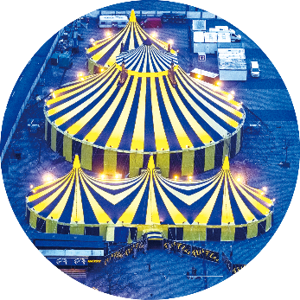
a private garden a circus

a busy street a hospital
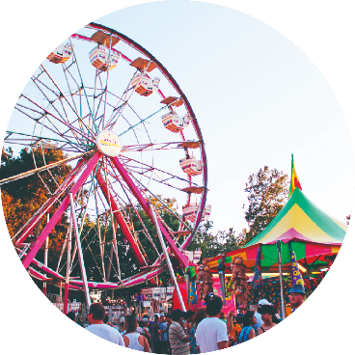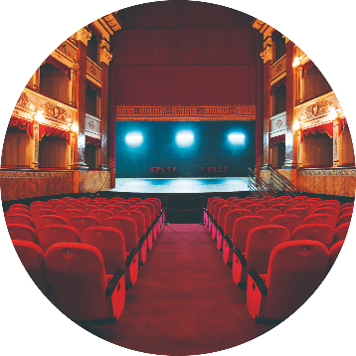
an amusement park a theatre
Suggested answers: a circus; an amusement park; a theatre
Now share what you know about clowns with the class.

Activity 2: Read the passage and find out what is special about this clown’s job.
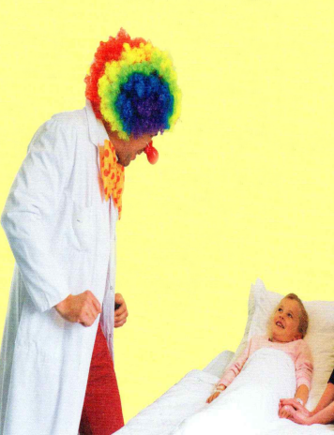
Answer:
This clown works in a hospital or other health care facilities. His job is to comfort, entertain and cheer up patients, their families as well as the hospital staff in order to remove their nervousness and make them feel better.

Activity 3: Match the main idea with its corresponding paragraph.
Paragraph 1
Paragraph 2
Paragraph 3
Paragraph 4
Paragraph 5
Paragraph 6
A.Which patient is in need of the clown doctor’s attention and why
B.What is a clown doctor and why did the author choose to be one
C.How does the author feel after a day’s work
D.What are the responsibilities of a clown doctor
E.How does the clown doctor help the patient
F. What does this clown doctor wear and what is his working environment like
Answers:
1 f; 2 a; 3 b; 4 d; 5 e; 6 c

Activity 4: Match the questions to the paragraphs and find out the answers.
1 What does this clown doctor wear and what is his working environment like?
2 Which patient is in need of the clown doctor’s attention and why?
3 What is a clown doctor and why did the author choose to be one?
4 What are the responsibilities of a clown doctor?
5 How does the clown doctor help the patient?
6 How does the author feel after a day’s work?

Answers:
1 This clown doctor wears a white coat, a curly rainbow wig, and a big red nose. His working environment is boring and tense.
2 A small girl called Lara is in need of the clown doctor’s attention, because she fell off her bicycle and spent her time crying in pain.
3 A clown doctor is a specially trained clown who works as part of a programme known as “hospital clowning”; the clown doctor helps people (patients) by entertaining them. The author chose to be a clown doctor because of his frightening and boring experience of going to hospital when he was a kid.
4 A clown doctor visits hospitals and other health care facilities, working together with medical professionals to cheer up patients, their families and the hospital staff.
5 He gets the patient’s attention by doing a magic trick — he produces the patient’s sock from out of his pocket.
6 He is still wearing a big smile as he remembers all the fun and laughter of the day, because he believes that “laughter is the best medicine”.

Activity 5: Organise information from the passage and complete the job advertisement.
CLOWN DOCTORS WANTED!
Employer The Healthy Humour Foundation
Job Clown Doctor (part-time)
Responsibilities
• visit hospitals and other ¹ __________________ on a weekly basis
• entertain young patients who are feeling ² _____________________
• cheer up the patients, their families and ³ _____________
• sing songs, tell stories and jokes, and do ⁴ ____________
• help make the hospital ⁵ _______________________
Send your CV to: healthyhumourfoundation@email.com
Answers:
1 health care facilities
2 nervous, pain or bored
3 the hospital staff
4 magic tricks
5 a friendlier place to visit

Activity 6: Complete the diagram comparing clown doctors and medical doctors.
Clown doctors
train as actors
_____________
_____________
Medical doctors
Need medical training
_____________
_____________
Similarities
Wear white coats
_____________
_____________

Answers:
Similarities
•wear white coats
•work in hospitals or other health care facilities
•aim to make patients and their family members feel better Differences
Clown doctors
•train as actors
•put on curly rainbow wigs and big red noses
•may have no or little medical knowledge
•usually help children can’t do medical examinations for patients
•cheer up patients, their families, and the hospital staff Medical doctors
•need medical training
•needn’t act as actors but humour is preferred, of course
•usually help patients of all ages
•give medical prescriptions relieve patients’ physical pain

Activity 7: Think and Share
1 How important do you think clown doctors are?
2 What is your understanding of the saying “laughter is the best medicine”? Do you agree with it? Why?
3 Would you like to work as a clown doctor? Why or why not?
4 How does the diagram in Activity 6 help you better understand the passage?
Suggested answers:
1 They cheer up patients, their families, and the hospital staff to make them feel better. So their work is necessary.
2 I agree with it because laughter not only helps to protect you from the damaging effects of stress or pain, but also helps to improve your health by strengthening your immune system.
3 I’d love to be a clown doctor because being a clown doctor can bring benefits to patients.
4 The form in activity 6 tells me that clown doctors are different from medical doctors. They do an equally important job and are irreplaceable.

Activity 8: Find the important words, phrases, and language points you want to share with your partner. Then discuss in groups and share their usage with the class.
1 entertain v. 使快乐
*Being a clown doctor means I can help people by entertaining them.
作为一个小丑医生意味着我可以通过使他们快乐来帮助人们。
entertaining adj. 令人愉快的
entertained adj. 娱乐的; 愉快的
entertainer n. 表演者, 演艺人员; 艺人
entertain sb. with sth. 用某物招待某人
entertain sb. to sth. 用某物招待某人
entertainment n. 娱乐; 消遣
to one’s entertainment 使某人高兴的是
2 look through浏览; 仔细检查(某物); 穿过……看
*People sit uncomfortably on plastic chairs, looking through old magazines, all of which have been read hundreds of times previously.
人们不舒服地坐在塑料椅子上，翻看旧杂志，这些旧杂志以前已经被阅读过数百次了。
【归纳拓展】
look on 袖手旁观
look out for 小心; 搜寻(某人或某物)
look down on 瞧不起
look into 调查; 查找
look up to 尊敬
look up 查阅
【即学活练】语法填空。
(1)Look _______ the newspaper to see if anything important took place in the world.
(2)We shouldn’t look down _______ the people who are in rags.
(3)There is someone around you who deserves looking up _______.
Answers: (1) through; (2) on; (3) to
3 in pain 痛苦地, 疼痛地
*Since getting here, Lara has spent her time crying in pain.
自从来到这里，劳拉一直在痛苦地哭泣。
【归纳拓展】
have a pain/pains in... ……部位疼
take pains to do sth. 努力做某事; 费尽力气做某事
spare no pain 不遗余力, 全力以赴
be a pain (in the neck) 令人极其讨厌
【即学即练】语法填空。
(1)I took great pains _______ (keep) the house clean.
(2)I’ve had a terrible pain _______ my stomach.
Answers: (1) to keep; (2) in
4 be designed for为……所设计; 设计用于……
Although the doctors and nurses did a great job, hospitals weren’t really designed for children.
尽管医生和护士工作出色，但医院的确不是为孩子们（专门）设计的。
【归纳拓展】
designer n. 设计师
by design=on purpose 有意地, 故意地
be designed as sth. 被设计为
be designed for sb. /sth. 为某人/物而设计
be designed to do sth. 被设计来做某事
【即学即练】语法填空。
(1)It’s said that the early European playing cards were designed _______ entertainment and education.
(2)Most colleges now offer first-year students a course, which is specially designed ______ (help) them succeed academically and personally.
Answers: (1) for (2) to help
5 cheer up (使)高兴起来; (使)振作起来
*On a typical day, we spend our time cheering up patients, their families, and more often than not, the hospital staff, too!
通常情况下，我们花时间让病人和他们的家人高兴起来，通常也包括医院的工作人员！
6 feel like 喜欢; 想要做某事
*Some children, though, don’t feel like laughing, especially if they’re in pain.
然而, 有些孩子却不想笑, 尤其是在他们感到疼痛的时候。
【归纳拓展】
feel like+名词， “觉得好像……”
feel like+物质名词， “摸上去像是……”
feel like+名词/代词， “觉得想做……”
feel like+doing “想做……”
feel like+反身代词， “感到舒适; 感觉身体好”
feel like+从句， “觉得好像是……”
【即学即练】语法填空。
(1)Why do I have to tell this news to him, I don’t feel like ______ (do) it.
(2)Leave me alone. Somehow I am not feeling ______ (me).
(3)I’m holding something that ______ a potato.
Answers: (1) doing; (2) myself; (3) feels like
7 do the trick 奏效; 达到预期效果
*And my magic medicine does indeed seem to do the trick.
我的魔法药似乎确实有效。
【归纳拓展】
play a trick on sb. =play tricks on sb. 捉弄某人
trick sb. out of sth. 骗取某人某物
trick sb. into doing sth. 欺骗某人做某事
【即学即练】语法填空。
(1)Watch out for Jack because he is just playing tricks ______ you.
(2)He tricked me ______ believing that he had done a good deed.
Answers: (1) on; (2) into
8 concentrate on 集中精力于; 全神贯注于
*While the doctor concentrates on examining Lara’s ankle, I get her attention by doing a magic trick.
当医生专注于检查劳拉的脚踝时，我通过变一个魔术来吸引她的注意。
【归纳拓展】
concentrate on (doing) sth. 专心(做)某事
concentrate one’s mind/attention/oneself on
集中注意力于; 致力于; 专心于
focus on 集中精力于
fix/focus one’s mind/attention on/upon...
集中注意力于……
concentration n. 集中; 专心
【即学即练】语法填空。
(1)I’m concentrating my efforts ______ preparing for tomorrow’s interview.
(2)Speaking on the phone requires ______ (concentrate) and takes a driver’s attention from the road.
Answers: (1) on; (2) concentration
【长句分析】
1 As I approach the hospital wearing my white coat, I look just like any other doctor.
Paraphrase：When I wear my white coat and come near to the hospital, I am like a medical doctor just like other doctors.
1）本句中的As 引导时间状语从句；wearing my white coat作伴随状语。
2）approach 在这里是及物动词，意为“接近”。它还可以作不及物动词。例如：Our holiday is approaching but we still haven’t decided where to go.（假期已经临近了，可是我们还没决定好去哪儿。）
3）在any other doctor中，any意为“任何一个”，所以doctor用单数形式。
2 People sit uncomfortably on plastic chairs, looking through old magazines, all of which have been read hundreds of times previously.
Paraphrase: People sit on plastic chairs uncomfortably, reading old magazines, which have been read a lot of times before.
looking through old magazines 作伴随状语；all of which 引导非限制性定语从句，修饰old magazines.
3 Anxious parents do what they can to comfort nervous and crying children.
Paraphrase: Anxious parents do everything they can to comfort nervous and crying children.
what they can 是省略句，补充完整是what they can do；to comfort...是动词不定式作目的状语。
4 In the middle of this particular scene I spot a small girl whose ankle is twice its normal size.
Paraphrase: In the middle of this special scene I notice a small girl, this girl’s ankle is two times bigger than its normal size.
whose ankle is twice its normal size 是定语从句，修饰先行词 girl；twice its normal size意为“是它正常大小的两倍大”，这是固定句式，其中twice作限定词，后面接度量名词（表示大小、高度、长度、重量、数量、宽度等），twice也可以换为其他表示倍数的表达，即...times（倍）+ the/its + size/height/length/weight/amount/width +of....例如：The new house is four times the size of the old one.（新房子是旧房子的四倍大。）
5 Although it’s the doctors and nurses who will treat her injury, it’s my job to make her feel better.
Paraphrase: Not like the job of the doctors and nurses which is to treat her injury, my job is to make her feel better.
it’s the doctors and nurses who will treat her injury是强调句式。强调句式的结构是“it+ be +强调的部分（主语/宾语/状语）+ that（如果强调人，可以用who）+句子的剩余部分”。本句的非强调句式是Although the doctors and nurses will treat her injury, it’s my job to make her feel better.
Summary:
1 What does a clown doctor do to help the patients?
2 Can you tell the value of a clown doctor?

