Unit 1 Period 3 Listening and Speaking
【学习目标】
Learning Objectives | 1 To get the main idea of the radio program and note down detailed information  2 To tell a practical joke and make comments on practical jokes

【学习过程】
Learning activities
目标一: To get the main idea of the radio program and note down detailed information
Activity 1: Describe the pictures and predict what the audio talks about.
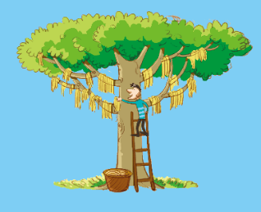
a b
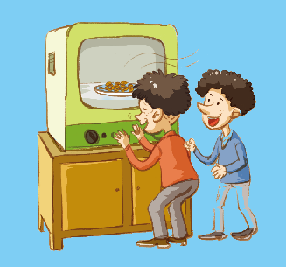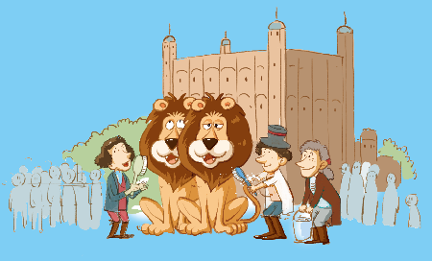
c d
Suggested answers:
a: A man is harvesting something off a tree.
b: A man is running near a house.
c: Two men are smelling a TV screen.
d: People are washing lions in the street.

Activity 2: Listen to the radio programme for the first time, check your prediction in activity 1 and summarize the main idea.
Answer:
Mark tells the presenter Karen about three of the best practical jokes in history.
Practical joke: a trick that is intended to embarrass someone and amuse others.

Activity 3:Listen to the radio programme and choose the pictures mentioned.
a b
c d
Answers: a, c, d

Activity 4: Listen again and complete the notes.
Joke 1
•Year: 1698
•Main story: A newsletter reported people going to watch ¹_____________ at the Tower of London. The joke was played on visitors throughout the ²_____________.
Joke 2
•Year: ³_____________
•Main story: The ⁴_____________ introduced an invention called “Smellovision”. It allowed ⁵_____________ over the airwaves.
Joke 3
Year: ⁶_____________
Main story: A news program told viewers that the spaghetti trees in Switzerland were having ⁷_____________
Answers:
1 the washing of the lions
2 18th and 19th centuries
3 1965
4 BBC News Channel
5 smell to be carried
6 1957
7 a really good harvest

Now work in pairs. Discuss which of the practical jokes you think is funny.
Sample:
Student A: The jokes are really funny. I think the lion one is the funniest for it worked for more than two centuries. Which one do you think is the funniest?
Student B: Yes, the lion one is funny, but the funniest one I think is the smellovision one. It reminds of the Emperor’s New Clothes; how could people smell something out of a screen! And some even said their eyes watered by the onion, wasn’t it ridiculous!
Student A: Yeah, funny enough. I am wondering if people would be annoyed when they knew they were fooled.
Student B: I guess not. Because that’s on April Fool’s Day, the jokes meant no harm and were out of amusing intention. Actually, a lot of people laughed as they knew they were taken in.

目标二: To tell a practical joke and make comments on practical jokes.
Activity 1: Complete the boxes with expressions from the radio programme.
•Let’s start with... •It’s a good one!
•I don’t get it. •That’s so funny!
•Now my favorite one... •I can imagine!
Telling a story
Let’s start with...
Now my favorite one...
Make comments
It’s a good one! I don’t get it. That’s so funny! I can imagine!

Activity 2: Work in pairs. Tell each other a funny story and make comments using the expressions in this section.
Sample 1:
Student A: My joke goes like this: I once changed all of my boss’ icons to open different programs. He clicked on Word and it opened Excel. He clicked on Firefox and it opened iTunes. I told IT about it in advance knowing he would take the computer to them.
Student B: That’s so funny.
Sample 2:
Student A: Last year on 1st, April, when I got to the class, I found I was actually in the third class. My roommate had set my alarm o’clock an hour back!
Student B: This is a good one. I have a joke: a man was told to go on business to another city. When he was on the train, he received his boss’s message: Happy April Fool’s day!
Student A: Oh, I can imagine.

Summary:
1 Can you say some expressions to tell a story and give comments?
2 Do you know more about April Fool’s Day?

