XB1 U3 Faster, higher, stronger
Understanding ideas: the Road to Success
Learning Objectives
At the end of the class, you are expected to be able to
1. figure out the difficulties,efforts and achievements in his different life stages.
- analyse how he turned the poor conditions into good results.
- summarize how yo write a biography
4. learn the spirit from Curry and create your success plan.
Task 1 Exploration
Complete the diagram with words and expressions from para1-3
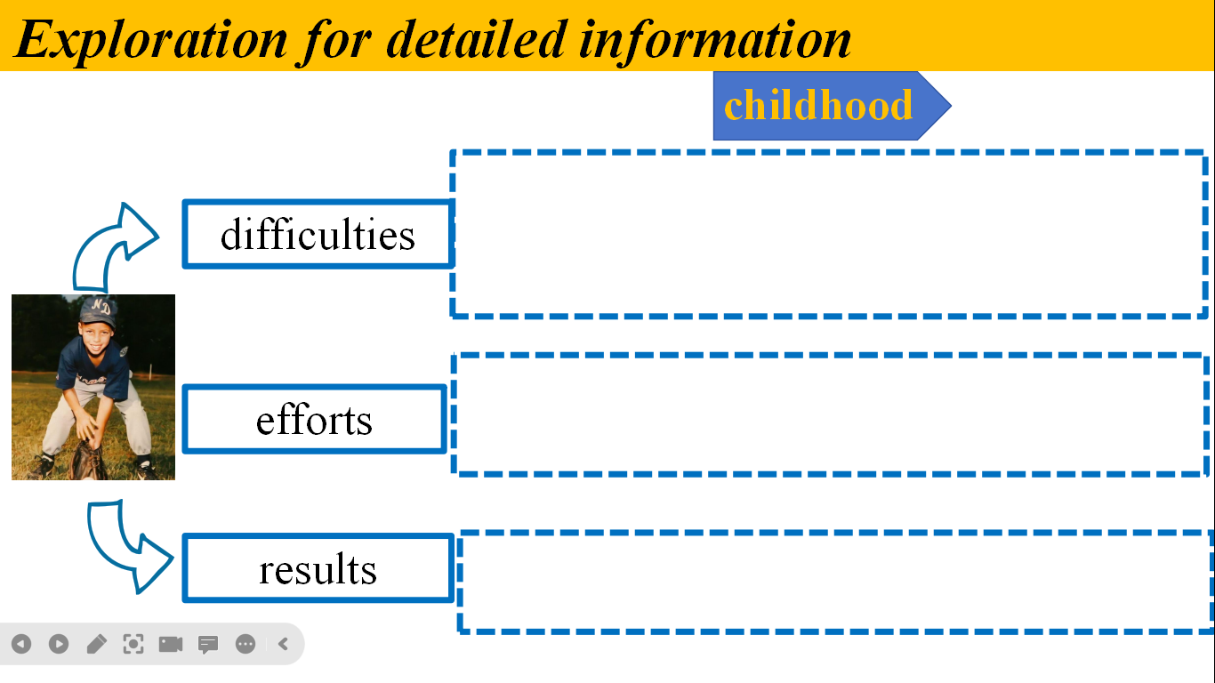
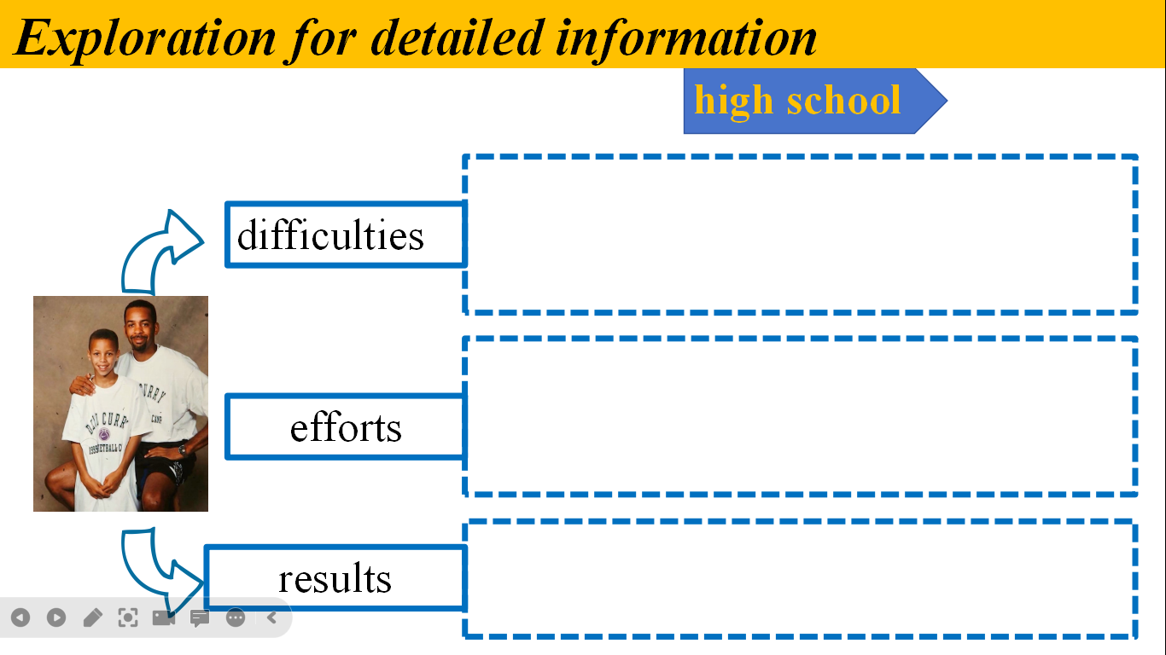
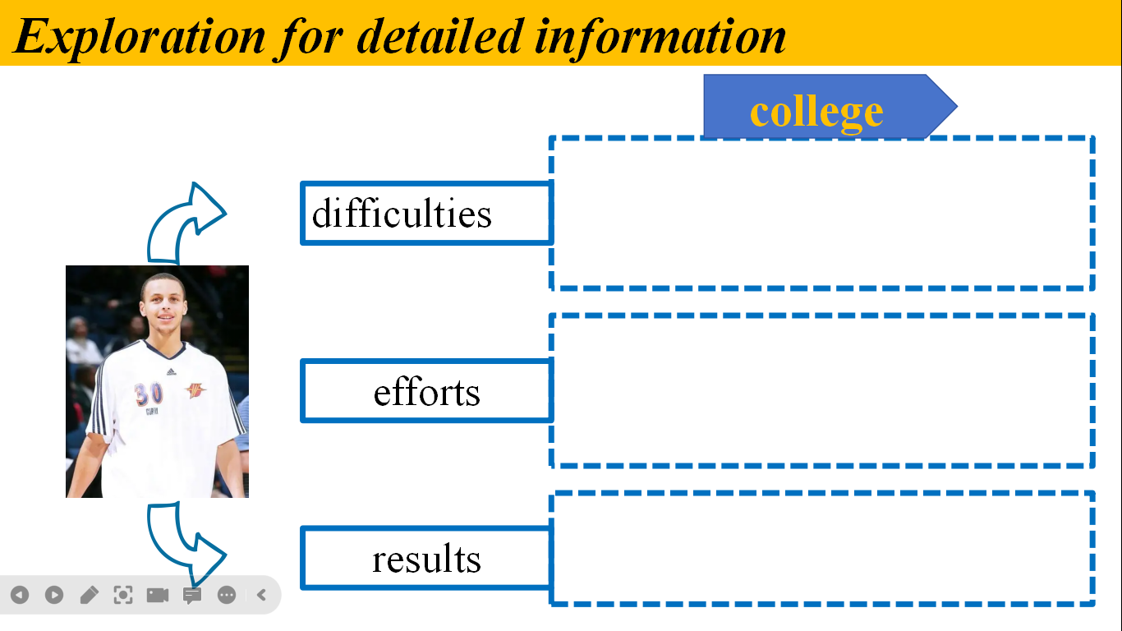
Task 2 Draw a mind-map
How can we write a good biography? What aspects do we need to consider?
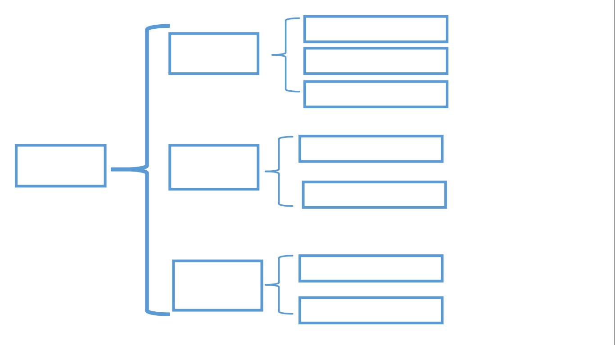

Task 3 Elaboration
How can you use the language in this passage talk about sportspeople? Give examples.

Task 4 Evaluation
The content | Self-assessment | Partner-assessment | Teacher-  assessment
Preparation
(课前准备）
Participation
（课上参与）
Cooperation
（小组合作）
Emotion
（上课状态）
Reflection：
- I have learned:

- I am not sure about:

- My suggestions:

Homework:
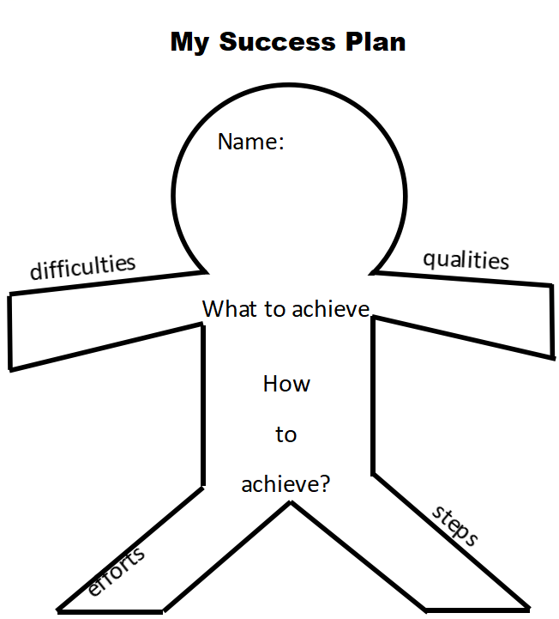
- Make your own success path

- Optional assignment
Write a living legend of sports within 120 words combining what we have learned.

