Unit 1 Period 1 Starting out & Understanding ideas
【学习目标】
Learning Objectives | 1 To get the conception and meaning of adult by watching the video and reading the poem  2 To get the main idea of the passage, find out what expectations Bethany, Lin Ning and Morgan has or had for turning 18 and what the reality is, then share your idea about being adult

【学习过程】
Learning activities
目标一: To get the conception and meaning of adult by watching the video and reading the poem
Activity 1: Watch the video and answer the questions.
1 What is a coming-of-age ceremony?
2 How do people celebrate in the video?
3 Which celebration makes the greatest impression on you? Why?
Answers:
_____________________________________________________________________
_____________________________________________________________________

Activity 2: Listen and read the poem. Answer the questions.
If-
If you can keep your head when all about you
Are losing theirs and blaming it on you;
If you can trust yourself when all men doubt you,
But make allowance for their doubting too;
If you can wait and not be tired by waiting,
Or, being lied about, don’t deal in lies,
Or, being hated, don’t give way to hating,
And yet don’t look too good, nor talk too wise;
If you can talk with crowds and keep your virtue,
Or walk with kings - nor lose the common touch;
If neither foes nor loving friends can hurt you;
If all men count with you, but none too much;
If you can fill the unforgiving minute
With sixty seconds’ worth of distance run
Yours is the Earth and everything that’s in it,
And -which is more - you’ll be a Man, my son!

1 What is the poem about?
2 According to Kipling, what qualities does his son need to “be a Man”? Tick those mentioned in the poem and add your own ideas.
self-belief honesty

confidence kindness

modesty pride

integrity patience

Other ____________________________

3 Which of these qualities are most important to you as you grow up?
Answers:
_____________________________________________________________________
_____________________________________________________________________

目标二: To get the main idea of the passage, find out what expectations Bethany, Lin Ning and Morgan has or had for turning 18 and what the reality is, then share your idea about being adult



Activity 1: Discuss at what age you are allowed to do the following things in China.
• Get a credit card.
• Get a driver’s licence
• Get a full-time job.
• Get the right to vote.
• Get a bank loan.
• Rent an apartment.

Activity 2: Predict what the passage is mainly about according to the title and the pictures.
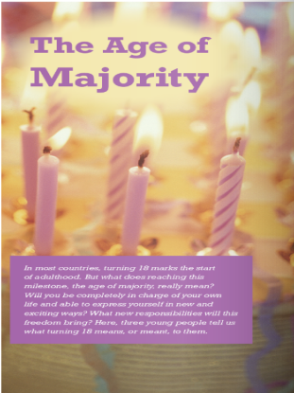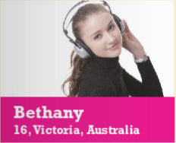
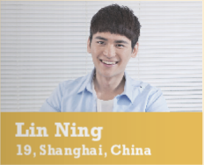

Activity 3: Read the passage quickly and find out the main idea of it. Then tell the meaning of “the age of majority”.
_____________________________________________________________________
_____________________________________________________________________

Activity 4: Choose another suitable title for the passage and give your reasons.
1 Eighteen — the Age of Indecision
2 Teenagers’ Hopes for the Future
3 The Right to Vote — Your Views
4 Turning Eighteen — What Does it Mean?

Activity 5: Read the passage carefully and finish the following tasks.
Task 1: Read paragraph 1, answer the question and then fill in the blanks.
Why can’t Bethany wait to be 18?
Answer:
Because she can’t vote or get a driving licence until she is 18.

Bethany 16, Victoria, Australia
I think it’s strange that I can now take ¹_______________,
yet I still can’t vote—I don’t think that’s fair, given that
² __________________________________________.
I should have a say on ³ ___________________________.
I’m mature enough to ⁴ ___________________________.

Task 2: Read paragraph 2, answer the questions and then fill in the blanks.
1 What did Lin Ning expect when he turned 18?
2 What is the reality like to him?
3 What change has he experienced after turning 18?
Answers:
_____________________________________________________________________
_____________________________________________________________________

At 18, I can do things like getting a credit card. More importantly, I can act on my desire to help others, for example by ⁵ ____________________________________
But although a lot of doors have opened for me, there are still ⁶ __________________________________________

Task 3: Read paragraph 3, answer the questions and then fill in the blanks.
1 How is the reality different from Morgan’s expectations for turning 18?
2 What is his understanding on turning 18?
Answers:
_____________________________________________________________________
_____________________________________________________________________

I thought that once I was 18 and in a full-time job I’d be able to 7 ______________________________ but my salary is not high enough. I also find it hard to save money because of 8 ______________________________ and high commuting costs.
Answers:

Activity 6: Read the sentences from the passage and decide if they are facts (F) or opinions (O).
1. Surely, if you’re old enough to earn a wage and pay taxes, you should be allowed to have a say on how the government spends them! _____
2. ... I will be taking my driving test on the very day I turn 18. _____
3. When I woke up the next day, there were still rules to obey and lessons to attend. _____
4. I guess some responsibilities are more about attitude than age._____
Now look for more opinions in the passage and talk about whether you agree with them.

Activity 7: Think & Share
1 Do you think the minimum age limits in the passage are sensible?
2 What right are you most looking forward to having as an adult? Why?
3 What do you think it means to be a responsible adult?
4 How can you use the language you have learnt in the passage to express your ideas clearly?
Answers:
_____________________________________________________________________
_____________________________________________________________________
_____________________________________________________________________
_____________________________________________________________________

Activity 8: Find the important words, phrases, and language points you want to share with your partner. Then discuss in groups and share their usage with the class.
_____________________________________________________________________
_____________________________________________________________________
_____________________________________________________________________
_____________________________________________________________________

Summary:
1 Can you share Bethany’s, Lin Ning’s and Morgan’s expectation of turning 18?
2 Can you share your expectation of turning 18?

