
Unit 1 Period 5 Writing & Presenting ideas
【学习目标】
Learning Objectives | 1 To get the main information and layout of the book review and write your own  2 To make a one-year self-improvement plan

【学习过程】
Learning activities
目标一: To get the main information and layout of the book review and write your own
Activity 1: Read the book review and find the information.
The Little Prince was written and illustrated by the French writer Antoine de Saint-Exupéry during World War Ⅱ. It is a children’s fantasy book, but it is also enjoyed by adults.
It tells a story about a pilot who has crashed in the desert. While he is trying to fix his aeroplane, a little prince comes to him. Visiting from another planet, the little prince recounts his adventures to the pilot, and the two become friends.
The book talks about the importance of looking beneath the surface of things to uncover their real meanings. I like it because it is simple, and yet it really made me think a lot about life and death, love and responsibility, friendship and loneliness. One of the most memorable characters in the book is a rose, which the little prince fell in love with. I was really touched by the line — “It’s the time you spent on your rose that makes your rose so important.” — because it shows how we form special bonds with others by caring and taking responsibility for them.
Personally, I think this is a touching book that everyone should read, whatever their age.
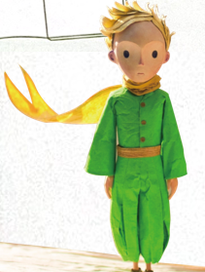
• the title of the book: _____________________________
• the name of the author: ___________________________
• the genre: _____________________________
• a memorable character: _________________________
• a quote from the book: ___________________________

Activity 2: Read the book review again and answer the questions.
1 What is the purpose of the author to write this book review?
2 What is the plot of the book?
3 What is the key message of the book?
4 What does the reviewer think of the book?
Answers:
_____________________________________________________________________
_____________________________________________________________________

Activity 3: Read the book review again and draw the layout of it.
Introduction
Main body
Conclusion

Activity 4: Choose a book that means a lot to you. Plan a review of it and make notes.
General facts about the book:
_____________________________________________________________________
_____________________________________________________________________
Plot of the book:
_____________________________________________________________________
_____________________________________________________________________
Comments:
_____________________________________________________________________
_____________________________________________________________________
Conclusion and recommendation:
_____________________________________________________________________
_____________________________________________________________________
Now write your book review.

Activity 5: Work in pairs. Make improvements to each other’s book reviews and share them with the class.
Sample:
_____________________________________________________________________
_____________________________________________________________________
_____________________________________________________________________
_____________________________________________________________________

目标二: To make a one-year self-improvement plan
Activity 1: Work in groups and discuss how to make a one-year self-improvement plan. Consider the following:
•what you have learnt from the past:
_____________________________________________________________________
_____________________________________________________________________
•what you plan to achieve:
_____________________________________________________________________
_____________________________________________________________________
•what you plan to avoid:
_____________________________________________________________________
_____________________________________________________________________
•what you plan to overcome:
_____________________________________________________________________
_____________________________________________________________________

Activity 2: Complete the table to help you draft your plan.
Goals | What to do
healthy living | Eat more fruit and vegetables.  Drink more water.  Do exercise three times a week.
positive thinking

Activity 3: Share your draft with your group and suggest ways to make improvements to each other’s plan.

Prepare a short presentation about your plan. Consider the following :
1 the structure of your presentation
2 useful words, expressions and structures

Give your presentation to the class. Check your self-improvement plan one year from now to see if you have achieved your goals.
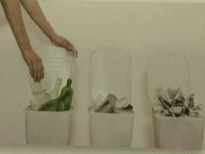

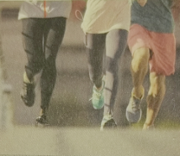

Summary:
1 Can you retell the structure of a book review?
2 Why do we need to make self-improvement plan?

