Unit 2 Period 2 Grammar
【学习目标】
Learning Objectives | 1 To know the usage of past perfect passive  2 To use past perfect passive correctly

【学习过程】
Learning activities
目标一: To know the usage of past perfect passive
Activity 1: Look at the sentences and answer the questions. Sentence (a) is from the reading passage.
a At the start of the detox, over 100 students had been persuaded to stop using social media, in ANY form, for seven days.
b At the start of the detox, people had persuaded over 100 students to stop using social media, in ANY form, for seven days.
1 Were the students in sentence (a) persuaded before the detox started, or afterwards?
2 What is the difference between sentence (a) and (b)?
3 Why does the author choose to use passive form instead of an active form?
Answers:
_______________________________________________________________________________
_______________________________________________________________________________
Now look for more sentences with the past perfect passive in the reading passage, and summarise its uses in your own words.
_______________________________________________________________________________
_______________________________________________________________________________
Activity 2: Read the sentences again and summarise the structure and concept of past perfect passive.
- At the start of the detox, over 100 students had been persuaded to stop using social media, in ANY form, for seven days.
- They had been promised money by family and friends for each day spent without using social media.
- I am to find out just how many have been motivated enough to last the full seven days!
- But on reflection, I can see how much of my time had been occupied with checking my phone.
_______________________________________________________________________________
_______________________________________________________________________________

Activity 3: Read the sentences and summarise the four sentence structures with past perfect passive voice.
1 The pen had been broken by the boy before it was found.
2 The problem had not been solved by the time I left the room.
3 Had the office been cleaned before the director came?
When had the buildings been destroyed?
_______________________________________________________________________________
_______________________________________________________________________________

目标二: To use past perfect passive correctly
Activity 1: Complete Jack’s blog post with the correct form of verbs in brackets.
Before I turned over a new leaf, I had always been a very lazy student. I was careless about handing in my homework, and none of my assignment deadlines ¹___________ (meet). Indeed, I would deliberately “lose” my homework in my incredibly messy room, so that I could put off ²___________(do) it! My parents soon worked out this trick, though, and one day I came home to find that my room ³___________ (clean), and my homework ⁴___________
(put) right in the centre of a spotlessly clean desk! A present
⁵___________ (leave) on the desk, too (I think Mum did that): a book called The Art of Procrastination.
The author, John Perry, said that procrastination was about ⁶___________ (avoid) the hardest and most important tasks. So,
⁷___________ (make) sure you do your homework, put it second or third on your to-do list, not at the top. Then put one or two really hard things you don’t want to do at the top of the list.
You will procrastinate to avoid the hard stuff-by doing your homework!

Activity 2: Work in pairs. Describe the pictures using the past perfect passive.
Jack started the habit of cleaning his room last week. This is what his room looked like yesterday morning.
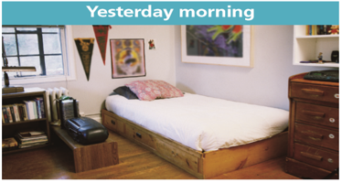

But two weeks ago, Jack’s room was like this...
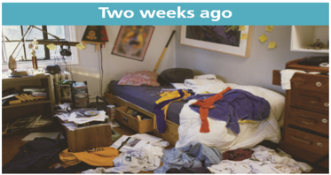

Suggested answer:
_______________________________________________________________________________
_______________________________________________________________________________

Activity 3: Work in pairs. Talk about what had happened before you started a new habit of your own. Use the past perfect passive where appropriate.
What happened before a new habit | I started a new habit

Summary:
1 Can you retell the structure and usage of past perfect passive?
2 Can you use the past perfect passive to describe change of your study habit?

