Unit 2 Period 3 Listening and Speaking
【学习目标】
Learning Objectives | 1 To know the phrases about inappropriate behavior and use them properly, talk about what the right thing is  2 To learn values education such as honesty in school and promote it

【学习过程】
Learning activities
目标一: To know the phrases about inappropriate behavior and use them properly, talk about what the right thing is
Activity 1: Look at the signs below and talk about what they mean.
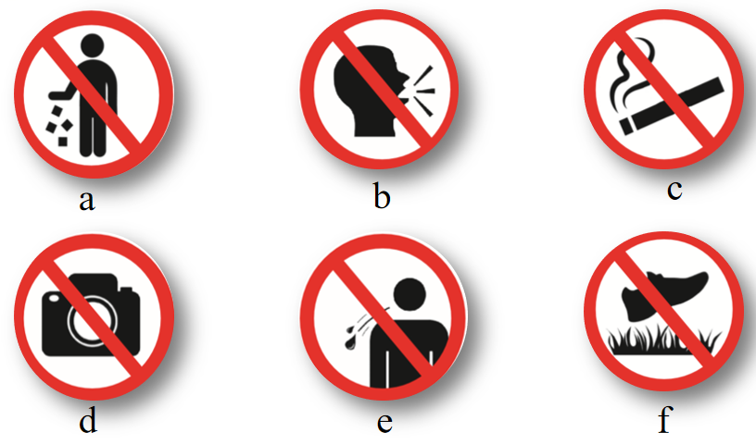
Activity 2: Match the sentences to the signs. Pay attention to the words and expressions in bold.
1 Do not litter.

2 Do not talk loudly in public.

3 Do not spit in public.

4 Do not walk on the grass.

5 Do not smoke.

6 Do not take photos.

Activity 3: Complete the conversations with the correct form of the words and expressions.
litter, talk loudly in public, spit in public,
walk on the grass, smoke, take photos
1 A: What do you do when people ______________________?
B: I put my headphones on. I don’t want to hear other people’s conversations.
2 A: How can we stop people ______________________?
B: We should tell them it’s dirty and it can spread diseases.
3 A: What would you do if you saw people __________________?
B: I would go up to them and ask them to put the litter into a rubbish bin.
4 A: How can we prevent people from ______________________?
B: If we keep the grass looking really neat, maybe people will realise they shouldn’t walk on it.
5 A: What would you do if you saw someone _________________ where it’s not allowed?
B: I’d politely remind them it’s not permitted, and that they should be considerate of others.
6 A: What would you do if you saw someone ________________ in a museum?
B: I’d ask them to stop, because it can damage the exhibits.

Activity 4: Now work in pairs. Think of more types of inappropriate behaviour and talk about what you think is the right thing to do when faced with them.
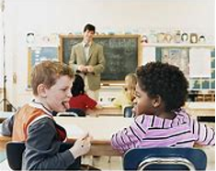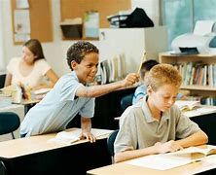
chat in class play trick on others
A: What do you do when people _________________________?
B: I would __________________ because __________________.
目标二: To learn values education such as honesty in school and promote it
Activity 1: Listen to the interview and choose a topic for it.
1 How to promote values education.
2 How to inspire students to work hard.
3 How to introduce school programmes.
4 How to fairly distribute books and umbrellas.

Activity 2: Listen again and complete the newspaper report.
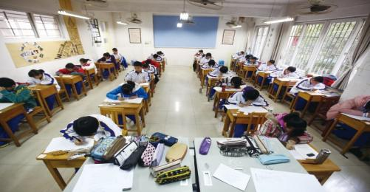
A school in our city came up with an innovative programme
to promote the traditional value of 1_____________________. School principal Ms Wu gave several examples of how the
programme works.
To begin with, the school introduced an activity called
the “unsupervised examination” for some of the classes.
That means during this examination, there is no teacher
2________________________. Before taking this
examination students first need to 3________________________.
Students generally expressed that it’s good to feel 4 ________________________ and they quite enjoyed 5________________________ in the examination. In turn, they developed 6________________________.
The school also introduced what is called the 7 “________________________”. Printed on each umbrella was short statement about 8________________________. At the end of the term, all the umbrellas were returned 9________________________. None of them had been lost or damaged.
Now Ms Wu and her colleagues plan to introduce the programme to 10________________________. Everyone needs to work together to build a culture of honesty. They hope more teachers and students will get involved.

Activity 3: Complete the boxes with the expressions from the interview.
• I can give a couple of examples.
• That is...
• Let me clarify...
• For instance,...
• I mean...
• Take...as an illusion.
• To put it another way, ...
Clarifying what you mean
Giving examples

Activity 3: Work in groups. Discuss how to promote values education at your school using the words and expressions in this section.

Now talk about how well you did in offering effective advice or ideas and developing effective solutions in the group discussion.
Summary:
1 Can you list more phrases about inappropriate behaviour?
2 Can you list more expressions about clarifying what you mean and giving examples?

