Unit 3 Period 2 Grammar
【学习目标】
Learning Objectives | 1 To know the usage of past continuous passive  2 To use past continuous passive correctly

【学习过程】
Learning activities
目标一: To know the usage of past continuous passive
Activity 1: Look at the sentences and answer the questions. Sentence (a) is from the reading passage.
a When I hurried to the store, I saw that the books were already being packed into boxes.
b When I hurried to the store, I saw that the books were already packed into boxes.
1 What is the difference between sentences (a) and (b)?
2 Which sentence emphasises process and which emphasises result?
Answers:
_______________________________________________________________________________
_______________________________________________________________________________

Now look for more sentences with the past continuous passive in the reading passage, and summarise its uses in your own words.
_______________________________________________________________________________
_______________________________________________________________________________

Activity 2: Read the sentences again and summarise the structure and concept of past continuous passive.
1 When I hurried to the store, I saw that the books were already being packed into boxes.
2 More and more customers were being attracted by chain stores and online discounts.
3 In one area, a book reading was being delivered.
4 ..., where customers’ comments on the month’s best-seller were being displayed.

Activity 3: Read the sentences and summarise the four sentence structures with past continuous passive.
1 Another bridge was being built over the Yangtze River then.
2 The plan was not being carried out well.
3 Was a new library being put up in their school just then?
4 What was being done to the machine?
Answers:
_______________________________________________________________________________
_______________________________________________________________________________
_______________________________________________________________________________
_______________________________________________________________________________
目标二: To use past continuous passive correctly
Activity 1: Rewrite the passage using the past continuous passive.
Walking home a few days ago, I saw that people were doing reconstruction work on the old market. It would be turned into modern shopping mall. Some people were tearing down the old gate. Some were removing the wooden stands. Some were clearing away rubbish from the floor. While all this going on, a journalist was taking photos. The resulting story in the local newspaper divided the people of the town: some were in favor of the new shopping mall, and some were against it.
_______________________________________________________________________________
_______________________________________________________________________________
_______________________________________________________________________________
_______________________________________________________________________________
_______________________________________________________________________________
_______________________________________________________________________________
_______________________________________________________________________________
_______________________________________________________________________________
_______________________________________________________________________________
_______________________________________________________________________________
_______________________________________________________________________________
_______________________________________________________________________________

Activity 2: Look at the two groups of pictures and describe the changes in the news industry using the past continuous passive where appropriate.

Yesterday, I watched a documentary about the news industry in the past. I saw that an interview was being done face to face. But now, interviews can be done online...
Sample:
_______________________________________________________________________________
_______________________________________________________________________________

Activity 3: Describe the changes in another industry using the past continuous passive where appropriate.
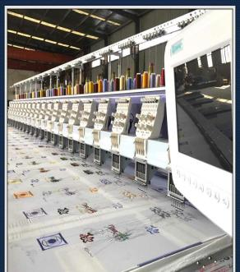
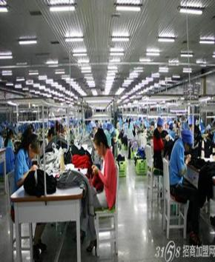

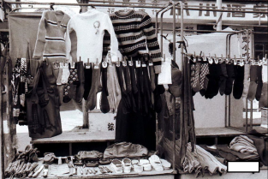
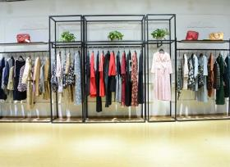

Sample:
_______________________________________________________________________________
_______________________________________________________________________________
Summary:
1 Can you retell the structure of past continuous passive?
2 Can you use past continuous passive to describe the change in your home?

