Period 5 Writing about a change
题型解读 | 谋篇思路
写一篇发展变化的文章。应用对比性的文字描述变化的原因、变化的主要方面和对人产生的影响 | 首段:提出将要叙述的话题  主体段落:比较变化的内容  尾段:总结这些变化带来的影响
满分佳句
■ 夺人眼球开头句
1.Over the past/last ..., great changes have taken place in ...
在过去的……,巨大的变化发生在……
2.... is quite different from what it was/used to be.
……和现在很不一样。
■ 亮点出彩篇中句
1.My reasons are as follows.
理由如下。
2.In the first place/To start with, ...
首先,……
3.The less we use our cars, the less we will affect the environment.
汽车用得越少,我们对环境的影响就会越小。
4.On the one hand ..., on the other hand ...
一方面……,另一方面……
5.It used to take several days to hear from each other in contrast to minutes nowadays.
过去用几天的时间才能联系上,和现在的几分钟就能联系上形成了鲜明的对比。
■ 韵味无穷结尾句
1.It is not only beneficial to ... but can also help me get rid of ...
不仅对……有益,并且能够帮助我去除……
2.In a word/All in all, it will be of great benefit to our life.
总之,它对我们的生活大有益处。
写作规范
请你根据图画,写一篇英语短文,描述今昔通讯方式的变化,以及这些变化给人们的生活带来的影响。
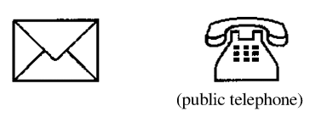Before | 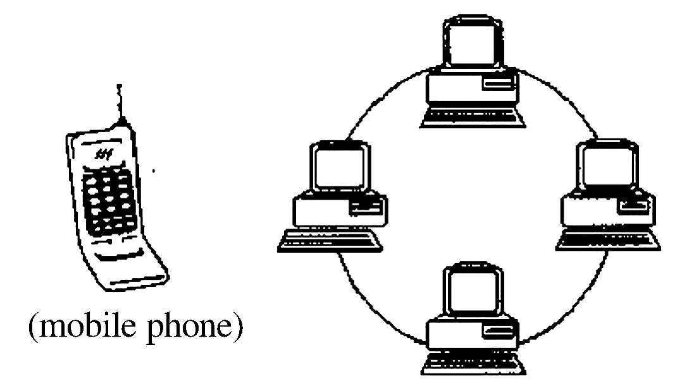Now
注意:写作词数应为80左右。
第一步:认真审题 谋篇布局
体裁 | 人称 | 时态 |  | 要点结构图 | 首段 | 说明目的——比较差异
应用文 | 第三人称 | 一般过去时和一般现在时 |  | 要点结构图 | 主体段落 | 根据提示,详细表达不同之处
 |  |  |  |  | 尾段 | 改变带来的影响
第二步:核心词汇 想周全
1.take place 发生
2.keep in touch with 与……保持联系
3.hear from/receive a letter from 收到来信
4.communicate with 交流
5.have easy access to the Internet 容易上网
6.in a word/all in all 总之
7.in contrast to 对比
第三步:由词及句 雏形现
1.过去人们主要通过写信和公用电话彼此保持联系。
In the past, people kept in touch with each other mainly by writing letters or using the public telephone.
2.现在几乎每个人都有电话。人们可以在任何时间与地点联系。
Now almost everyone has his/her own mobile phone. People can communicate with each other at any place and at any time.
3.过去用几天的时间才能联系上,和现在的几分钟就能联系上形成了鲜明的对比。
It used to take several days to hear from each other, but nowadays it takes minutes.
4.人们很容易就能上网。这使他们能随时接收邮件。
People have easy access to the Internet. It enables them to send and receive e⁃mails whenever they like.
第四步:句式升级 造亮点
1.将句2升级为含有定语从句的句子
Now almost everyone has his/her own mobile phone with which people can communicate with each other at any place and at any time.
2.将句3升级为含有介词短语表示对比的句子
It used to take several days to hear from each other in contrast to minutes nowadays.
3.将句4升级为含有定语从句的句子
People have easy access to the Internet, which enables them to send and receive e⁃mails whenever they like.
第五步:合理过渡 完美卷面

答案
Great changes have taken place in the way of communication in people’s life in recent years.
In the past, people kept in touch with each other mainly by writing letters or using the public telephone. But now almost everyone has his/her own mobile phone with which people can communicate with each other at any place and at any time. It used to take several days to hear from each other in contrast to minutes nowadays. What’s more, people have easy access to the Internet, which enables them to send and receive e⁃mails whenever they like.
With these changes, people’s pace of life has been quickened and people’s work has been made more efficient. In a word, people have an easier life nowadays.

