高二年级上学期英语学案
选必二 Unit 4 Breaking boundaries（第1课时）
Starting out and understanding ideas
自主学习【学】
【课标要求】
1 本单元的主题语境是“人与社会”，涉及的主题语境内容是打破边界；
2本课语篇类型为日记，记录了100天以来作者与其他无国界医生共同抗击埃博拉病毒时的所见所闻所感，展现了无国界医生所具有的责任感、团队意识、奉献精神和永不放弃的信念。基本行文结构为“所见所闻——所感”模式。
【学习目标】
1引导学生快速阅读课文，了解作者作为无国界医生所要参与解决的问题，并获取文章的主要观点；
2引导学生再次阅读课文，找出相关细节信息并梳理课文的写作脉络，总结作者从出发前到写日记时的经历和感受；
3帮助学生基于文章内容，从无国界医生无私奉献的精神中感知单元主题意义，加深对“无国界”和“人类命运共同体”这两个概念的理解。
【自学评价】
- 核心词汇

- 分界线；边界n. __________
- 统计数据 n.. __________
- 协助、帮助v. __________
- 处理、对付（难题）v. __________
- 极其重要的 a. __________
- 悲惨的、不幸的 a.__________
- 专家 n. __________
- 传染性的 a. __________
- 诊所；门诊部 n. __________
- 爆发，突然发生 n. __________
- 奉献 n. __________
- 双胞胎的 a. __________
- 病房 n. __________
- 人类 n.__________
- 阅读词汇

- comrade n.. __________
- Ebola n. __________
- combat v. __________
- relieve v. __________
- disinfect v. __________
- vomit n. __________
- miracle n. __________
- van n. __________
- compensate v. __________
- collaborate v.__________
- 重点词组

- regardless of _____________
- in danger _____________
- take any chances _____________
- put … at risk _____________
- be involved in _____________
- at least _____________
- give up on _____________
- against all odds _____________
- be caught up in ____________
- not to mention _____________
- step into one’s shoes ____________
- call on _____________

师生研学【研】
【学习过程】
Step 1 Starting out
- Watch the video and answer the questions.（P49 Activity 1,2）
- Look at the pictures (P49) and answer the questions.
Step 2 Pre-reading
Read to know more about MSF and answer the questions. (P50 Activity 1)
Step 3 While-reading
Fast reading:
1. Read the passage and choose the ideas conveyed in the passage and find evidence to support your choices. (P52 Activity 3)
Careful reading:
1. Organise information from the passage and complete the table (P53).
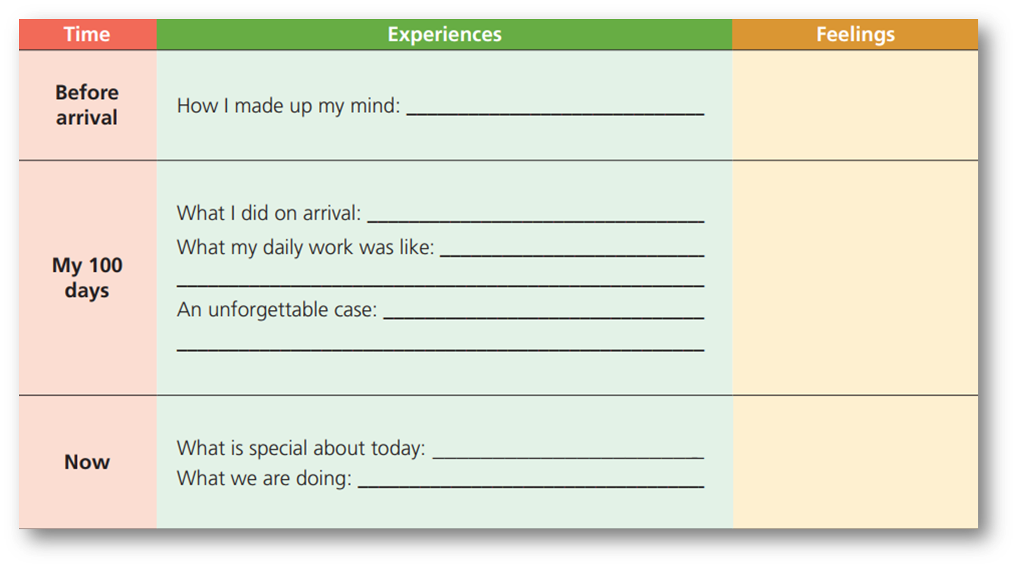
2. Read the information (P53) and answer the questions.
Step 4 Post-reading
Discuss the following questions and express your ideas.
1. What is your understanding of the first sentence in Paragraph 6?
2. What difficulties do you think the author might have faced during his work?
3. Do you know of any other similar organisations? What do they do?
4. What have you learnt from the passage that can help you talk about “a community with a shared future”?
- 训练提升【练】
【当堂检测】
- 课文语法填空
Three months ago，I arrived in Liberia with MSF to help the local people to fight with Ebola. I felt 1.____ was my duty to go there and offer my help，even though I knew I was 2.____ risk. My mission was 3._____(relieve) Emma，a Canadian specialist in infectious diseases. She talked me through the daily routine and introduced me some of the others working for or alongside MSF.I found that I was the only Chinese doctor among people from every continent except Antarctica. I felt 4.____ sense of pride as part of the extraordinary team,5.____ devotion to the cause shone from their eyes. We worked together,6.______(surround) by blood，vomit and death，but we never gave up on a patient，and our efforts did sometimes end in miracles.
To be caught up in such a crisis creates 7._________(power) bonds between carers and patients as well as between all those who have come from different 8._______(part) of the world and joined together in a common cause. In a world still 9.__________(face) so many problems，it is 10._________(absolute) essential for us all to collaborate to create a global community with a shared future of peace and prosperity.
- 翻译句子
1. 饭后，我总帮父母洗碗。（assist）
___________________________________________________________________________
2. 重要的是我们不能心存侥幸。(take any chances)
____________________________________________________________________________
3. 为了应对粮食短缺的危机，袁隆平选择学习农业。(tackle)
____________________________________________________________________________
4.母亲对孩子的关爱是不可衡量的。(devotion)
____________________________________________________________________________
5.科技是把人们聚集在一起的主要因素。(be responsible for) (P55) ____________________________________________________________________________
- 阅读理解
Cases of the omicron variant of the coronavirus popped up in countries on opposite sides of the world on Sunday and many governments rushed to close their borders even as scientists cautioned that it’s not clear if the new variant is more alarming than other versions of the virus.
The variant was identified days ago by researchers in South Africa, and much is still not known about it, including whether it is more infectious, more likely to cause serious illness or more able to evade the protection of vaccines. But many countries rushed to act, reflecting anxiety about anything that could prolong the pandemic that has killed more than 5 million people.
Israel decided to bar entry to foreigners, and Morocco said it would suspend all incoming flights for two weeks starting Monday. Scientists in several places — from Hong Kong to Europe to North America — have confirmed its presence. The Netherlands reported 13 omicron cases on Sunday, and both Canada and Australia each found two.
Dr. Francis Collins, director of the National Institutes of Health in the United States, meanwhile, emphasized that there is no data yet that suggests the new variant causes more serious illness than previous COVID-19 variants. Collins, along with several experts, said that the news should make everyone redouble their efforts to use the tools the world already has, including vaccinations, booster shots and measures such as mask-wearing. “I know, America, you’re really tired about hearing those things, but the virus is not tired of us,” Collins said.
As more omicron cases have been found in more countries such as Dutch, Canada, Australia, many countries are introducing travel bans or closing borders, though they go against the advice of the WHO. It has warned against any overreaction before the variant is thoroughly studied, noting that travel restrictions may play “a role in slightly reducing the spread of COVID-19 but place a heavy burden on lives and livelihoods.”
Spain announced it won’t admit unvaccinated British visitors starting Dec. 1. David Hui, a respiratory medicine expert in Hong Kong, agreed with that strategy, saying the two people who tested positive for the omicron variant had received the Pfizer vaccine and exhibited very mild symptoms, such as a sore throat.
5．What does the underlined word “evade” in Paragraph 2 probably mean?
A．escape from B．help with C．come down with D．engage in
6．According to Dr. Francis Collins, we know that ________.
A．more and more countries will have to close their borders.
B．omicron has already made Americans tired of the disease.
C．the new variant has caused more serious illness than the previous one.
D．regular public health measures are effective against the variant.
7．What can we learn from the passage?
A．World Health Organization is against omicron-related travel bans.
B．The new variant is thought to have originated in South Africa.
C．The previous vaccine is of little use in fighting against omicron.
D．Spain has its border closed to foreign travelers including British visitors.
8．Which would be the best title for this passage?
A．More countries have begun to introduce travel bans
B．Great damage caused by a new variant called omicron
C．More omicron cases emerge as world rushes to learn more
D．Vaccinations and booster shots recommended to be pushed
七选五
We all have read those amazing stories where we feel as if we are taking part in the action: the weapons in our hands, the eyes filled with tears, and magic circling through the land. ____1_G___, however. Stories can be found anywhere in imaginary worlds or in your kitchen at home. Here are five suggestions to help you explore and write your own story.
Find inspiration everywhere
Some of the most interesting stories have come from a boy’s simple car ride back from school, or from a memorable dream a girl just can’t forget. ____2____. E
Live with your characters
The most interesting characters are those that seem to come to life. One of the greatest ways to have your characters jump from the pages is to imagine what it would be like to live with each of them for a day. ___3__C_. How do they speak? How do they walk? What do they like to eat?
____4_A__.
Everyone writes differently, but outlining your story often helps your readers follow your story more easily. List your characters, the settings, the time, and the main story plot. What happens? When? In what order?
Open with excitement
Now it’s time to begin writing! ___5_F___. Would you rather read a story that begins with “Hi, my name is John and I would like to tell you about my day.” Or “‘AHHHHHHH,’ John screamed. He was so late.”?
Write to describe something
Here is a common writing idea: show, don’t tell. For example, when you write, you don’t have to say: Marie was so sad. Often, a more effective way to convey her sadness would be like this: tears rolled down her face leaving dark, salty lines.
A．Outline your plot
B．Write down something special
C．Small details help you build them
D．Make up stories based on your daily life
E．Discover an inspiring moment to write about it
F．Work on the first sentence to attract your readers
G．They needn’t be adventurous with exciting events
【布置作业】____________________________________________________________________________
师生总结【结】

