Class: _______________ Name: _______________

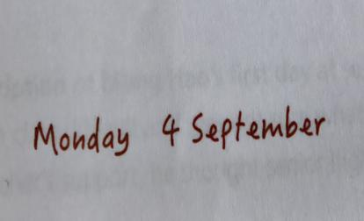
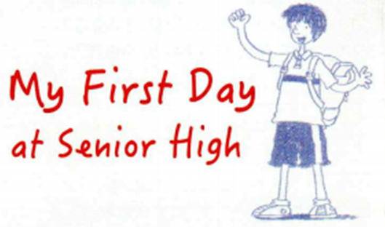
Activity 1
Make a prediction from the two pictures.
Who: _______________
Genre: _______________
What does the author include in the passage?
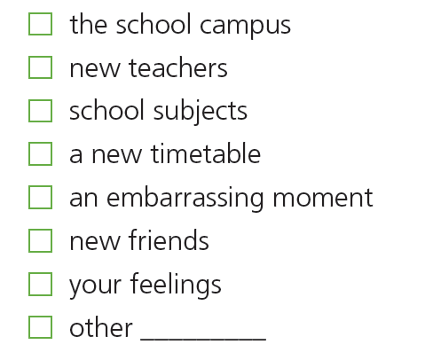
Activity 2 1. Skim the diary and find the information.
Genre: Who:
Where: When:
What: Meng Hao recorded what
How the author develops the diary: in order
- Sequence the pictures and divide the passage into several parts.
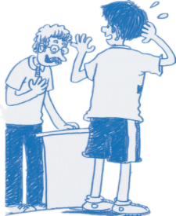
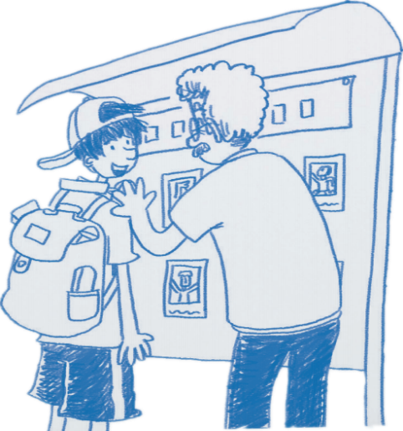
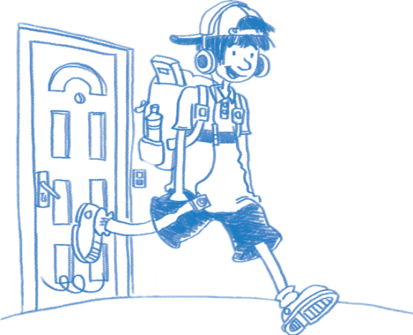
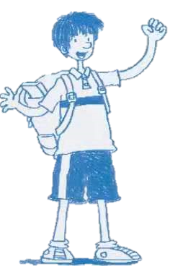
_____ English class (para_____)

_____ school
(para_____)

_____ school
(para_____)

_____ class
(para_____)

Activity 3 Scan para1 and Fill in the blanks.
Meng Hao’s actions | Meng Hao’s emotions

Activity 4 Scan para2 and Fill in the blanks.
Meng Hao’s actions | Meng Hao’s emotions
Activity 5 Scan para5-6 and Fill in the blanks.
Meng Hao’s actions | Meng Hao’s emotions

After the English class, Meng felt .
In your opinion, what’s the meaning of “well begun, half done”?

Task 6 Retell the story according to the timeline.

Before going to school

Arriving at school

During the English class

After class

Activity 7 Finish the profile of Meng Hao.


Name:

Hobby:

Personalities:

Motto:
Homework
- Find and Collect the words and phrases about emotions in the text; make some sentences with these new expressions (at least one for each).

- Finish the questionnaire on page 1.

- (optional) Record a vlog of your first day at senior high (you need to speak English in your vlog).

