B1U3 Family matters--Understanding Ideas
导学案
Step1: Leading-in
- Watch and think: What does a family mean to Chinese people?

2.Read and tick: When you meet something important, will you turn to your parents for advice? Tick the things you would ask your parents about for advice.
school studies friendship troubles
joining an after-school club getting a new hairstyle
shopping for new clothes and shoes choosing your future area of study

Step2: Prediction
- What do you see in the picture?
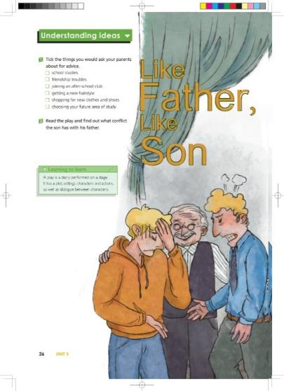
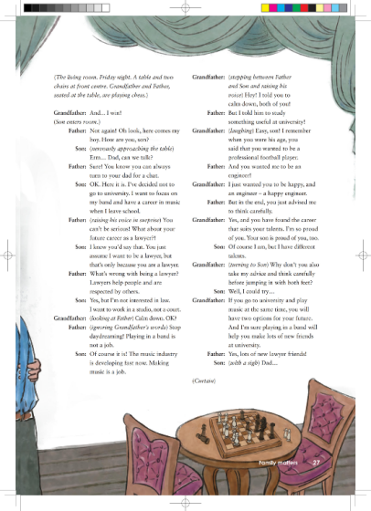

- How does the young man feel?

- When he is in trouble, who may he turn to for advice?

Step3: While-reading
1.Fast reading
(1)Read the play and find out what conflict does the son have with his father?

(2)Add the tags to the director’s notes.



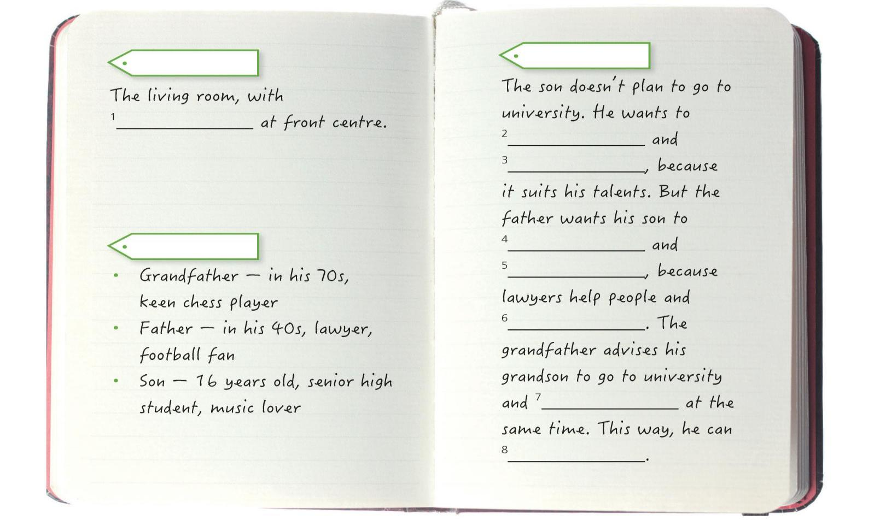

Now complete the director’s notes with expressions from the play.
2.Detailed reading
(1) How does the son act at the beginning? What’ s his father’ s response?

(2)When the son says“I want to focus on my band and have a career in music when I leave school”, how does the father’ s response change? How do you know ?

(3)Why doesn’t the father agree with his son? Why does he become emotional?

- When the father and son have conflict and they cannot reach an agreement, what happens? Who helps them resolve the conflict?

(5)How does the grandfather help them resolve the conflict? What role does the grandfather
play in resolving the conflict?

(6)What advice does the grandfather give finally?

Step 4: Post reading
1.Retell the story according to Activity 4.
◎Phrases: be seated at the table nervously approach advise sb. to do
focus on his band jump in with both feet have a career in music
have two options for future
2.How do you understand the title Like Father Like Son?

3.Choose another suitable title for the play and give your reasons.
(1) The Secret to a Happy Family (2) A Generation Gap
(3) Grandfather’s advice (4) My Career, My Choice

Step 5: Practical application
◎Think and share
If you were in a similar situation to the son, what would you do? Why?

Step 6: Homework
Think about what conflicts you once had with your parents. How did you resolve them? After learning this lesson, how can you improve your ways of resolving conflicts?
Tips:1. Decide on a conflict between you and your parents.
2. Describe how you resolved the conflict.
3. Write how you will resolve that conflict after learning this play.

