四川省仪陇中学校教学设计表
备课时间：
年 级 |  | 高2024 级 |  | 学 科 |  | 英语
课题名称 |  | Book1 Unit3  Understanding ideas |  | 课 型 |  | Reading
设 计 者 |  | 胡思雨，刘微薇，王纺 |  | 课 时 |  | 第 1 课时
育 人  目 标 |  | 学生能通过语篇学习掌握戏剧的文体特征、基本要素并通过本文能够正确看待并妥善解决日常生活中的家庭矛盾，树立正确的家庭观。
学 习  目 标 |  | ①学生能够读懂剧本，理解文章大意，并根据文章内容准确理解标题的含义，为文章选择另一个合适的标题；
 |  | ②学生能通过语篇学习掌握戏剧的文体特征、基本要素和常见阅读方法；
 |  | ③学生能够正确看待并妥善解决日常生活中的家庭矛盾，树立正确的家庭观。
学 习  重 点 |  | 引导学生准确理解文章大意及文章标题，并运用正确的语法和词汇表达自己的家庭及家庭成员。 |  | 学 习  难 点 |  | 引导学生理解戏剧的基本特征及正确看待家庭矛盾、树立正确的家庭观。
核 心  问 题 |  | 理解并运用一些复杂的家庭关系词汇和表达方式。
课 时  目 标 |  | ①学习并巩固有关家庭关系的词汇和表达方式。
 |  | ②训练学生的综合语言运用能力，能够用正确的语法和词汇表达自己的家庭及家庭成员。
 |  | ③培养学生主动思考家庭对个人的重要性，并进行相关写作训练。
教学过程
 | 学习内容 |  | 教师活动 |  | 学生活动 |  | 设计意图
任务一 | Lead-in:  1.Play a video and think: What does a family mean to Chinese people?  2.Ss list the things that they would ask their parents about for advice. |  | 1.Play a video ;  2.Give the question |  | 1.Watch and think: What does a family mean to Chinese people?  2.Tick the things you would ask your parents about for advice. |  | Stimulate Ss' interests.
任务二 | Prediction:  Look at a picture and make predictions. |  | - Let Ss look at the picture.  - Give the questions:  1). What do you see in the picture?  2). How does the young man feel?  3). When he is in trouble, who may he turn to for advice? |  | Look at a picture and make predictions. |  | Prepare Ss for reading.
任务三 | Reading |  | 1. Let Ss read the play and find out what conflict the son has with his father;  2.Ask Ss to add the tags to the appropriate places;  3. Ask Ss to pay attention to the major components of a play;  4.Ask Ss to retell the story and choose a suitable title in Activity 3 and give reasons. |  | 1.Read the play and find out the conflict;  2.Add the tags to the appropriate places;  3.Answer the questions;  4.Retell the story and choose a suitable title in Activity 3 and give reasons. |  | 1.Read for main idea;  2.Train the reading skill of getting key information;  3.Understand the main features of a play.
任务四 | Practical application |  | Let Ss discuss the question in groups and share their opinions:  If you were in a similar situation to the son, what would you do? Why? |  | Ss discuss the questions in groups and share their opinions in class. |  | 1. Further explore the topic and the unit theme.  2. Improve Ss’ critical thinking and problem-solving ability.  3. Apply what Ss have learnt in real-life context.
作 业  设 计 |  | Homework：  Think about what conflicts you once had with your parents. How did you resolve them? After learning this lesson, how can you improve your ways of resolving conflicts?  Tips:  1. Decide on a conflict between you and your parents.  2. Describe how you resolved the conflict.  3. Write how you will resolve that conflict after learning this play.
板 书  设 计 |  | 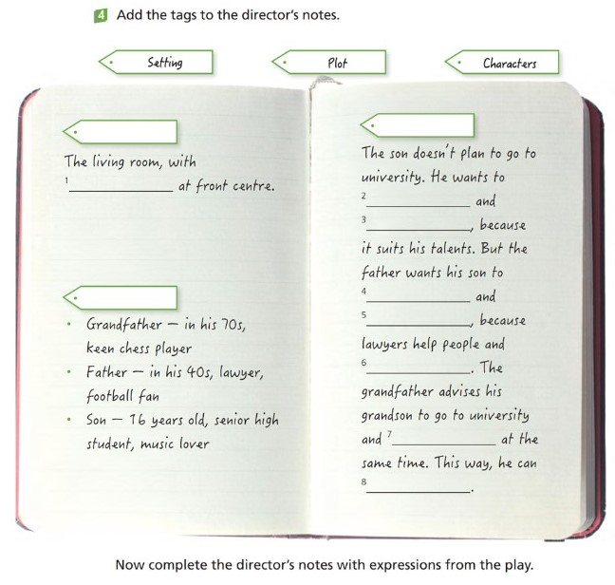
教 学  反 思 |  | - 对于一些复杂的家庭关系词汇和表达方式需加强巩固。  - 可以考虑引入更多与学生实际生活相关的练习，以提高学生的学习兴趣，并帮助他们将课文内容与现实情境联系起来。

