四川省仪陇中学校教学设计表
备课时间：2024年8月
年 级 |  | 高2024 级 |  | 学 科 |  | 英语
课题名称 |  | Unit 6 At One with Nature ——Longji Rice Terraces |  | 课 型 |  | 阅读
设 计 者 |  | 宋龙 汪朝文 |  | 课 时 |  | 第 1 课时
育 人  目 标 |  | 培养学生的文化意识和逻辑性、思辨性、创造性思维品质
学 习  目 标 |  | ①Simply describe the natural environment of your hometown and its impact on your own life;
 |  | ②Read the text, understand the construction background, construction reasons and operation principles of the Longji terrace, and properly use the knowledge to introduce the Longji terrace;
 |  | ③Understand the local people's behavior of respecting nature, rationally using nature and transforming nature, and gradually cultivate their own awareness of environmental protection.
学 习  重 点 |  | - Guide students to initially understand the impact of the natural environment on human life, and based on their own experience, simply describe the natural environment of their hometown, tell the impact of the environment on their own life;  - Guide the students to read the text, understand the author's writing intention, and understand the relevant knowledge of the Longji terrace; |  | 学 习  难 点 |  | - Guide the students to think about how to live in harmony with nature  - Guide students to appreciate the wisdom of the local people and understand the importance of harmony between human and nature.
核 心  问 题 |  | Guide the students to think about how to live in harmony with nature
课 时  目 标 |  | ①Simply describe the natural environment of your hometown and its impact on your own life;
 |  | ②Read the text, understand the construction background, construction reasons and operation principles of the Longji terrace, and properly use the knowledge to introduce the Longji terrace;
 |  | ③To express the idea about the importance of the harmonious relationship between human beings and nature
教学过程
 | 学习内容 |  | 教师活动 |  | 学生活动 |  | 设计意图
任务一 | Warming-up and leading up |  | - Teacher asks students to watch a video and discuss the two questions in groups of four. Then teacher asks each group to choose one speaker to share the group’s answer with the class.  - look at the four pictures on page 61 and find out what are in the picture and then asks students to discuss the two questions in groups of four and share their opinion.  3.Teacher asks students to enjoy a video to learn about Longji Rice Terraces and then look at the two pictures and learn about the Zhuang and Yao ethnic groups. |  | Enjoy the video and discuss the questions and then think how people solve natural environmental problems as soon as possible |  | To make students be aware of the relations between natural environments and people’s lives and prepare students for reading.
任务二 | Skimming |  | Teacher asks students to read the passage quickly and the main ideas of each paragraph. |  | Get the main ideas of each paragraph by paying attention to the topic sentence and key words. |  | To get the main idea of the passage.
任务三 | Scanning |  | - Teacher asks students to read every paragraph carefully and answer questions and draw a mind map of the passage with group members. Teacher asks every group’s representative to share and explain their mind map. |  | read every paragraph carefully and answer questions and  Then draw a mind map of the passage with group members.. |  | To get the detailed information of the passage.  examine how much students have grasped the detailed information,and enhance student’s critical thinking ability.
任务四 | Think & share  Read for transferring and creating |  | - Teacher asks students to think about and answer the questions:  1. What type of writing is the passage?  2. How are these paragraphs connected with each other?  3. What’s the author’s purpose in writing this passage?  4. How do you define “ working in harmony with nature” ?  5.Supposing you are a publicity ambassador of Longji, please introduce the Longji Rice Terrace to foreigners.  6. What can we do to live in harmony with nature? |  | Think about the questions given by teachers and try to finish the tasks with their partners |  | To develop students’ abilities to transfer knowledge and discover phenomena in real life.
作 业  设 计 |  | Assignment:Make a survey about the natural problems that people are faced with and design a project to live in harmony with nature.
板 书  设 计 |  | 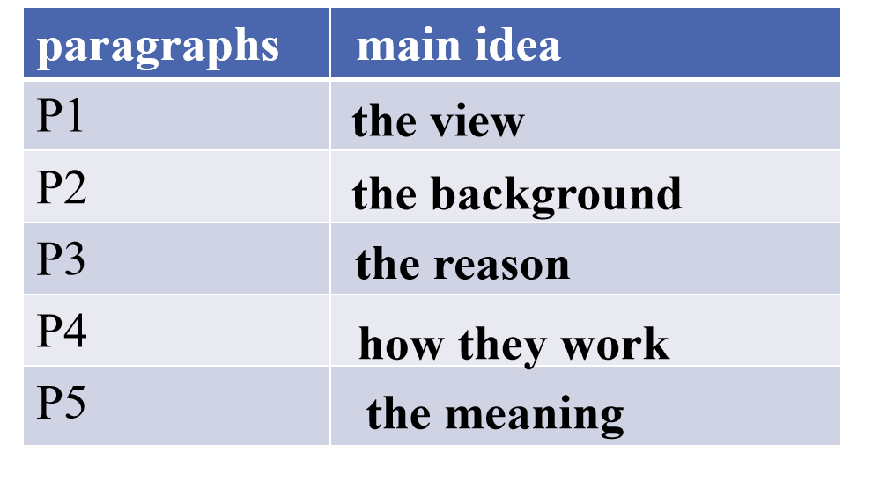
教 学
反 思

