Book 2 U1 FOOD FOR THOUGHT
A child of Two cuisines
Learning Objectives(学习目标):
By the end of this lesson, you will be able to:
1.get the meaning of the title and the main idea of the passage and introduce the food you like and share it with the people you would like to share.
2.find out the key words that express the characters' views on food and sort out the details.
3.get a positive attitude towards different food from different countries and grasp some useful expressions.
Learning Procedures(学习过程)：
- Lead-in
2. Pre-reading
Step 1 Prediction
Look at the pictures and the title on page 2, answer the following questions and predict the main idea of this passage.
Do you have any questions about the title?
——Who is the child?
——What are the two cuisines?
——Why is she or he “a child of two cuisines”?
3. While-reading
Step 1 Read for detailed information
1. Choose the main idea of the passage
1 How the family stays healthy by eating Chinese food.
2 What the family has done to promote Chinese food.
3 How the family cooks both Chinese and English food.
4 How the family combines food from two cultures.

2. What type of writing is this passage?
A .Argumentation(议论文) B.Exposition(说明文) C.Narration（记叙文）
Step 2 Read for detailed information
1. Read paragraph 1 carefully and finish the family map.
A mother A father

A son
Chinese food English food
2.The author says “I’ve enjoyed food from both countries”, and what will be talked about in the following paragraphs to prove his idea?
________________________________________________________________________________________
3. (1) Read para. 2-3 carefully and find some details about their opinions on Chinese food.
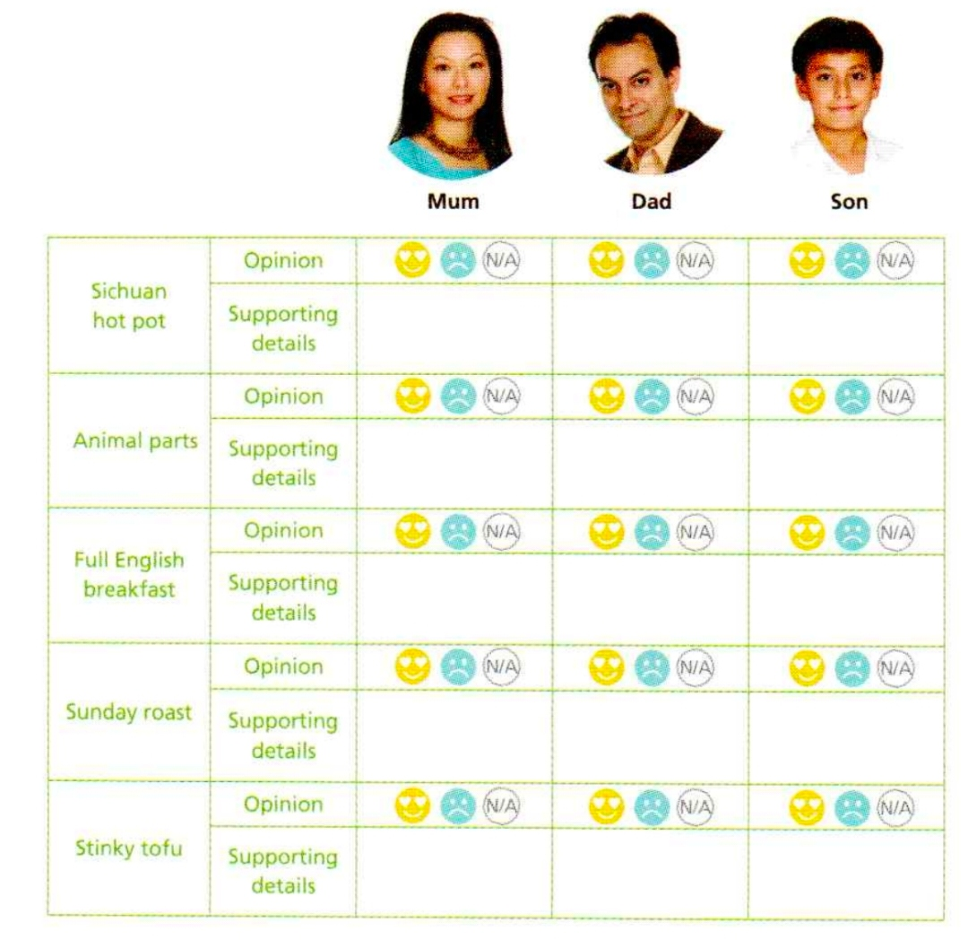
(2) Q: In paragraph 3, why does the author mention the butcher’s story?
__________________________________________________________________________________
4. (1) Read para. 4 carefully and find some details about their opinions on British food.

(2) In paragraph 4, why does the author mention the sentence “Mum says we’d better not eat too much roast food as it may make us suffer from heat inside our bodies, according to traditional Chinese medicine”?

_____________________________________________________________________________________
5. (1)Read para. 5 carefully and find some details about their opinions on stinky tofu.

(2) Read para. 5 carefully and draw a line to show the author’s changing feelings towards stinky tofu.
Feeling

maybe/someday

came across stinky tofu

gathered all my courage to take a bite

(3) Q: What can we learn from the author when we are faced with unacceptable food?

6. (1) Read para. 6 carefully and figure out What does the sentence “one man’s meat is another man’s poison” mean?
__________
(2) What is the author's attitude towards the two cuisines?
_______________________________________________________________________________
4. Post-reading
Step 1 Discussion (Group work)
Q: 1. What causes the differences in cuisines?
_______
________
Q: 2. What attitude should we take towards different culinary cultures(烹饪文化)?
_______________________________________________________________________________
_______________________________________________________________________________
5. Read for language
1.What expressions does the author use to describe food and people’s feelings towards
food?
Feelings(like)
Food
Feelings(dislike)

2. Phrases:
1. 长大vi______________ 2. 幸亏_______________
3. 喜欢_________________ 4. 去肉店______________
5. 最好(不)干…_______________ 6. 受…之苦_____________
7. 根据________________ 8. 鼓励某人干…______________
9. 去…的参观______________ 10. 处理_______________
11. 遇到 ____________________ 12. 鼓起勇气干…_______________
13. 提醒某人…____________ 14. 爱上___________________
15. 感觉舒适______________
Practice:
- __________/___________(长大) in Zibo, I _________________(爱上了)the beautiful place which is well-known _________its delicious barbecue.
- What the teacher said that day reminds me _________ my dream and encourages me ________(go)all out to achieve it.
- You ______________(最好不要) go to the butcher’s ______I was once cheated.
- The first time I came ______him, he was dealing ______ a case for a school ________ (belong) to a local company.
6. Homework
假如你是李华，你的外国朋友Tom下周将来拜访中国，希望你给他推荐你最喜欢的中国美食。
1.对他的到来表示欢迎
2.从色、香、味等方面描写你最喜欢的食物
3.推荐理由

Dear Tom,

