四川省仪陇中学校教学设计表
备课时间：2025.2.11
年 级 |  | 高2024 级 |  | 学 科 |  | 英语
课题名称 |  | Book1 Unit3  Understanding ideas—A Game for the World |  | 课 型 |  | Reading
设 计 者 |  | 胡思雨，刘微薇，王纺 |  | 课 时 |  | 第 1 课时
育 人  目 标 |  | Know the benefits of sports and some basic facts about football and and get detailed information of the text, and apply what they have learned this lesson to describe a popular Chinese sport and express their ideas and how to collaborate in team competition.
学 习  目 标 |  | ①Students are able to experience the popularity of football, become more proficient in using reading strategies, and have a clear understanding of the structure of the article.
 |  | ②Students also learn how to use this structure to express their ideas and how to collaborate in team competition.
学 习  重 点 |  | Lead the students to figure out the structure of the text |  | 学 习  难 点 |  | Analyse the author’s writing purpose and appreciate the language .
核 心  问 题 |  | Analyse the author’s writing purpose and appreciate the language .
课 时  目 标 |  | ①Know the benefits of sports and some basic facts about football and and get detailed information of the text. And summarize the main idea of the text and figure out the structure of this text.
 |  | ②Analyse the author’s writing purpose and appreciate the language .
 |  | ③Apply what they have learned this lesson to describe a popular Chinese sport and admire the spirit of sports.
教学过程
 | 学习内容 |  | 教师活动 |  | 学生活动 |  | 设计意图
任务一 | Lead-in |  | 1.Have a free chat,what does the title “on the move”mean?  2.To play the video and divide the students several groups. |  | 1.Watch the video and answer the following questions  1). What sports are mentioned in the video?  2). Which one do you like best and what benefits can you get from doing it? |  | To activate the background information about football.
任务二 | Fast-reading |  | Give some reading tips, and ask Ss to finish some questions. |  | - Read the passage quickly and choose the author's purpose of writing the passage.  - Choose the right structure of this passage. |  | - To know the writing purpose of the text.  - To improve the ability to get the main idea of the text.
任务三 | Careful-reading |  | Give some reading tips, and ask Ss to finish some questions. |  | Work in groups to find the answers of the following questions:  1. What is the history of football?  2. What is special about cuju in ancient China?  3. What is the basis of the popularity of football? |  | To practise getting the detailed information skills and cooperate with others.
任务四 | Post-reading |  | Idea sharing:  - What kind of sport is popular in China? Please use the same structure to introduce it.  - Summary: Team cooperation  - Spend 3 minutes having the students create a team poem belonging to our class, which elevates the classroom content. |  | - Fulfill the table.  - Summarize.  - Finish a poem. |  | - Integrate the use of language for self-expression.  - Summarize this lesson from the perspectives of knowledge, abilities, and values.  - Raise their awareness of sports and strengthen their confidence in traditional Chinese culture.
作 业  设 计 |  | Homework：  1.Read the additional reading material about cuju.  2.Write a passage about a sport in China according to your structure.(pay attention to the conjunctions)
板 书  设 计 |  | 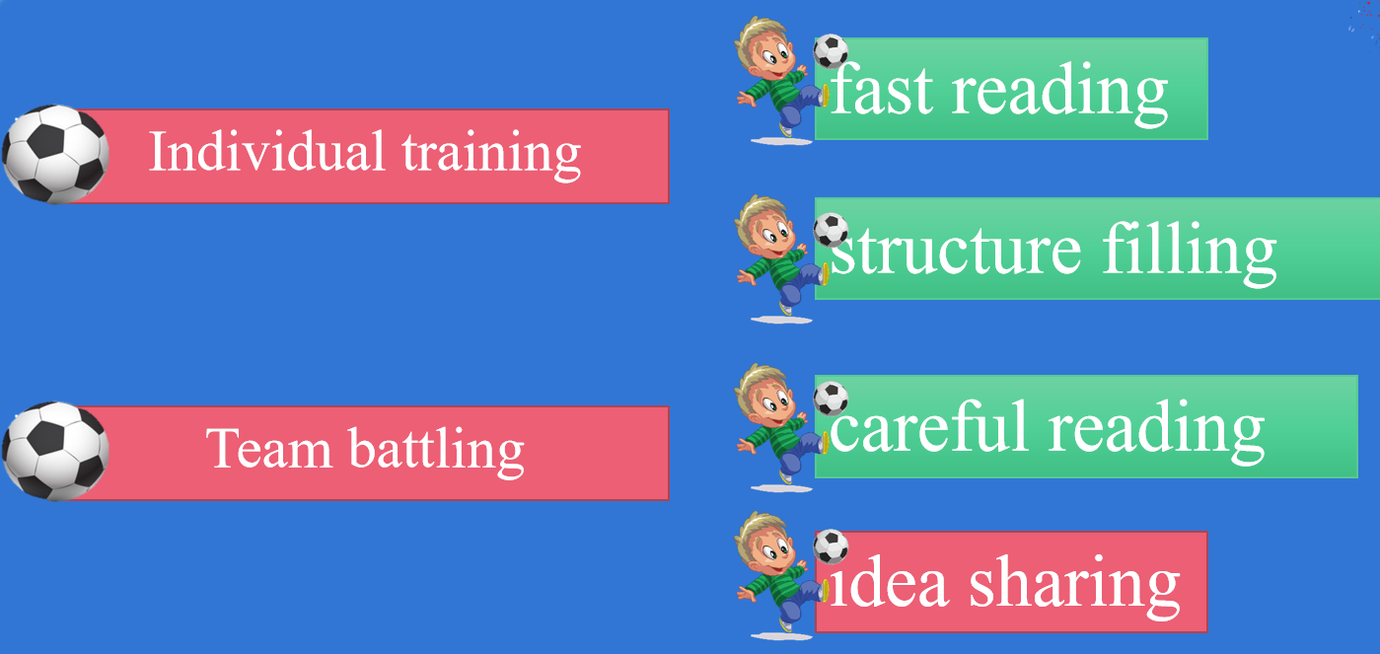
教 学  反 思 |  | After class, there was also a teaching reflection. This lesson was relatively complete, and the teaching objectives were basically completed. However, due to the fact that students have just learned this article and react very quickly during the reading process, the speed of the first half of the class is accelerated, but it is a blessing in disguise. This also allows more students to have time to present their viewpoints.Through these two days of competition, I have learned a lot. Thank you very much for your criticism and suggestions.

