
Students’ Card
Learning adjectives:
By the end of this lesson, you will be able to:
1. know more about football and experience its popularity
2. train you reading strategies:fast reading, careful reading and structure analyzing
3. use the structure you learned to express your own idea
4. highlight the importance of team cooperation
<Before class>（课前预习）
1. Find the meaning and pronunciation of the following words in your dictionary.
popular | kick | popularity | creativity
recognize | professional | score | defend
conflict | assure
2. What do you know about football?

<Cooperated exploring>（合作探究）
Fast reading (individual activity)
1. Choose the author’s purpose in writing the passage.
A. To talk about the history of football.
B. To express his or her love of football.
C. To explain why football is such a popular game.
D. To prove that he or she is a professional football fan.

2. Circle the right structure of this passage


Structure filling (individual activity)
Football enjoys popularity all over the world and it has a history that goes back to_______________.
Football is much more than a sport.
Reason 3
It breaks down walls and________
Example
British and German soldiers put down their guns and________ on Christmas Day 1914
Reason 2
It is a game with________.
Example
It is amazing to see how professional players use their bodies to_________.
Reason 1
It is________.
Example
The young Pele played football to his heart’s content with_________.

Careful reading (group activity)
Work in groups to find the answers of the following questions.
1. What is the history of football?
2. What is special about cuju in ancient China?
3. What is the basis of the popularity of football?

Idea sharing (group activity)
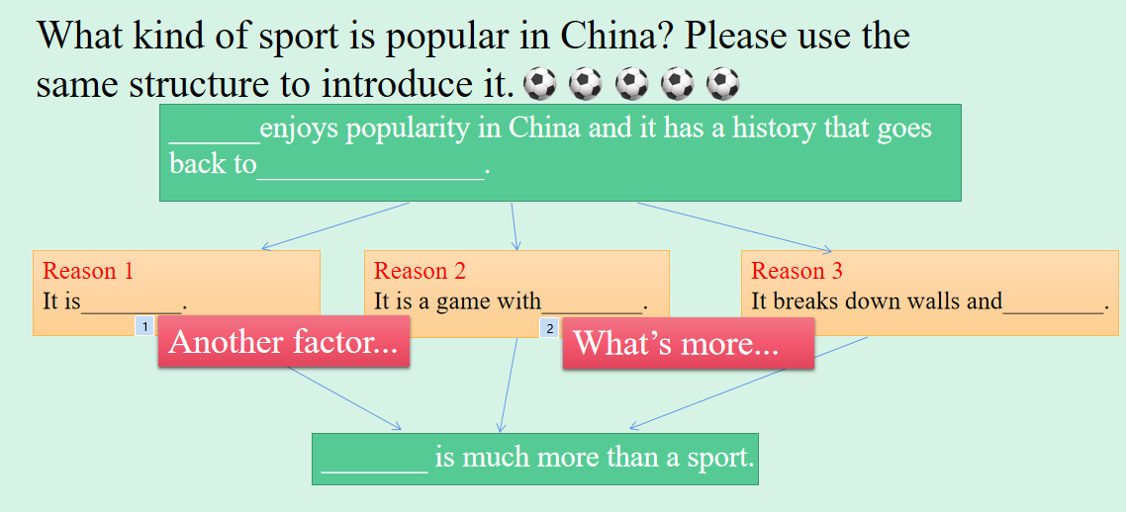
Let’s finish the poem together!
We are class ___________, we are_________
We fight for our Team
We fight for our Dr________
We fight for our success of ice-cr________
We are class__________, we are___________
We are always on the move!

