B2U5-Understanding ideas作业设计-
I have sometimes given money to beggars. ___36___ Please let me explain why.
First, for every dollar that we give to a beggar, the more profitable we make begging and, comparatively, the less profitable we make working. This is bad, for we want people to work, not beg. Working is productive while begging is at best neutral and often a burden. Second, the beggar who receives the money might spend it on alcohol or drugs 37__
When I wentto elementary school, I remember that I was very moved by a song named "Streets of London". The song tells a heartbreaking story about some of London's poorest, an old man in particular. Not long ago, however, when I heard the song on the radio, it struck me that the man in the song does not live that horrible a life after all. Judging from the lyrics of the song, the man has shoes, and occasional access to a newspaper 38 So why should you give money to the
beggar in the developed world instead of the starving child in Africa?
It might be harsh to claim that it is immoral to give money to Western beggars. After all, it seems reasonable that you can spend the money as you like. 39_ If our aim is to benefit
ourselves, then giving money to beggars is not suitable. If our aim is to benefit others, then giving money to beggars is also wasteful.
In seeking to help others, we should not merely give to those who are geographically close to
us and whose appearance arouses our sympathy 40_ To achieve this, we should first decide
how much we are willing to spend helping others, and then donate money to the most efficient charity.
- Many people die of hunger in Africa.
- True as it might be, we should spend our money wisely.
- Why not donate money to those in need of financial aid?
- Upon reflection, however, I have come to change my mind.
- You almost certainly spend money helping the wrong people.
- In a world where thousands die of hunger every day, that's a pretty comfortable life.
- Rather, we should aid those who are the least responsible for the situation they're in.

完形填空：
James’s New Bicycle

James shook his money box again. Nothing! He carefully __41__ the coins that lay on the bed.
$24.52 was all that he had. The bicycle he wanted was at least $90! __42__ on earth was he going to get the __43__ of the money?
He knew that his friends all had bicycles. It was __44__ to hang around with people when you were the only one without wheels. He thought about what he could do. There was no __45__ asking his parents, for he knew they had no money to __46__.
There was only one way to get money, and that was to __47__ it. He would have to find a job.
__48__ who would hire him and what could he do? He decided to ask Mr. Clay for advice, who usually had __49__ on most things.
“Well, you can start right here,” said Mr. Clay. “My windows need cleaning and my car needs
washing.”
Thatwas the __50__ of James’s odd-job（零工） business. For three months he workedevery day after finishing his homework. He was amazed by the __51__ of jobs that people found for him to do. He took dogs and babies for walks, cleared out cupboards, and mended books. He lost count of the __52__ of cars he washed and windows he cleaned, but the __53__ increased and he knew that he would soon have __54__ for the bicycle he longed for.
The day __55__ came when James counted his money and found $94.32. He __56__ no time and wentdown to the shop to pick up the bicycle he wanted. He rode __57__ home, looking forward to showing his new bicycle to his friends. It had been hard __58__ for the money, but James knew
that he valued his bicycle far more __59__ he had bought it with his own money. He had
__60__what he thought was impossible, and that was worth even more than the bicycle.
41. A. cleaned B. covered C. counted D. checked

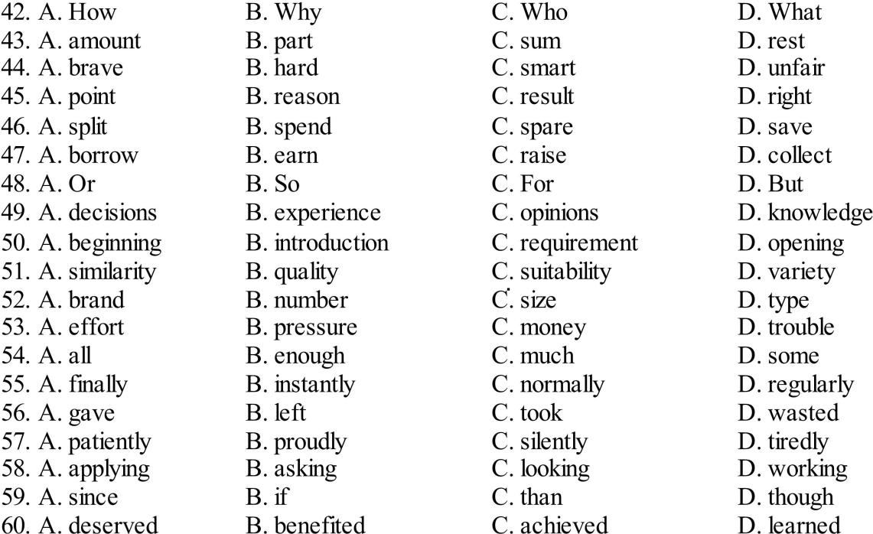

练习答案

36. D 37. E 38. F 39. B 40. G

41-60 CADBA CBDCA DBCBA DBDAC

