Unit 5 On the road
Understanding ideas 导学单
课前导学:
Learning Objectives:
- Make sense of the main idea of the passage and give a brief introduction about Lauren Bath.
- Understand the effect that her photos have on people.
Useful Expressions(核心知识)：
- post pictures 发布
- on my blog在我的博客上
- over 200,000 people reading my blog看了我的博客超过20万人
- regard it as a hobby把这件事当作爱好
- pay me to take photos付费请我拍照
- be determined to make my dream come true 决定实现自己的梦想
- a professional photo blogger职业博主
- three weeks out of/in every month 每个月三周时间
- fans following me关注我的粉丝
- your connection to Western Australia 你与西澳大利亚州的渊源
- make work trips开始工作旅行
- in particular尤其是
- unique and untouched view（独一无二的原生态景观）
- bright light and amazing colours明亮的光线和绚丽的色彩
- work full time 全职工作
- admire the natural world感受大自然
- force myself into the natural world 拼命让自己融入自然
- make an impact on people影响他人
- make a comment about评论
- become familiar with熟悉
- make her a danger to the people nearby 会成为附近居民的威胁
- make others aware of…让别人意识到
- be part of the solution一定程度上促进问题的解决

课中引学
Starting out
Watch the video and answer the questions:
1.What are the top five tourists destinations and why?
2.Which country do you want to visit most? Why?
Free talk:
Q:1. When we can’t travel by ourselves, what can we do to have a look at the views around the world?
2.Do you have a favorite travel blogger or v-logger?

________________________________________________________________________________________________________________________________________________________________________________________________________________________________________________________________________________________________________
While reading
Activity 1. Fast-reading
1.Read an interview with a travel blogger and write the questions on the lines.
a. What do you love most about Western Australia?
b. What is your connection to Western Australia?
c. Who are you and what do you do?
d. Does your photography support environmental protection?
e. How does your love of nature influence your photography?
Activity 2. Choose the best description of the interview with Lauren Bath.
1. Why Lauren Bath quit her job as a chef and chose a different profession.
2. Where Lauren Bath loves to travel and how she helps protect the environment.
3. How Lauren Bath turned her hobby into a career and her story of being a blogger.
Activity 3. Complete the blogger profile with words and expressions from the passage.

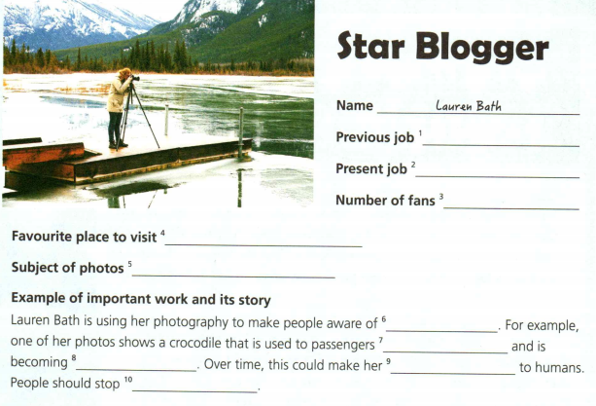

小组研学
Activity 6. Think and share.
Is travel blogger/vlogger your dream job?
If so, how would you like to influence people with your blogs/vlogs?
If not, would you like to do other jobs that involve travel?
____________________________________________________________________________________________________________________________________________________
Homework: If you have a pen friend .Can you introduce your hometown to him ? It should include :Introduce its beautiful scenery;Introduce the local customs and traditions;

