新外研版高中英语必修二 Book 2 Unit 6
Understanding ideas 学案
While-reading
Task 1: Read the passage and find out how sharks are described in the film Jaws.
(P62 2)
Task 2Read the passage and decide the following statements true(T) or false(F).
1. The film Jaws made people frightened of sharks, which led to fishing for sharks, killing as many as they could.
2. After finning, the sharks are thrown back into the sea where they die quickly.
3. The book the film Jaws was based on was wrong about sharks.
4. A lot of people are killed by sharks every year.
Task 3: Quickly go through the passage. Match the main ideas with each paragraph.
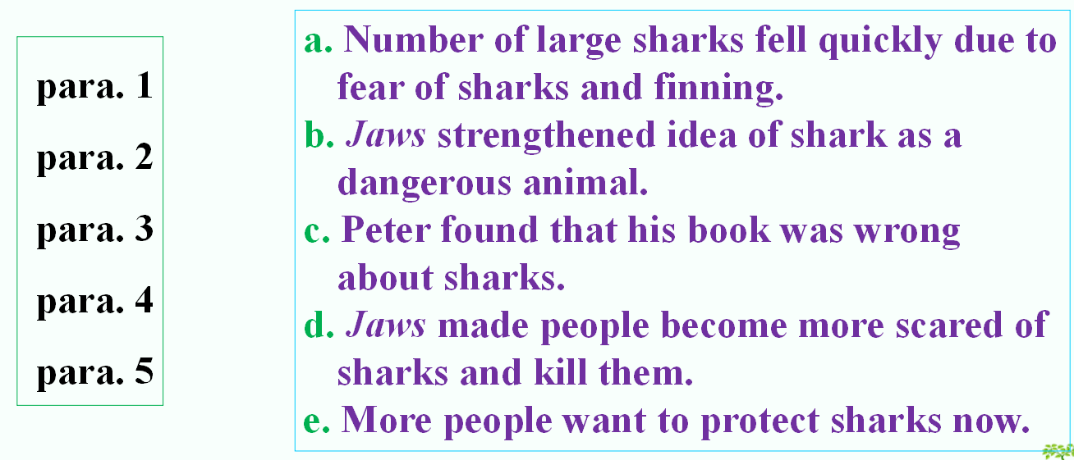

Task 4: Complete the chart showing how attitudes towards sharks have changed with words and expressions from the passage.
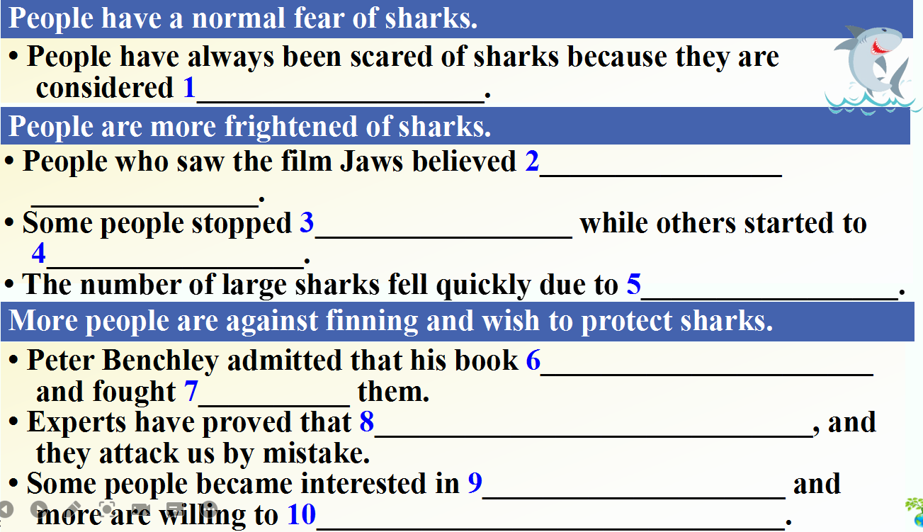
Task 5: Choose the author's purpose in writing the passage.
1. To criticise Peter Benchley's misleading description of sharks in his book and advocate the protection of sharks.
2. To explain people's misunderstanding of sharks and raise awareness of shark protection.
3. To inform people about sharks and recommend the film and the book to them.
Think and share
How do you think Peter Benchley felt after diving in 1980?

After-reading
- Look through the passage again and try to get its structure.
- Sentence analyzing for better understanding
Discussion
What can people do to protect endangered sharks?
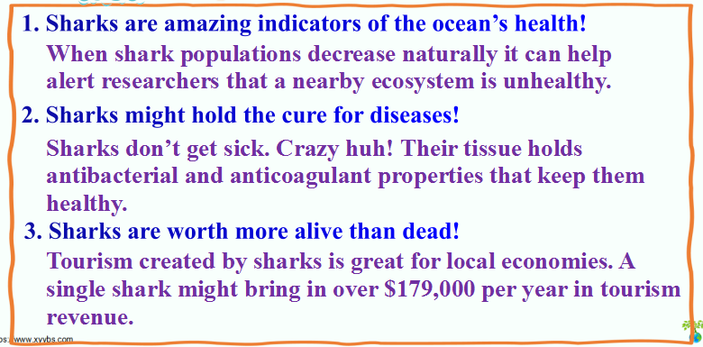
Quiz
- Match the words with their definitions.
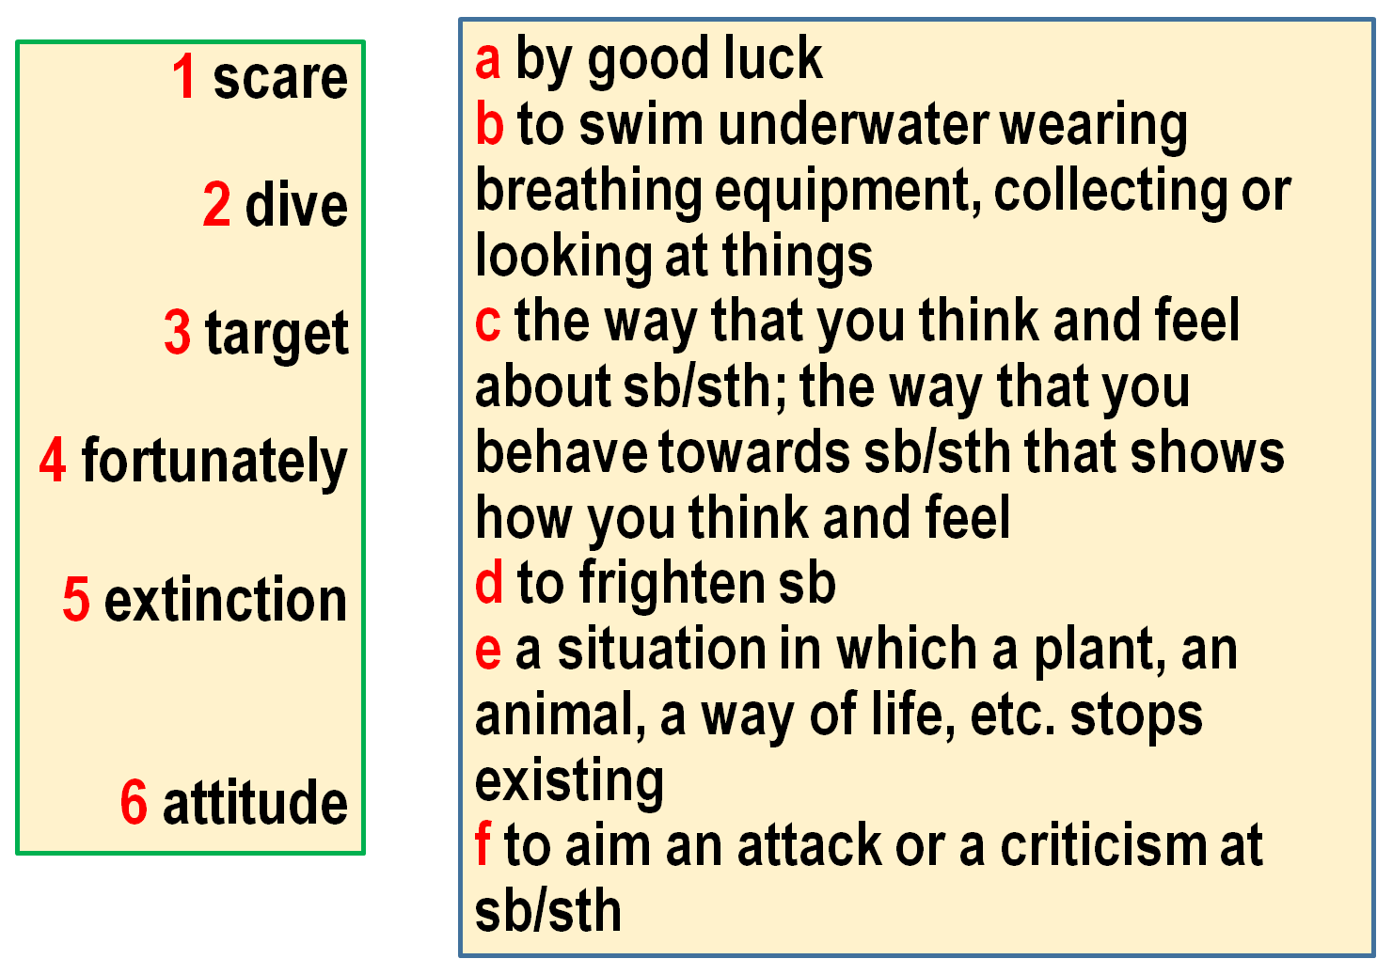
II. Complete the sentences with the correct form of the words or phrase.
due to target extinction attitude fortunately
1. ___________ they have an excellent teacher.
2. If you ________a particular group of people, you try to appeal to(吸引) those people or affect them.
3. They are in danger of __________. So we have to save them.
4. I never return the product or refund(退款) _______ product quality.
5. If you want to pass your exams you'd better change your _________!
III. Fill in the blanks with the correct form of the words.
Have you ever seen the film Jaws? It tells the story of a great white shark ___________ attacks and kills swimmers. It makes people more ________ (scare) of sharks. After 1975, the number of large sharks around America fell quickly, and soon fell around the world. This was not only ______ fear of sharks, but also finning. Finning is a type of fishing in which sharks ___________(catch) and their fins are cut off. The sharks are thrown back into the sea where they die slowly and painfully. The fins are used in shark fin soup. Finning kills millions of sharks a year.
In 1980, Peter Benchley, the ________of the book the film Jaws was based on, was shocked _______ (see) the sea floor was covered with dead sharks. Benchley saw sharks __________(kill) and this caused a deep change in him. He came to see people as a danger to sharks. He ________ (admit) that his book was wrong about sharks’ behaviour. He told people that sharks didn’t target humans. He called on people to protect sharks.
__________(fortunate), more people than ever want to protect sharks from __________ (extinct) because sharks are part of nature.

