Unit 2 Lessons in life
Teaching design

Period 3 Developing ideas & Presenting ideas
教学设计
( Teaching material analysis)
In the reading part, the students will read an excerpt from the play The Blue Bird. The text is an abstract of the whole play that explores the essence of happiness in the symbolic. Through reading and discussion, students are expected to further understand what happiness is and different life lessons. Also,they will master how to compose a plot summary as well as how to appreciate a play better.
In the part of writing, the students will learn how to write a plot summery with the writing help. A plot summary covers the introduction of the play, describing relevant details that lead to the climax of the story, and stating the central ideas of the story as well as the conclusion.
(Teaching objectives & Core Competencies and Values for students)
1. Guide the students to learn about basic elements,including plot, setting, roles, and language of drama.
2. Lead the students to better understand the plot of the play The Blue Bird and the theme of the play.
3. Guide students to figure out the truth of happiness and develop a positive attitude towards life that it’s important not to lose oneself in a dilemma but go ahead with life goals.
4. Help the students learn how to write a plot summary and better taste a play.
(Teaching focuses)
1. To improve the students’ the appreciation of English play, including the basic elements,the structure and the theme of the Blue Bird.
2. To help the students to make sense of the symbolic meaning of the Blue Bird and life lessons taught by the passages.
3. To improve the students’ writing ability by composing a summary of a play.
(Teaching procedure)
Step 1 Before reading
Activity 1
Have students read the brief introduction to The Blue Bird and answer relevant questions.
① Share your understanding of the symbolic meaning of The Blue Bird.
② Predict where the children find The Blue Bird.

Step 2 While reading
Activity 2
Ⅰ. Read the text and complete the following questions quickly.
1. Which of the following can best describe the boys according to the text?
A. Stubborn B. Foolish
C. Caring D. Cold-hearted
2. How do the Happiness feel when they meet with Tyltyl and Mytyl?
A. Delighted B. Awkward
C. Depressed D. Annoyed
3. What are the boys doing at the Palace of Happiness?
A. They are searching for the Happiness. B. They are searching for the Blue Bird.
C. They are playing with the Blue Bird. D. They are playing with the Happiness.
И. Complete the notes with key information from the play The Blue Bird.
Table 1:
ACT IV SCEN II
Characters
Setting
Plot
The children come to the Palace of Happiness and are welcome by a troop of Happiness...

Table 2:
ACT VI SCEN II
Characters
Setting
Plot
The children return home without finding the Blue Bird...

III. Work in groups and give the reasons why you like the play The Blue Bird.

Step 3 Post reading: Learning to learn and Think & Share
1. Learning to learn: understand the basic elements of dramatic structure.
a | Acts and scenes
b | Characters in different acts and scenes
c | Settings and costumes

2. Think and share: according to the passage, share your personal opinion.
① Why can’t Tyltyl recognize any of the Happiness?
② Are there any Happiness in your home? What are they?
③ What does the author want to express by making the Blue Bird fly away at the end of the play?
④ What different life lessons can you learn from the two reading passages in this unit?
Step 4 Practise performing the play
1. Read the play again and make clear the following elements of the play
Plot: | Setting:
Roles: | Language:
2. Work in groups and act out the play.
Step 5 Before writing : Activity 4
1. Read the reference: Learning to learn what the summary of a play is.
2. Read the summary of The Blue Bird and answer the questions.
◎ Which paragraph introduces the main characters, setting and start of the play?
◎ What is the climax of the play?
◎ What is the theme of the play?

Step 6 Writing: Activity 5
1. Work out the structure of a summary of the play on Page 23 in Activity 5.
For example: the play Robinson Crusoe written by Daniel Defoe
Title and author of the play | ✩ Robinson Crusoe written by Daniel Defoe
Main character (s) | ✩ Robinson Crusoe, savages, a young native called Friday,  captain of a ship
Start of the play | ✩ Robinson Crusoe went sailing and his ship went under the sea.
climax | ✩ Crusoe helped the captain and returned to England.
Conclusion | ✩ Look for what’s good for you even in desperate situations and always be optimistic and enthusiastic about life.
2. Choose another play you have read and write a summary of it.
Robinson Crusoe is a novel written by the English author Daniel Defoe. ......

3. Polish each other’s summary and share your writing with the class.
Step 7 Presenting ideas
1. Look at the pictures on Page 24 and talk about what you know about one of the works.
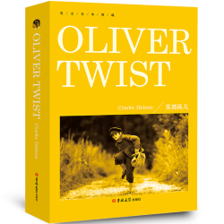 | It is one of Charles Dickens’s best known works. It was the first of author’s works to realistically describe the impoverished London underworld and to illustrate his belief that poverty leads to crime. It has been adapted for film several times.
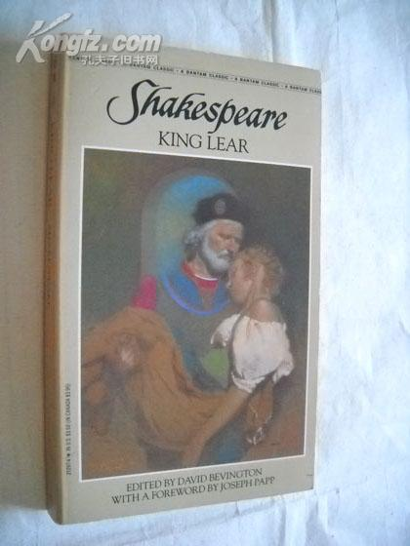 | It is one of the tragedies written by William Shakespeare. It depicts the aging King Lear decides to divide his kingdom among three daughters, allocating each a portion in preparation to her declarations of love.
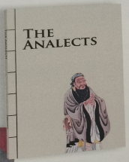 | It is a collection of sayings and ideas attributed to the Chinese philosopher Confucius and his followers. It was probably compiled by the succeeding generations of Confucius followers.
2. Think of one literary works from which you have learned life lessons.
For example: Madame Curie-- A Biography
General information | This is a biography written by Eve Curie.
Main idea | It tells readers in detail the life of Madame Curie, who was the first woman to win a Noble Prize and was the only woman to win the reward in two different fields.
Life lessons in the work | Madame Curie was a determined woman and set a good example to all the women who are eager to achieve life goals.
Step 8 Language appreciation
1. Unable to find the Blue Bird anywhere, the children say goodbye to their magical friends and return home.
[句式分析] 形容词短语 Unable to find the Blue Bird anywhere原因状语，用来说明主语的状态，语境中相当于状语从句：Because the children are unable to find the Blue Bird anywhere.
[尝试翻译] 由于到处都找不到蓝鸟，孩子们告别了他们神奇的朋友们，回到了家。

2. You will see him every time you go to the window...
[句式分析] every time 意为“每次”， 本语境中作连词，引导时间状语从句。类似的可以引导时间状语从句的还有：the first/second time(第一次/第二次); any time（任何时候）; the moment/ minute/instant=as soon as（一...就...）, 等等。
[尝试翻译] 你每次走到窗口都能看到他。

3. When writing a summary of a play, your purpose is to convey the basic ideas of the original...
[句式分析] 当状语从句的主语与主句的主语一致时，常常可以省略从句的主语，同时将从句的谓语改变为非谓语动词形式，从句的主谓构成主动关系时，常常用现在分词；若构成被动关系时，常常保留过去分词。本语境中，动词write与暗示性逻辑主语you构成主动关系，故采用现在分词writing。
[尝试翻译] 当你写一个剧本的总结时，你的目的是传达原文的基本思想......
Step 9: Homework
1. Review new words , phrases and useful expressions learned in this period.
2. Think back about how to write a summary of a play.
3. Polish your writing-- a summary of a play.

