Unit 3 The world meets China
Teaching design

Period 1 Starting out & Understanding ideas
教学设计
( Teaching material analysis)
As an introduction to a unit topic, the part “Start out” briefly introduces the history of the Silk Road, which played a vital role in promoting the communication between Chinese and foreign culture. Also, the Belt and Road Initiative further is bringing the Silk Road to life. Through watching the video and talking about relevant questions, The students are expected to understand the diversity of cultures and enhance confidence in the Chinese culture in the course of China and the world embracing each other.
In the reading part, the text presented as an English tour guide speech covers Dunhuang’s glorious history, the Dunhuang murals and the famous Library Cave as well as how it is brought to life through the Belt and Road Initiative. Through reading and thinking, students will not only better understand the theme of the text but also How Dunhuang promotes cultural exchange and enhance the pride in Chinese culture.
(Teaching objectives & Core Competencies and Values for students)
1. Lead students to think and talk about the role the Silk Road and Dunhuang played in intercultural communication by watching the video and looking at the pictures.
2. Guide students to read and understand the theme and the type of the text.
3.Guide students to discuss Dunhuang’s historical significance and influence on intercultural communication to cultivate the deep understanding and exploring the meaning of the theme.
4. Lead students to think and share his or her opinion on how the Silk Road of Dunhuang is once again a meeting place for people from around the world.
(Teaching focuses)
1. Lead the students to talk about the history and the development of Dunhuang on the old Silk Road as well as the role in cultural exchange.
2. Develop students’ reading comprehension and analyze Dunhuang’s historical significance and influence on intercultural communication.
3. Guide the students to voice his or her point of view on why Dunhuang has once again become a global crossroads.
(Teaching procedures)
Step 1 Starting out
1. Have a quiz about the ancient Silk Road.
a | The earliest dynasty it appeared | The West Han Dynasty
b | The pioneer of the Silk Road | In spite of hardships, Zhang Qian made two diplomatic trips to the Western Regions to communicate the trade relations between China, West Asia and Europe, and the silk and silk fabrics of China
c | The role of the Road | The Silk Road is an international passageway of profound historical significance. It is the first bridge connecting China and the Western world. Through this ancient road, ancient Chinese culture, Indian culture, Persian culture, Arab culture and ancient Greek and Roman culture are connected together, and the communication between the Eastern and Western civilizations is promoted.
2. Watch the video and get the key information for the answers of the questions.
① | What is the video about?
② | How did the road get its name?
③ | What is remarkable about the road?
3. Look at the pictures on Page 25 and talk about intercultural communication.
① | What can you see in the pictures?
② | What messages do these picture convey?
③ | In what other areas is China attracting attention around the world?
Step 2 Before reading
Activity 1 Look at the pictures and answer the questions about Dunhuang characteristics.
1. What makes Dunhuang unique?
2. What else do you know about Dunhuang?
Step 3 First reading
Activity 2 & Activity 3 Read the passage and answer the following question.
1. where is the passage most probably from? (Suggested answer: B)
A. A travel brochure B. A tour commentary C. A blog D. A lecture
2. Which of the following is true about Library Cave? (Suggested answer: D)
A. It is the greatest finding of the 20th century. B. It was discovered by archaeologists.
C. It is far from other caves in good condition. D. Its treasures dates from 405AD to 1002AD.
3. Why is Dunhuan the ideal place for the 2017 Silk Road International Cultural Expo?
(Suggested answer: A)
A. it meets the theme B. its location is important
C. it is prosperous as before D. it attracts visitor at home and abroad.
4. The best summary of the passage is __________________________. (Suggested answer: B)
A. The Silk Road was an ancient trade route between East and West, which passed through Dunhuang.
B. The Silk Road city of Dunhuang has a splendid history and is once again a meeting place for people from around the world.
C. In Dunhuang there are grottoes, murals and other sights that attract tourists from all over the world.
D. Dunhuang as a new place of interest is attracting visitors at home and abroad.
Step 4: Second reading Activity 4
1. Analyze the structure of the passage and summarize the main idea of each paragraph.
Parts | Paragraph(s) | The main idea of each part
Part 1 | Para 1, 2 | Dunhuang’s great history and its present-day status as a world-class tourist destination.
Part 2 | Para 3, 4,5 | Dunhuang’s tourist attractions with a long history and splendid culture such as murals and the Library Cave.
Part 3 | Para 6 | The Belt and Road Initiative is bringing Dunhuang to life once more.
2. Organize information from the passage and complete the travel web-page.
Dunhuang | Caves in Mogao Grottoes
Location: Gansu Province | The caves were carved out of the rock ³ ______________
Significance:  ▼UNESCO-protected heritage sites  ▼¹ ____________________________  ▼² ___________________________  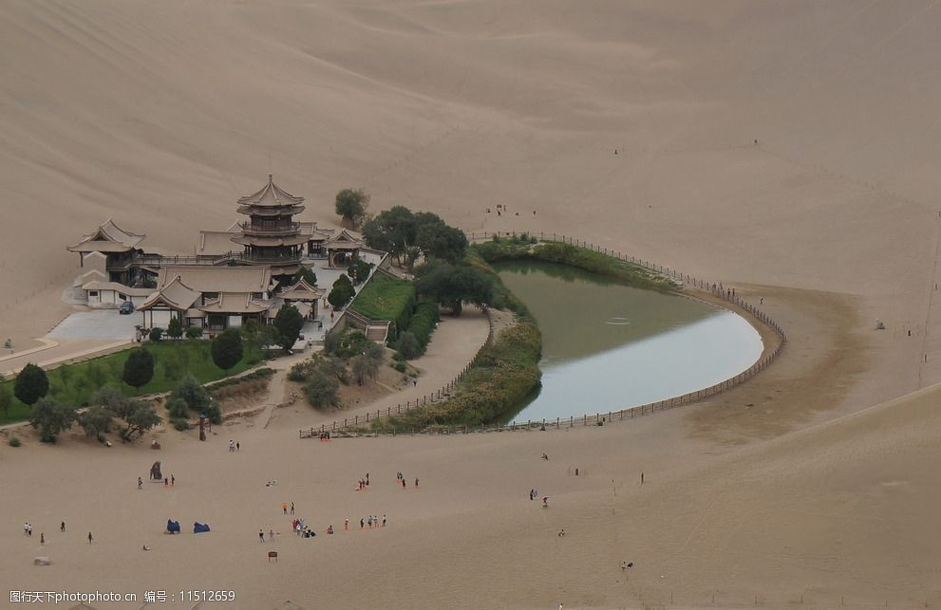 | Statues  The statues include elements from ⁴ ________________
Murals
▼Coverage: ⁵ _____________________________.
▼Topics: ⁶ ________________________________.
Apsaras
▼Also called ⁷ ________________________, they represent
⁸ ___________________________________.
▼Apsaras painted during the Tang Dynasty are a reflection of the ⁹ ________________________ during that time.
Dunhuang has once again become  ¹² ____________________________. | Library Cave  ▼Discovered inside were ¹⁰ _______________________  ▼These give us ¹¹ _______________________________

Step 5: Post- reading: Think & share
1. In what ways is present-day Dunhuang influenced by its past?
2. What would you most like to visit in Dunhuang? Why?

Step 6: Language appreciation
1. If you look up, you can see the paintings and other artworks that are testimony to how the Silk Road brought East and West together.
[句式分析] that are testimony to how the Silk Road brought East and West together 是关系代词that引导的定语从句，修饰先行词the paintings and other artworks；其中how the Silk Road brought East and West together为how 引导的宾语从句并充当介词to宾语。
[尝试翻译] 如果你抬头看，你会看到绘画和其他艺术品，它们证明了丝绸之路是如何把东西方联系在一起的。

2. In a sealed cave, now known as the famous Library Cave, were hidden thousands of manuscripts, paintings and scrolls as well as silk embroideries.
[句式分析] 本句采用一个完全倒装句，其结构为“介词短语+谓语+主语”，正常句序是“hidden thousands of manuscripts, paintings and scrolls as well as silk embroideries were in a sealed cave..... ”；其中过去分词短语now known as the famous Library Cave 作后置定语修饰说明名词短语a sealed cave;
[尝试翻译] 在一个封闭的洞穴里，现在被称为著名的图书馆洞穴，隐藏着成千上万的手稿，绘画和卷轴以及丝绸刺绣。

3. Given that the theme of the Expo was to promote cultural exchange and strengthen mutual cooperation between the countries along the Silk Road, Dunhuang was the ideal place.
[句式分析] given that-从句，given 为介词, 意为“考虑到...，鉴于...”,常常用来引导原因状语从句。
[尝试翻译] 鉴于本届世博会的主题是促进丝绸之路沿线国家之间的文化交流和加强相互合作，敦煌是一个理想的地方。

Step 7: Assignments
1. Review the basic usage of the new words and expressions learned in this period.
2. Read and listen to the passage to get more information about Dunuang and the Silk Road.
3. Writing a 60-word summary of the passage.

