四川省仪陇中学校教学设计表
备课时间： 2024.8
年 级 |  | 高20 23 级 |  | 学 科 |  |  | English
课题名称 |  | SB1 Unit1 developing ideas |  | 课 型 |  |  | Reading
设 计 者 |  | 李雪 |  | 课 时 |  |  | 第 4 课时
育 人  目 标 |  | Raise the students’ cooperative awareness and individual thinking capability in their study and life.
学 习  目 标 |  | - Lead students to read through the text quickly and find out the author’s experience and feelings .
 |  | ② Strengthen students’ reading comprehension ability by skimming, scanning and summarizing to solve reading comprehensive problems.
 |  | - Improve the student’s reading ability, especially their skimming and scanning ability.
学 习  重 点 |  | 1.Teach the students how to be successful language learners.  2.Let the students pass "Observation—Imitation—Practice "to study language.  3.Teach the students how to master dialogues and how to communicate with others. |  | 学 习  难 点 |  |  | - To develop the students’ abilities of listening, speaking and reading.  - To train the students’ ability of working in pairs.
核 心  问 题 |  | Raise the students’ cooperative awareness and individual thinking capability in their study and life.
课 时  目 标 |  | - Lead students to read through the text quickly and find out the author’s experience and feelings .
 |  | - Strengthen students’ reading comprehension ability by skimming, scanning and summarizing to solve reading comprehensive problems.
 |  | - Improve the student’s reading ability, especially their skimming and scanning ability.
教学过程
 | 学习内容 |  | 教师活动 |  | 学生活动 |  |  | 设计意图
任务一 | Step 1  Lead-in |  | 1.Teacher asks two students to read the short introductions to Mark Twain and Lin Yutang respectively and helps students clear the obstacles in reading.  2.Teacher asks students to read the short introductions and get the main ideas of them. |  | 1. Students read the short introductions to Mark Twain and Lin Yutang respectively and clear the obstacles in reading.  2.Students read the short introductions and get the main ideas of them. |  |  | To activate students’ theme-related background knowledge and prepare for the following reading activities.
任务二 | Step2  Pre-reading |  | - Teacher asks students to read the activity instruction and make sure they understand the reading task.  - Teacher asks students to read the passage to find out Mark Twain and Lin’s attitude towards humour, and refer to dictionary when necessary. |  | 1.Students read the activity instruction and make sure they understand the reading task.  2.Students read the text to find out Mark Twain and Lin’s attitude towards humour, and refer to dictionary when necessary. |  |  | - To train students to read a passage with tasks and find out the key information.  2.To skim and get the main idea of the passage.
任务三 | Step 3  While-reading |  | 1.Teacher asks students to read the passage individually, organise the information from the passage and complete the diagram.  2.Teacher asks students to check their answers and learn from each other in groups and invites some students to retell the passage. |  | - Students read  the passage individually, and complete the diagram.  2.Students check  their answers and  learn from each  other in groups.  3.Some students retell the passage and others make supplements. |  |  | To test students’ abilities to sort out the structure and specific information of a passage  and inspire Ss to get further understanding of the theme value.
任务四 | Step 4  Post-reading |  | - Teacher asks students to work in pairs to discuss the four questions.  - Teacher asks students to answer the questions and other students to make supplements . |  |  | - Students work  in groups to discuss the four questions.  - Some students  answer the questions and other students make supplements or free discussion. |  | 1.To help students further explore the topic.  2.To improve students’ critical thinking ability.
作 业  设 计 |  | - Complete the workbook.  - Preview the next part.
板 书  设 计 |  | 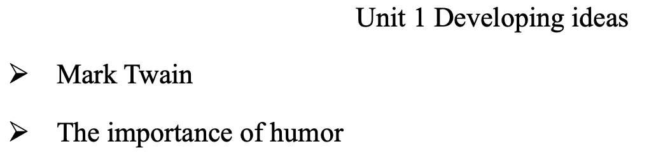
教 学
反 思

