四川省仪陇中学校教学设计表
备课时间： 2024.8
年 级 |  | 高20 23 级 |  |  | 学 科 | English
课题名称 |  | SB1 unit1 starting out& understanding ideas |  |  | 课 型 | Reading
设 计 者 |  | 李雪 |  |  | 课 时 | 第 1 课时
育 人  目 标 |  | Students can know the importance and significance of clown doctors.
学 习  目 标 |  | Students can learn about a clown doctor’s working responsibilities and working ways.
 |  | Students can have a deeper understanding on the positive attitude towards life.
 |  | Students can form a primary recognition on self-value, career value and career choice.
学 习  重 点 |  | The class will focus on:  1.leading students to learn about the clown doctor’s working responsibilities and working ways.  2.helping students to understand the meaning of clown doctor’s work and further shaping their values. |  |  | 学 习  难 点 | - developing students’ elementary recognition on career value and career choice.  - inspiring students to form a positive attitude towards pains and challenges in life.
核 心  问 题 |  | Students can know the importance and significance of clown doctors.
课 时  目 标 |  | - Students can learn about a clown doctor’s working responsibilities and working ways.
 |  | - Students can have a deeper understanding on the positive attitude towards life.
 |  | - Students can form a primary recognition on self-value, career value and career choice.
教学过程
 | 学习内容 |  | 教师活动 | 学生活动 |  |  | 设计意图
任务一 | Lead-in |  | Can you think of anything you know about a clown? | - Students think about the questions  - Students raise their hands to share their ideas. |  |  | To activate students’ previous knowledge of a clown and arouse their interest on the class.
任务二 | Setp1  Pre-reading |  | - Look at the picture and describe what you see.  - Based on the picture and the title, try to predict what the author believes is the most useful drug. | 1. Describe what they see from the picture.  2. Volunteer to share their idea.  3. Guess what is best medicine |  |  | 1.Train students’ predicting ability based on a picture and a title.  2.Light students’ interest on learning the passage.
任务三 | Step 2  While-reading |  | Activity 1  Read the passage and complete the clown doctor’s profile.  Activity 2  Why does the author choose to be a clown doctor?  Activity3  (Group work)  How do Lara’s feelings change? How about her parents’? Complete the chart.  Activity 4  - How does the author feel after a day’s work?  - Why? | - Read the passage quickly with the required information in mind.  - Share their answers and pay attention to the teacher’s feedback.  Start to locate the relevant paragraph and understand the reasons.  Use their own words or the original sentences to answer the question.  Cooperate with group members to complete the chart and share their views. |  |  | - To train students’ reading skill of find relevant information.  To let students be clear about the responsibilities of a clown doctor.  To encourage students to find out the reasons why the author decided to be a clown doctor.  To hint students that a person’s career choice is related with their experience and care for others.  To guide students to perceive the reasons why the clown doctor’s work is meaningful and why laughter is the best medicine.
任务四 | Step3  Post-reading |  | (Individual work )  Homework  Doctor Larry is invited to make a speech for Chinese students, introducing his daily work as a clown doctor. Please help him complete his presentation based on the given structure chart. | Read the specific paragraph and find out how the clown doctor feel after a day’s work and complete the writing task.  Read several times to correct mistakes like spellings. |  |  | To inspire students to think about the fact that laughter is contagious and helping others can make ourselves happy too.  Further understand the roles and significance of a clown doctor.
作 业  设 计 |  | - Complete the workbook.  - Preview the next part.
板 书  设 计 |  | 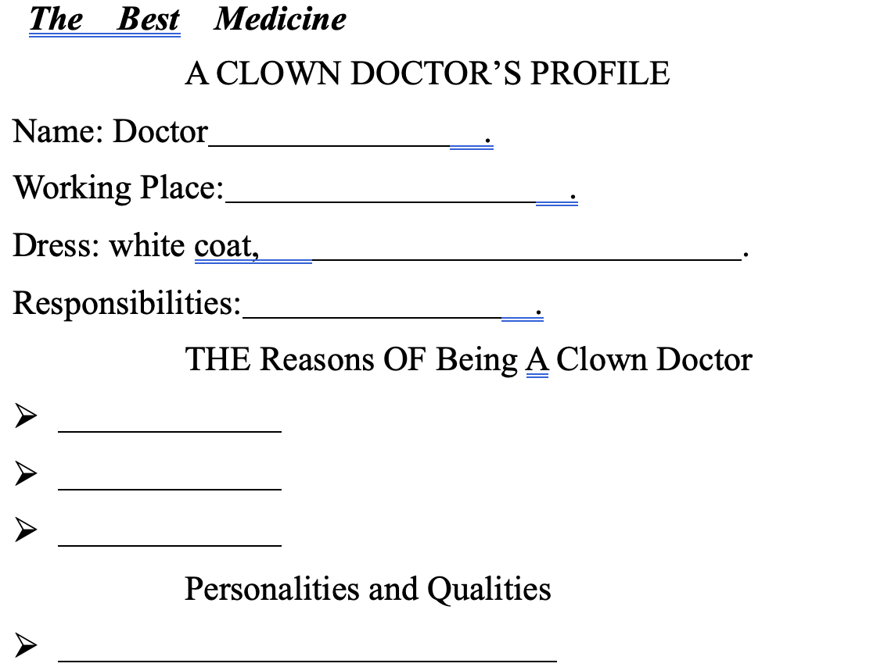
教 学
反 思

