四川省仪陇中学校教学设计表
备课时间： 2024.8
年 级 |  | 高20 23 级 |  | 学 科 |  | English
课题名称 |  | SB1 Unit1 using language |  | 课 型 |  | Grammar
设 计 者 |  | 李雪 |  | 课 时 |  | 第 2 课时
育 人  目 标 |  | Guide students to pay attention to pragmatic functions, learn to tell humorous stories and make comments in English, and be able to apply the relevant expressions learned in real life.
学 习  目 标 |  | - Understand the similarities and differences between restrictive attributive clauses and non-restrictive attributive clauses, and learn to correctly use non-restrictive attributive clauses in text writing.
 |  | - Learn and use English idioms to express "laughter", find more similar English idioms, and understand the meaning of these English idioms.
 |  | - Guide students to think about how to maintain a healthy and optimistic attitude in difficult situations, so that they always have a positive attitude.
学 习  重 点 |  | 1. Guide students to further understand the similarities and differences between restrictive attributive clauses and non-restrictive attributive clauses, and master the usage of non-restrictive attributive clauses;  2. Guide students to learn to use more English idioms to express a variety of simple "laughter". |  | 学 习  难 点 |  | 1. Guide students to correctly use non-restrictive attributive clauses in text writing, and learn to tell humorous stories and make comments in English;  2. Guide students to think about how to maintain a healthy and optimistic attitude in difficult situations, so that they always have a positive attitude.
核 心  问 题 |  | Guide students to pay attention to pragmatic functions, learn to tell humorous stories and make comments in English, and be able to apply the relevant expressions learned in real life.
课 时  目 标 |  | - Understand the similarities and differences between restrictive attributive clauses and non-restrictive attributive clauses, and learn to correctly use non-restrictive attributive clauses in text writing.
 |  | - Learn and use English idioms to express "laughter", find more similar English idioms, and understand the meaning of these English idioms.
 |  | - Guide students to think about how to maintain a healthy and optimistic attitude in difficult situations, so that they always have a positive attitude.
教学过程
 | 学习内容 |  | 教师活动 |  | 学生活动 |  | 设计意图
任务一 | Step 1  Lead-in |  | 1.Teacher asks students to read the sentences in the first box and pay attention to the words in bold.  2.Teacher asks students to conclude the usage and pay attention to the differences of defining and non-defining attributive clauses. |  | 1.Students read and compare the example sentences again to answer questions and conclude the uses and the similarities and differences of defining and non-defining attributive clauses. |  | 1.To encourage students to discover the grammar usage by themselves.  2.To further enhance students’ understanding of the non-defining attributive clauses.
任务二 | Step 2  Know the rules |  | Teacher asks students to read the two simple sentences given in each advice and decide which sentence should be the main clause and which one should be the subordinate clause. |  | Students read the two simple sentences given in each advice and decide which sentence should be the main clause and which one should be the subordinate clause. |  | To get students to practise using non-defining attributive clause.  To enable students to rewrite the tips with non-defining attributive clauses.
任务三 | Step 3  Complete exercises |  | Teacher asks students to find out the relationship between the modified nouns or sentences and the conjunctions of clauses and teacher asks students to rewrite the tips with non-defining attributive clauses. |  | - Some students read the clauses they made and others check the answers.  Students conclude how to make sentences using non-defining attributive clauses. |  | To get students to practise using non-defining attributive clause.  To have students pay attention to the pragmatic function.
任务四 | Step 4  Work in groups |  | - Teacher asks students to work in groups and think of a joke they find funny and write it down using non-defining attributive clauses where appropriate.  - Teacher asks some students to share their jokes in front of the class. Teacher makes comments. |  | - Students think of a joke they find funny and write it down using non-defining attributive clauses where appropriate.  - Some students share their jokes in front of the class. |  | To enlarge students’ vocabulary and have them form an optimistic outlook on life.  To help students learn from each other.
作 业  设 计 |  | - Complete the workbook.  - Preview the next part.
板 书  设 计 |  | 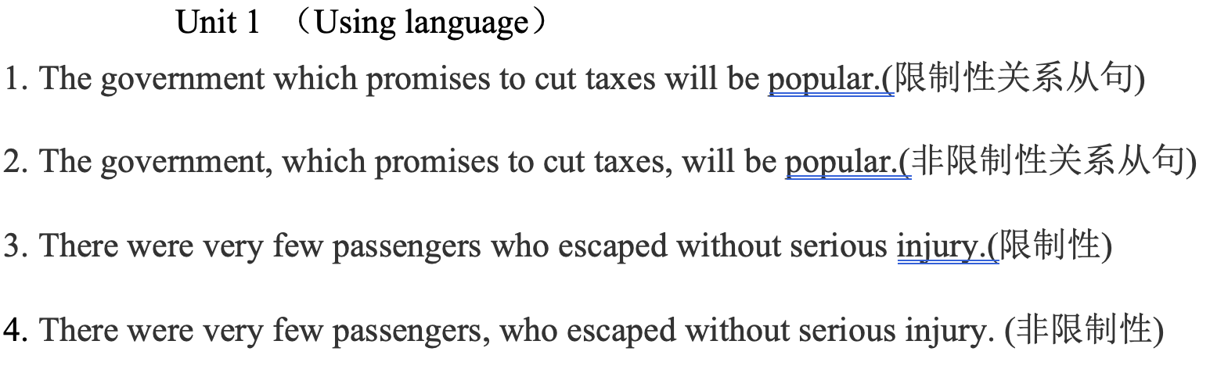
教 学
反 思

