四川省仪陇中学校教学设计表
备课时间： 2024年8月
年 级 |  | 高20 23 级 |  | 学 科 |  | 英语
课题名称 |  | XB1U3 Using language |  | 课 型 |  | 语法课
设 计 者 |  | 席俭朴 |  | 课 时 |  | 第 3 课时
育 人  目 标 |  | 1. summarise the use of -ing as subject  2. practice the use of –ing as subject by doing some exercises
学 习  目 标 |  | ①To summarise the use of -ing as subject
 |  | ②To practice the use of –ing as subject by doing some exercises
学 习  重 点 |  | Students can use the -ing as subjects correctly. |  | 学 习  难 点 |  | Students can use the -ing as subjects and practice fluently.
核 心  问 题 |  | Students can use the -ing as subjects correctly.
课 时  目 标 |  | Students practice the use of –ing as subject by doing some exercises
教学过程
 | 学习内容 |  | 教师活动 |  | 学生活动 |  | 设计意图
任务一 | Activity 1  Warming up |  | 1 What are the subjects in sentences (a) and (b)?  2 What does it refer to in sentences, C and D?  3 Why does the author choose to use sentences A and B in the reading passage? |  | Compare them with the following sentences and answer the question. |  | 复习课文，预热语法。回答问题，聚焦句型，理解意义，归纳语用
任务二 | Comparing,answering and summarizing |  | Activity 2  summarizes the use of-ing as subject |  | Now look for more sentences with -ing as subject in the reading passage and summarizes its use in your own words. |  | 实践语法巩固使用真实语境内化运用
任务三 | Completing  and speaking |  | Check Ss’answers |  | Complete the passage with the correct form of the words in the box. |  | 内化巩固迁移应用，发表观点，提升思维。
作 业  设 计 |  | Read the text again and underlying all sentences with- ing as subject.
板 书  设 计 |  | 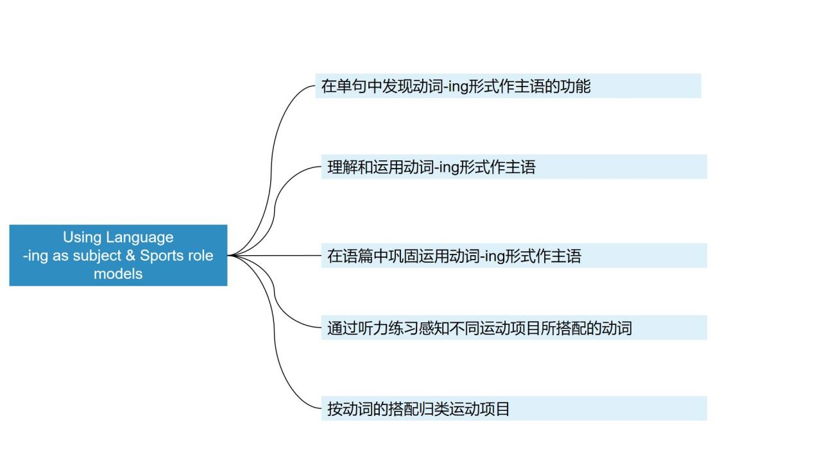
教 学  反 思 |  | 动词ing作主语很多同学都容易混淆，所以要求他们一定要背住规则。加强做动词ing的练习题，教学中要多举例子围绕主题开展活动，搭建教学步骤的台阶，让学生从不懂到懂，从朦胧到清晰，带领全体学生而不只是部分学生共同进步。在教学过程中，我一直坚持在语境中进行语法教学，而不是为了教语法而教语法。

