四川省仪陇中学校教学设计表
备课时间：2024年8月
年 级 |  | 高20 23 级 |  | 学 科 |  | 英语
课题名称 |  | SB2U2 Developing ideas:Valuable values |  | 课 型 |  | Reading
设 计 者 |  | 文海云 |  | 课 时 |  | 第 4 课时
育 人  目 标 |  | 启迪学生思考金钱方面的有效管理策略，提高学生的自控能力，塑造积极乐观的人生态度。
学 习  目 标 |  | ① get the main idea of the passage and understand the title clearly
 |  | ②acquire the detailed information of the method of 4 jars and share how you will spend money wisely.
 |  | ③ understand how money management makes a great difference to your life and develop students’ consciousness of managing money.
学 习  重 点 |  | 1. 带领学生把握文章大意，培养学生有理有据地表达观点的意识；  2. 引导学生以理性客观的态度看待金钱的价值。 |  | 学 习  难 点 |  | 引导学生学会用英语阐释自己的观点，增强逻辑思辨能力，能以理性客观的态度看待金钱的价值，培养理财意识，积极尝试从不同角度进行自我管理。
核 心  问 题 |  | 启迪学生思考金钱方面的有效管理策略，提高学生的自控能力，塑造积极乐观的人生态度。
课 时  目 标 |  | ① get the main idea of the passage and understand the title clearly
 |  | ②acquire the detailed information of the method of 4 jars and share how you will spend money wisely.
 |  | ③ understand how money management makes a great difference to your life and develop students’ consciousness of managing money.
教学过程
 | 学习内容 |  | 教师活动 |  | 学生活动 |  | 设计意图
任务一 | Activity 1 |  | 1.Teacher asks students to finish a questionnaire about money management  2. Teacher shows the results of the Questionnaire to the students and analyzes which type they belong to. |  | 1. Students choose their answers according to  their life experiences  2. Students get a general idea of which type they belong to |  | To understand their ability to manage money and lead students into the  topic of managing money.
任务二 | Activity 2 |  | 1. Teacher asks students to look at the title of the passage and understand the word play. |  | 1. Students look at the title of the passage and have a basic understanding of the title and word play. |  | To strengthen students’ ability to understand the meaning of the words.
任务三 | Activity 3 |  | 1. Teacher asks students to read the first two paragraphs and answer the following questions.  (1) Which sentence can describe this picture?  (2) Why does the author use the example of Khloe Thompson?  (3)How did Khloe Thompson make good use of her money?  2. Teacher invites some students to share the answers with the class. |  | 1. Students read the first two questions and find answers to the three questions.  2. Some students share their answers with the class. |  | To test and strengthen students’ ability  to summarize the key information
任务四 | Activity 4 |  | 1. Teacher asks students to read the third paragraph, get the key point and summarize the ways for the young to spend money wisely.  2. Teacher invites some students to give answers. the |  | 1. Students think about the questions and present their answers by summarizing key information. |  | To enhance students’ ability to summarize the key information and encourage students to show their own opinions.
任务五 | Activity 5 |  | 1. Teacher asks students to sort out the structure of the first three paragraphs. |  | Students analyze the structure under the guidance of teacher. |  | To enhance their ability to sort out the structure
任务六 | Activity 6 |  | 1.Teacher asks students to read from para 4 to para 8 and finish the exercise 3 on page 22.  2.Teacher guides students to |  | 1.Students read the following 5 paragraphs and get the detailed  information of the method of four jars.  2. Students share their answers |  | 1.To help students learn to get the detailed information as quickly as possible.  2.To help students have a good command of the method of 4 jars.
任务七 | Activity 7:Think and share |  | 1. Teacher asks students to think about which jar they believe is the most important and complete the notes.  2. Teacher asks them to discuss their ideas in groups.  3. Teacher invites several students to give their group idea to the class and others to make comments.  4. Teacher gives students some practical suggestions concerning how to make the most of the method of 4 jars |  | 1. Students discuss their ideas in groups and take notes when necessary.  2. Some students give their group ideas to the class and teacher makes comments |  | 1. To help students learn to give their opinions.  2. To improve students’ speaking skill and performance ability.
作 业  设 计 |  |  | 《课后素养评价》
板 书  设 计 |  |  | 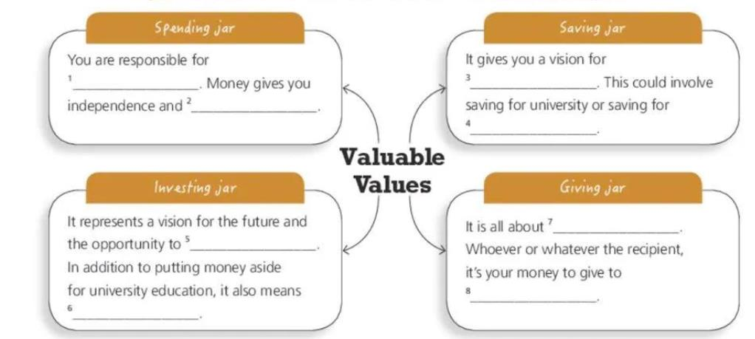
教 学
反 思

