四川省仪陇中学校教学设计表
备课时间： 2025.2.10
年 级 |  | 高20 23 级 |  | 学 科 |  | 高二英语
课题名称 |  | Unit 4 Breaking Boundaries  Developing ideas |  | 课 型 |  | Reading
设 计 者 |  | 彭灿 |  | 课 时 |  | 第 3 课时
育 人  目 标 |  | 通过对本单元主题内容的探究，理解打破边界、携手共进是全世界人民的共同的愿景，是人类历史发展的必然趋势。
学 习  目 标 |  | 根据标题和图片，预测文本主题内容，了解演讲这一文体特点及构成要素；
 |  | 运用 KWL模式，自主提问并自主阅读寻找答案，完成演讲背景信息的分析，训练学生逻辑思维；
 |  | 运用分析、对比、概括、归纳等高阶思维能力，探索《葛底斯堡演说》中的主题内容、演讲手法、演讲者特点，总结成功演讲的构成要素，训练学生评判性思维能力；
学 习  重 点 |  | 通过分析解葛底斯堡演说的内容、手法，理解该演说所传达的主题意义及历史作用，总结一个成功演讲的构成要素。 |  | 学 习  难 点 |  | 通过分析演讲内容，让学生理解演讲者在演讲中如何运用语言的力量——文学性语言、宗教语言、文学表现手法——说服听众，感染听众，统一思想，凝聚民心，站在民族生死存亡的时刻，力挽狂澜，扭转了整个国家的命运。
核 心  问 题 |  | 通过对本单元主题内容的探究，理解打破边界、携手共进是全世界人民的共同的愿景，是人类历史发展的必然趋势。
课 时  目 标 |  | 迁移运用本课《葛底斯堡演说》演讲的主题、表现手法、篇章结构，针对当今世界依然存在的种族歧视问题，仿写一篇演讲稿，发表看法，呼吁打破边界；
 |  | 运用分析、对比、概括、归纳等高阶思维能力，探索《葛底斯堡演说》中的主题内容、演讲手法、演讲者特点，总结成功演讲的构成要素，训练学生评判性思维能力；
 |  | 运用 KWL模式，自主提问并自主阅读寻找答案，完成演讲背景信息的分析，训练学生逻辑思维；
教学过程
 | 学习内容 |  | 教师活动 |  | 学生活动 |  | 设计意图
任务一 | Lead in |  | T: Are you nervous in front of the cameras? Well, don’t worry. You can totally count on me. Just relax and try your best. Feeling better now?  T: My words have greatly comfort you and give you power. This is the power of my words and my speech. OK，can you give more examples of the power of words  T:actually, in Chinese history, there are many examples of the power of words of speech, such as Zhang Yi，Zhu Zhiwu and Yan Ying. This is the power of words. |  | S:Yes, when my best friends said sorry to me, our cold war ended.  S: Yes, when my parents praised me, I got courage. When I feel down, a few words from my parents will give me great courage. |  | 通过真实场景互动，让学生真实地初步感受语言的力量，直击本课主题，顺势引出本课内容 The Words That Changed A Nation.
任务二 | Pre-appreciation —Prediction |  | 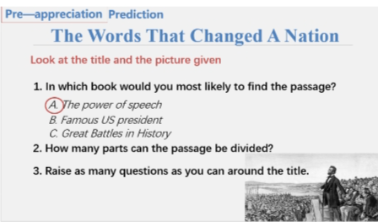 |  | appreciate a passage titled The Words that Changed A Nation. |  | 让学生根据文本标题和图片，通过预测，让学生对文本的内容、框架进行初步了解。
任务三 | While-appreciation—Background, content, and Rhetorical DevicesStep1 Analysis on the background |  | T:scan part 1 find the answers to these questions。  Q1;Whose words? (who said the words?)  Q2: When did he/she said the words? (on a grey afternoon on 19 November 1863)  Q3：Where did he/she give the words?  Gettysburg）how much do you know about it  Q4:In which situation did he/she said the words?  America was bitterly divided and in a Civil War.  Q5:Why did he said the words?  In memory of the dead.  Q6:What is the influence of the words? |  | ( 1.changed the mind of the people, 具体而言就是 gave his people hope, belief and a vision of what the United States of America should be based on the ideals set down by its founding Fathers 87years before.  2.shape a nation.具体而言就是 remove division...boundaries... finally towards the equality of humankind.)  (其余的问题都能在第一部分找到，只有 what are the words 和 how could the words change a nation.找不到,需要继续探索。) |  | 学生通过自主阅读，完成对文本中第一部分，即演讲背景信息的梳理与总结。本部分中，最后两个问题归属于第二部分——演讲，学生不能在第一部分找到，进而顺势引入分析第二部分——演讲。进行演讲语言预测，最后回应该问题，体会林肯如何通过语言的选用，达成打破界限的目的。
任务四 | Appreciation of the speech |  | 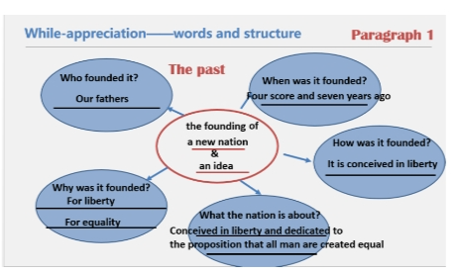 |  | 回到文章开篇的问题——林肯用了哪些具体的词汇，为什么。 |  | 通过问题链，引导学生总结出第三段大意——林肯的演讲意图，即号召投入伟大的未竟事业，了解演讲的组织结构和主题。并理解为了达成打破南北、黑白人界限，维护国家统一，林肯选用了哪些词，这些词如何在传达演讲主题、引起共鸣起作用的。
作 业  设 计 |  | 见“作业设计”
板 书  设 计 |  | Whose words?  When did he/she said the words?  Where did he/she give the words?  In what situation/context did he/she said the words?  Why said the words?  (What was the purpose of saying the words?)  What is the influence of the words?  What was the nation like before the words were said?  What was the nation like after the words were said ?
教 学
反 思

