高中英语选修第二册 Unit 6 Survival
（2024 -2025学年度上学期）
【课 题】 | Understanding ideas — The Wild Within Sky
【学习目标】 | - 通过观察图片能够提取相关信息；能掌握与话题城市动物相关的重点单词并能进行简单的交际  2. 了解野生动物在都市中的现状、原因、困境等基本信息，并能总结出段落关键词、梳理出文章结构，并在此基础上总结2-5段的段首句  3. 树立与野生动物“共享、共生”的理念，通过微视频制作呼吁市民与动物和谐共存，培养学生的社会责任感
【重点难点】 | 1. 全面掌握本课时重点单词、短语及句型  2. 归纳文章主旨大意
导 学 内 容 与 过 程
【情境导入】
Step 1: Starting out
Activity 1:Look at the pictures and answer the questions.
1. What does each picture show?
2. What difficulties would people have surviving in these situations?

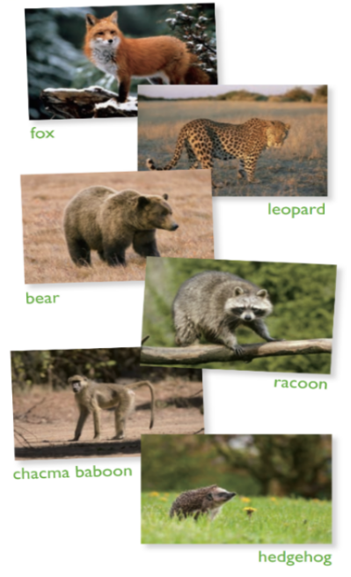
【学习新知】
（文章解构）
Step 2 Pre-reading
Activity 1: Look at the pictures and answer the questions.
1. Where would you normally expect to find these animals?
2. Would you be surprised to see these animals in a city? Why or why not?
3. What problems could they encounter in cities?

Step 3 While - reading
Activity 1: Fast - reading:
- Look at the title of the passage and the picture. Think about what the title means.
2. Choose the topic sentences for Paragraphs 2-5 and write them on the lines to complete the passage.
a For those animals that don’t adapt, the city can be a dangerous or even deadly place.
b People often wonder about the reasons behind this mass migration.
c One thing crucial to the increasing number of “urban animals” is their ability to adapt.
d Yet, for its newest and wildest inhabitants, a city can offer many benefits.

Activity 2: Careful-reading:
Organize information from the passage and complete the diagram.
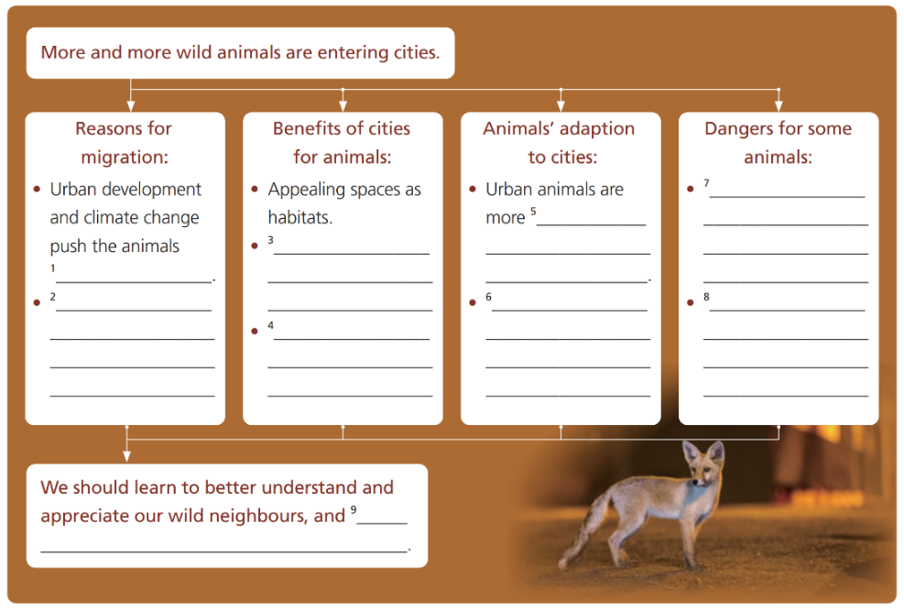
Step 4 Post-reading
Think & Share
- How would you describe the relationship between people and urban animals in the passage?
2. What figure of speech is used in the first paragraph? Why does the author choose to start the passage this way?
3. Some environmentalists argue that we should restrict urban development to leave enough natural habitats for wild animals. Do you agree with this? Give your reasons
<教材原文>
The Wild Within
The crime took place in a seaside suburb of Cape Town. Spotting the car with its window left open, the greedy thief didn't hesitate. Within seconds, he had reached inside and run away with a bag of shopping. No matter how many crimes he committed, the police were powerless to arrest him. You see, this was no ordinary criminal: it was a chacma baboon. Once almost unheard of, scenes like this one in Cape Town are now common all over the world. With foxes in London, mountain lions in San Francisco and wild pigs in Hong Kong, it is almost as if our cities are being taken over by wild animals.
_____________________________ Most of us would assume that urban development and climate change are responsible for pushing the animals out of their natural habitats. However true this is, we also need to consider that some of these so-called “urban animals” have never moved at all-it’s we humans who have moved into their territory, Wherever they go, animals find towns and cities in their way. With nowhere else to make their homes, they have no choice but to move in with us.
_____________________________ As our cities become greener, they offer increasingly appealing spaces to animals looking for new habitats. Out of reach from many of their natural predators, these newcomers often flourish in their new city lives.Today, foxes can be seen all over London - one even being found living on the 72nd floor of the Shard building when it was under construction! What’s more, hungry animals are finding plenty to eat in our gardens and in the leftovers we throw away.
_____________________________ There is evidence that urban racoons are more intelligent than their wild cousins, as they frequently have to figure out difficult problems such as how to open rubbish bins and other containers which they would not find in the wild. Some animals have even changed their living habits to fit in with their new homes. Although naturally active at night, urban foxes come out in daylight if the reward is good enough.Their city location also means that they are getting a taste for the multicultural cuisine on offer from the garbage, such as hamburgers, lamb kebabs and even garlic bread!
_____________________________ Unable to distinguish between blue sky and glass, birds crash into windows at speeds of about 50 kilometres per hour. Recent studies estimate that between 400 million and 1 billion birds die from window impacts each year in the US alone. Shockingly, these deaths amount to around ten per cent of the total US bird population. Some species are more affected than others. One theory behind this is that these birds have yet to change their migratory routes that take them through cities with high-rise buildings.
However they adapt to our ways of urban living, it’s important that we get a better understanding of and even learn to appreciate our wild neighbours. Only then can we look towards harmoniously sharing our urban habitats.Whatever the reasons behind these species entering our cities, one thing is for sure - as it’s often a means of their survival, they could be with us to stay.
（知识探究）
夯基础词汇全解
1. greedy adj. 贪婪的，贪心的
<原文重现> （教材P82) Spotting the car with its window left open, the greedy thief didn’t hesitate. 贪婪的小偷发现车窗开着的汽车，毫不犹豫。
<归纳拓展>
① be greedy for... 贪图…的；渴求…
② greedy eyes 贪婪的眼睛
③ greed n. 贪心、贪婪
You greedy pig! You’ve already had two helpings! 你这个馋嘴！你已经吃了两份了！
更经济的节能技术在发达国家已经投入使用。
He stared at the diamonds with greedy eyes. 他眼巴巴地盯着这些钻石。
<能力提升>
Ⅰ. 在空白处填入单词的正确形式。
- Not everybody is simply greedy __________ power.
- He came up from the water, __________ (greedy) breathing in air.
- 英译汉
- Nothing will ever content the greedy man.
____________________________________。
- The greedy boy ate up all the food remaining on the table.
_________________________________________________。
2. commit v. 犯（错误或罪行）；承诺；忠于（某人、机构等）；全心全意投入（工作、活动等）
<原文重现> （教材P82) No matter how many crimes he committed, the police were powerless to arrest him. 不管他犯了多少罪，警察都无权逮捕他。
<归纳拓展>
① commit a mistake/crime 犯错/犯罪
② commit sb.oneself to (doing) sth. 承诺（做）某事
③ commit to sb.sth. 忠于…
④ be committed to doing sth. 尽力做某事
⑤ committed adj. 忠诚的，坚定的
⑥ commitment n. 承诺；委托；献身
This government is committed to extending parental choice in education.
本届政府承诺扩大父母在教育方面的选择权。
She committed herself body and soul to fighting for the career. 她全心全意为这一事业而奋斗。
<能力提升>
I. 在空白处填入单词的正确形式。
1. The government must commit itself to __________ (improve) health care.
2. The most awkward email mistake __________ (commit) in anger all the time.
II. 英译汉。
1. He was seen to enter the building about the time the crime was committed.
_____________________________________________________________。
2. The government is committed to housing the refugees.
______________________________________________。
- out of reach 吸引某人的注意力
<原文重现>（教材P82) Out of reach from many of their natural predators, these newcomers often flourish in their new city lives.
在许多天敌无法触及的地方，这些新来者往往在新的城市生活中蓬勃发展。
<归纳拓展>
① out of+n 的含义与该名词含义相反；反义用法为：within reach 触手可及，在附近
② out of sight 看不见
③ out of control 失去控制
④ out of patience 失去耐心
⑤ out of breath 上气不接下气
These products are normally bought and stored carefully, out of reach of children.
这些产品一般在购买和储藏过程中都要小心，避免儿童碰触。
Be sure to keep the medicines out of reach of the children.
这些药物务必放在孩子们够不着（拿不到）的地方。
<能力提升>
Ⅰ. 在空白处填入单词的正确形式。
1. But at times it seem too difficult and too far out __________ reach.
2. The forest fire was nearly out of __________ when suddenly it rained heavily and saved the day.
II. 英译汉
1. We eventually ran out of patience with his childish behaviour.
___________________________________________________。
2. He turned to look back, but by then she was out of sight.
___________________________________________________。
4. under construction 在建设中
<原文重现> （教材P82) one even being found living on the 72nd floor of the Shard building when it was under construction! 其中一位甚至在Shard大楼施工时被发现住在72楼！
<归纳拓展>
①“under+n” 常表示正在进行的动作，而且包含被动含义，相当于进行时的被动语态。
② under repair 在修理中
③ under observation 在监视中
④ under consideration 在考虑中
⑤ under treatment 在治疗中
⑥ under discussion 在讨论中
⑦ under attack 受到攻击
The hotel currently under construction can contain more than five hundred guests.
目前在建设中的那个宾馆能容纳五百多位客人。
There is a new music hall near here under construction. 附近正在建造一座新的音乐大厅。
<能力提升>
Ⅰ. 在空白处填入单词的正确形式。
1. When a leafy plant is ________ attack, it doesn't sit quietly.
2. It is still under ________ whether the old bus station should be replaced with a modern hotel or not.
Ⅱ. 英译汉。
1. These questions and others are under consideration among the technology developers.
______________________________________________________________________。
2. The doctor decided to keep him under observation for another week.
______________________________________________________________________。

全突破句式剖析
<原文重现> （教材P83) Only then can we look towards harmoniously sharing our urban habitats.只有那时，我们才能展望与它们和谐分享城市栖息地的未来。
<归纳拓展>
当“only+状语（从句）”位于句首时，其后习惯上用部分倒装。句型： Only+状语（从句）+be/助动词/情态动词+主语+其他.
Only then did l recognize him.直到那时我才认出了他。
Only in this way can we calm the little girl down.只有这样我们才能使这个小女孩平静下来。
<能力提升>
I. 在空白处填入单词的正确形式。
1. Only with all your time and energy _________ you do the job well.
2. Only _________ he told me did I know details of his trip.
【迁移应用】
（对点训练）
在空白处填入单词的正确形式或一个适当单词。
1. The most _________ (terrify) aspect of a nuclear explosion is radiation.
2. The area has _________ (stun) scenery, beautiful beaches, and much more besides.
3. Scientists are _________ (convince) of the positive effect of laughter on physical and mental health.
4. People who live the most _________ (fulfill) lives are the ones who are always satisfied with what they have.
5. On the morning of your arrival, we will show you around our school and introduce our most _________ (advance) science lab to you. (2011天津书面表达）

（达标测试）
课文语法填空
In Cape Town, you will witness many crimes 1._________ (commit) by animals, but there’s nothing the police can do about it.Nowadays, many wild animals are moving into cities, as if our cities are being taken 2._________ by them. People often wonder about the reasons behind this mass urban migration, one of 3._________ is that we humans have moved into their territory. Cities offer 4._________ (increase) appealing places to animals 5_________ (look) for new habitats. Without natural predators, the animals in cities often flourish and are easy to find plenty to eat.6._________ (figure) out difficult problems in cities, animals need to be more 7._________ (intelligence) and some have even changed their living habits. However, many animals are also faced with many dangers. Unable to distinguish between blue sky 8._________ glass, birds often crash into windows, resulting in many deaths. The reason is 9._________ they have yet to change their migratory routes. Through this, we can get a better understanding of and even learn to appreciate our wild 10._________ (neighbour). Only then can we look towards harmoniously sharing our urban habitats.
【学习小结】
重点短语
1. 挡道，妨碍 ____________
2. 除…别无选择 ____________
3. 够不着，够不到 ____________
4. 正在建设中 ____________
5. 适应，符合 ____________
6. 品尝，体验 ____________
7. 以…的速度 ____________
8. 可以肯定的是 ____________
【课后拓展】
（必备知识）
用方框内所给短语的正确形式填空。
fit in with, in one’s way, under construction, get a taste for, out of reach, have no choice but to,
crash into, amount to

- Don’t be ____________ or I will crash into your car!
2. We must study hard to ____________ the modern society,in which we can obtain substantial information easily.
3. The stored data should be ____________ of the criminals for the security of the customers.
4. Our university building is now ____________ in the suburb.
5. For some teenagers, being an adult is the coolest thing inthe world and they cannot wait to ____________ the mysterious world.
6. I accept that the aircraft has no choice but to ____________ the sea.
7. Their expenses of organizing the activity of protecting endangered species ____________ , fifty million dollars.
8. I ____________ take part in the competition on behalf of our school.

（关键能力）
根据汉语意思补全句子。
- 只有努力学习，你才能实现上重点大学的梦想。（only+状语从句）
_____ _____ you study hard _____ _____ _____ your dream of going to a key university.
- 无论遇到什么困难，这位科学家都决心继续他的研究。（疑问词+-ever；be determined to do sth）
_________________________________________________________________________________.
3. 袁隆平致力于消除全世界的饥饿。（devote oneself to;get rid of）
_________________________________________________________________________________.
4. 受他的故事的影响，许多年轻人开始做志愿工作。
_____ _____ _____ _____，many young people began to do voluntary work.
5. 自从我们认识以来，我们已经是多年的搭档了。（since从句）
We have been partners for many years _____ _____ _____ _____ _____.

（学科素养、核心价值）
A new study published this week in the journal Nature Communications has concluded that a 100 percent change to organic food production in England and Wales would actually lead to a great increase in greenhouse gas emissions （排放）. In turn, this would contribute to further climate change.
Although organic farming directly pours out fewer emissions than conventional farming -- around 20 percent lower for crops and 4 percent for farm animals -- it produces notably less food. As to this study’s findings, total organic agriculture in England and Wales would produce 40 percent less food. With less food in the market, the countries would need to increase food imports, which would produce more global greenhouse gas emissions.
Organic farming also increases the amount of absorbing carbon, a process where carbon dioxide (CO2) is “absorbed” out of the atmosphere and captured by plants and stored in the soil. However, even a total change to organic farming would only be equal to a tiny part of the higher emissions from overseas land use.
“We predict a drop in total food production of 40 percent under a fully organic farming process, compared to conventional farming, if we keep to the same national diet,” Dr Adrian Williams, lead author and reader in Agri-Environmental Systems at Cranfield University, said in a statement. “This results from lower crop quantity, because output is limited by a lower supply of nitrogen, which is mainly from other crops or solid waste from cattle on the grassland.”
Nevertheless, it is important to note that organic farming still holds some useful benefits for the environment, such as reducing exposure to chemicals and improving the varieties of creatures. In conclusion, the study suggests that organic farming will continue to play a key role in resolving the world's environmental problems. However, it's just one part of a much wider solution.
1.What will total organic agriculture bring to England?
A.More main food.
B.More species crop.
C.More food imports.
D.More fresh oxygen.
2. How does organic farming increase the amount of absorbing carbon?
A.By taking in CO2
B.By changing CO2
C.By giving off CO2
D.By producing CO2
3. What is the last paragraph mainly about?
A.The ways to reduce organic farming.
B.The results caused by organic farming.
C.The solution to the environment problems.
D.The advantages of organic farming.
4. Which of the following is the best title of the text?
A.Organic farming, green food
B.Organic farming, our hope in future
C.Organic farming, a mistake we made
D.Organic farming, a double-edged sword
【反思感悟】

